

**FEDERATION EUROPEENNE DE LA MANUTENTION**

**SECTION X**

**EQUIPEMENT ET PROCEEDES DE STOCKAGE**

**FEM 10.2.06**

**THE DESIGN OF HAND LOADED**

**STATIC STEEL SHELVING SYSTEMS**

**SHELVING DESIGN CODE**

**AUGUST 2000**

# Version 1.01















FEDERATION EUROPEENNE DE LA MANUTENTION

SECTION X

The Design of Hand Loaded

Steel Static Shelving

August 2000

Version 1.01

Disclaimer: This document is published by Federation Europeene De La Manutention, Section X. While FEM Section X consider this worked design example to represent good engineering discipline and practice it is not mandatory and should without prejudice to any legal requirements from time to time in force only be regarded as a consultative document.

FEM Section X shall be under no liability of whatsoever kind howsoever caused whether or not due to negligence or wilful default of FEM Section X or their servants or agents arising out of or in connect with this document or any part thereof.

This FEM document has been prepared by Working Group 2 (WG2) of Section X of FEM and deals with the requirements of the design of Hand Loaded Static Steel Shelving Design. A clear understanding of these aspects is required for the provision of safe storage design as a compliment to the safe working conditions of the product.

**©** Copyright

Federation Europeene De La Manutention

Section X

August 2000

### MEMBERS OF TECHNICAL COMMITTEE WORKING GROUP 2

**Chairman** CJ Tilburgs Nedcon, Netherlands

**Member** S Calzolari Consultant, Italy

K G Carlsson Dexion-Constuctor Group, Sweden

# J S Cowen SEMA, United Kingdom

R Dunning Consultant, United Kingdom

J M Durantin Eurostock, France

G Hellwig Bito, Germany

J Hepp Polypal, Belgium

C Hinton Dexion-Constructor Group, United Kingdom

D Hohl Dexion-Constructor Group, Germany

J D Labesse Simma France

J R Palacio Permar Polypal, Spain

G Rougeot Esmena SA, Spain

K Schroter Verband fur Lagertechnik, Germany

T Sowa Verband fur Lagertechnik, Germany

A Worrell Schaefer, United Kingdom

**Experts** Prof JM Davies University of Manchester, United Kingdom

Dr M H R Godley Oxford Brookes University, United Kingdom

Dr R Moll Buro Moll, Germany

**In** P Monnier Cetim, France

**Attendance** R Vis TNO, Netherlands

G Neuhaus Verband fur Lagertechnik, Germany

#### SPECIAL ASSISTANCE

Two external experts have intensively supported the technical working group of FEM Section X with specific expertise in the field of cold rolled sections and the stability phenomena of steel structures. They have been largely responsible for the preparation of these recommendations.



Prof J J M Davies, of



Dr M H R Godley, of

FEM Section X owes them a great debt of gratitude.

# Contents

**Symbols**

**Chapter 1: General**

1.1 Scope

1.2 Other regulations and standards to be considered

1.3 Other regulations and standards to which reference is made

1.4 Definitions

1.5 Types of shelving systems

1.6 Design working life

1.7 Durability

1.8 Materials

1.9 Average yield strength of sections

1.10 Fracture toughness

1.11 Thickness of material

1.12 Dimensional tolerances

1.13 Tolerances with regard to design and assembly

1.14 General requirements for connections

1.15 Identification of performance of shelving installations

1.16 Shelving configuration

**Chapter 2: Safety philosophy, loads and imperfections**

2.1 General

2.2 Methods of design

2.3 Limit states

2.4 Actions

2.5 Actions arising from imperfections

2.6 Impact loads

2.7 Safety factors and combination rules

2.8 Stability against overturning

2.9 Shelving systems braced against the building structure

**Chapter 3: Member design**

3.1 General

3.2 Calculation of section properties

3.3 Effect of local buckling

3.4 Flexural members

3.5 Compression members

3.6 Combined bending and axial loading

3.7 Design of splices

3.8 Design of baseplates

**Chapter 4: Global analysis of shelving systems**

4.1 General

4.2 Design criteria

4.3 Global analysis

4.4 Design of beams

4.5 Design of beam end connectors

4.6 Design of uprights

4.7 Design of shelf to upright connections

**Chapter 5: Tests**

5.1 General

5.2 Materials

5.3 Stub column compression tests

5.4 Compression tests on uprights

5.5 Bending tests on beam end connectors

5.6 Looseness test on beam end connectors

5.7 Shear tests on beam end connectors and connector locks

5.8 Tests on floor connections

5.9 Tests for the shear stiffness of upright frames

5.10 Bending tests on upright sections

5.11 Bending tests on beams

5.12 Tests on shelves

5.13 Bending tests on shelf to upright connections

5.14 Tests on upright splices

5.15 Charpy type impact tests

5.16 Full scale tests

5.17 Tensile tests on shelf to upright connections

Appendix A: Amplified sway method for down-aisle stability analysis

Appendix C: Simplified method for cross-aisle stability analysis

Appendix D: Effective width of elements in compression

Appendix F: Lateral torsional buckling (from ENV 1993-1-1)

**1 GENERAL**

**1.1 Scope**

These design procedures apply to hand loaded shelving systems which may or may not support walkways and floors. As a general rule, the provisions of sections 1 to 5 of this document also apply to other types of shelving systems unless specific exception is made in this section.

In hand loaded shelving systems, the unit loads do not normally exceed 25kg. Hand loaded shelving systems are not designed to be climbed upon by operatives.

*Comment: It is a characteristic of such shelving systems that adjustment of the shelf positions and the number of shelves in a bay is often a simple process which can be carried out by the user. To ensure safe operation of the shelving system, the Engineer shall define the limits to his initial design and advise the user of any restrictions on the number and positions of shelves in the system.*

These procedures do not apply to rack­-supported buildings (integrated systems, silos) nor mobile storage systems. In the case of ancillary structures, where shelving system components are employed for the main structural members, the relevant sections of these design procedures are also applicable.

*Comment: These procedures apply only to shelving systems. It is anticipated that recommendations for other types of storage structures (e. g. drive-in, drive-through, cantilever) will be added later. The design of steel static pallet racking is covered in FEM publication 10.2.02.*

Shelving systems are generally standard products where design by calculation alone may not be appropriate or may not lead to the most economical solutions. It is, therefore, usually appropriate to design on the basis of a combination of tests and calculation and relevant test procedures are given in Chapter 5.

Restrictions regarding geometrical properties or materials only apply to design by calculation.

**1.2 Other regulations and standards to be considered:**

· ENV 1993: EUROCODE 3: Design of steel structures including Part 1.1: General rules for buildings and Part 1.3: Cold-formed steel sheeting and members

· EN 10002.1: Tensile testing of metallic materials: methods of test at ambient temperatures.

· EN 10025: Hot rolled products of non-alloy structural steels.

· EN 10113: Hot rolled steel sheet of high yield stress of structural quality.

· EN 10143: Continuously hot dipped metal coated sheet steel and strip: tolerances on dimensions and shape.

· EN 10147: Continuous hot dip zinc coated carbon steel sheet of structural quality.

· prEN 10149: Hot rolled flat products of high yield stress.

· ISO 4997: Cold reduced steel sheet of structural quality.

**1.3 Other regulations and standards to which reference is made:**

· ISO 7438: Metallic materials - bend test.

**1.4 Definitions**

In addition to the definitions used in ENV 1993-1-1 and ENV 1993-1-3 and those contained in FEM document 10.2.01 (1979) the following supplementary definitions are used in this document.

**1.4.1 Upright Frame**

Two (often perforated) upright sections linked together by a system of bracing or batten members. Upright frames lie in the vertical plane, in the cross aisle direction, normal to the main aisle of the rack. Typical examples are shown below.

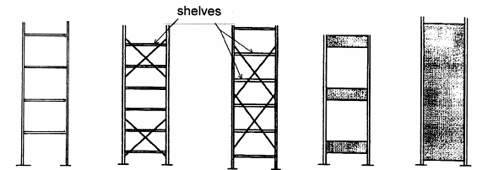

1

Open Diagonally Diagonally Battened Clad

braced braced

**Figure 1.1 Typical upright frame bracing systems**

**1.4.2 One piece frame:** An upright frame, usually perforated, which is manufactured from a single sheet of material within which the profile of the upright has been formed by cold-forming the edges.

**1.4.3 Cladding:** Steel sheet panels, often with perforated edges, which are used as shear panels in either the down-aisle or cross-aisle direction in order to provide horizontal stability to the structure.

**1.4.4 Beam:** A horizontal member linking adjacent frames and lying in the horizontal direction parallel to the main aisle.

**1.4.5 Beam End Connector:** A connector, welded to or otherwise formed as an integral part of the beams, which has hooks or other devices which engage in holes or slots in the upright.

**1.4.6** **Shelf** (a) A steel shelf is a thin metal sheet, with cold formed edges to provide adequate rigidity, on which goods are stored.

(b) Shelves made from other materials, such as timber or particle board are normally just infill panels fitted between beams to support the shelf loads.

**1.4.7** **Reinforced Shelf:** A shelf which is strengthened along its edges, and sometimes between its edges, in either the cross-aisle or down-aisle direction in order to enhance its load carrying capacity.

**1.4.8** **Non-Structural Shelf:** A shelf which is connected to the upright in such a way that only vertical shear can be transmitted between the shelf and the upright.

**1.4.9** **Shelf Clip:** A device which engages with the perforations in the upright and on which the shelf is supported, normally at its corners.

**1.4.10 Spine Bracing:** Sway bracing in the vertical plane parallel to the main aisle of the rack, linking adjacent frames.

**1.4.11 Perforated Member:** A member with multiple holes regularly spaced along its length.

**1.4.12 Basic Material:** Flat steel sheets or coiled strip from which the components are pressed or rolled. The basic material may be cold-reduced.

**1.4.13 Batch of Steel:** Quantity of steel, all to the same specification, purchased from one supplier at one time.

*Comment For material in sheet or coil forms, items in a batch should normally have the same nominal thickness.*

**1.4.14 Spring back:** The tendency of a cold-formed section to undergo spontaneous cross-sectional distortion when it is cut from a longer length.

**1.4.15 Unit load:** The weight of an individual stored item, eg. a pallet or a box or package on a shelving system.

**1.4.16 Compartment load:** The load which can be loaded into one compartment of a shelving structure from one side.

**1.4.17** **Bay load:** The sum of the compartment loads in one bay of the structure, not including the weight of any goods stored on the ground.

**1.5 Shelving systems**

**1.5.1 General**

In shelving systems, shelves are usually connected directly to the uprights by means of bolts or clips, or the shelf may be supported on beams. Such beams may be stepped in order to provide a flush loading surface. Down-aisle stability may be achieved by the action of semi-rigid joints between the shelves or beams and the upright, or by bracing or sheeting in the spine of the rack. Typical arrangements for achieving down-aisle stability are shown in Figures 1.2, 1.3 and 1.4. In Figures 1.2 and 1.3, down-aisle stability is provided by full and partial spine bracing respectively. In Figure 1.4, the semi-rigid shelf or beam to upright connections stabilise the system. Normally the shelves act as plan bracing to stabilise the front face of the rack.

In the cross-aisle direction, stability is achieved by bracing or by sheeting (integral in the case of one piece frames), or by the action of semi-rigid connections between the shelf and the upright. Figure 1.1 shows typical frame bracing arrangements.

Cladding, intermittently fastened to the upright with rivets, bolts or clips, may be used in the cross-aisle or down-aisle directions to provide stability to the structure by tension field action. The design of such cladding is normally determined by the strength of the connection to the upright, to which careful attention should be given. One piece frames are clad frames which are integrally stiffened in plane.

**6.3.2 Shelf Connections**

It is a characteristic of shelving systems that the shelf connection is designed to make it easy for the user to move the shelf to a new position in the assembly. The shelf, however, usually has a structural role to play in stabilising the system. Consequently the engineer shall take account of the whole range of possible shelf positions in assessing the load carrying capacity of the structure.

A large variety of novel devices in the form of clips, hooks and tabs has been devised for making the connection between the shelf and the upright so that, in order to be able to assess the structural integrity of the shelving system, and to investigate its overall stability, the structural behaviour of the connection between the shelf and the upright must be known. This is usually achieved by testing. Tests for the stiffness and strength of semi-rigid shelf to upright connections are described in section 5.13. A test for the stiffness and strength of the connection in horizontal tension is given in section 5.17.

**Note:**  that the portal frame test described in section 5.13 includes the effect of any looseness in the shelf to upright connections within the moment-rotation relationship.

Connections between shelves and uprights may be categorised as structural or non­structural. When the connection is capable only of transferring vertical shear into the upright, having no horizontal shear or moment capacity, the shelf is designated "non­structural" and shall not be accounted for as a structural member in assessing the overall stability of the complete system, except to the extent that it is capable of transmitting horizontal forces in compression.

In addition to transmitting vertical shear and sometimes bending between the shelf and the upright, the shelf connection is also required to transmit tensile and compressive forces to the upright frame. These forces arise primarily from the lack of straightness of the uprights in the structure. Compressive forces are easily transferred in compression between the shelf and the upright, but tensile forces are often transferred through novel forms of connection that are semi-rigid. A test to determine these structural characteristics is described in section 5.17.

Because such lack of straightness is random in its occurrence and in its magnitude and direction, it is not possible to calculate the design forces for the shelf to upright connection from a rational analysis of the applied effects. Consequently a simple arbitrary analysis model to determine these designs forces is specified in section 4.7.

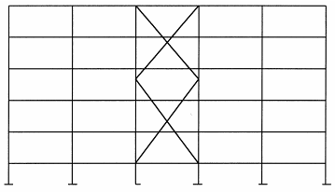

2

**Fig. 1.2 System fully braced in the down-aisle direction**

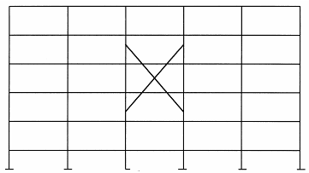

3

**Fig. 1.3 System partially braced in the down-aisle direction**

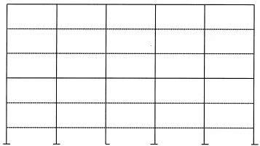

4

**Fig. 1.4 Semi-rigid shelf to upright connections provide down-aisle stability**

**1.6 Design working life**

Solely for determining the loading, a notional design working life of at least 10 years shall be considered. This should not be construed as indicating any guarantee regarding the actual working life of the shelving system. Attention should be given to the possibility of low cycle fatigue at locations where frequent loading and unloading take place, for example at pick up and delivery points (see section 2.3.1).

*Comment It is the duty of the operator of a shelving system to ensure that it is properly used and that any damage is repaired immediately. The working life of most shelving systems is determined by wear and damage sustained during operation or by corrosion. These cannot be pre-determined at the design stage and are not covered by this clause.*

**1.7 Durability**

In order to ensure the durability of the structure under conditions relevant to both its intended use and intended life the following factors should be considered at the design stage:

(a) the environment;

(b) the degree of exposure;

(c) the shape of the members and the structural detailing;

(d) whether maintenance is possible.

Where different materials are connected together, the effects of this on the durability of the

materials shall be taken into consideration.

*Comment Unless there is damage as a result of collision or misuse, normal protective coatings will give at least 10 years protection in dry internal conditions. External or corrosive conditions require special treatment.*

**1.8 Materials**

**1.8.1 Requirements**

Steels shall have properties which conform to the required suitability for cold-forming, welding and galvanizing. They shall be subjected by either the producer or purchaser to analysis, tests and other controls to the extent and in the manner prescribed by the standards given in section 1.8.2.

Steels with similar strength and toughness to the specified steels and complying with the test requirements are also permitted.

|  |  |  |  |  |
| --- | --- | --- | --- | --- |
| **Type of steel** | **Standard** | **Grade** | **fyb**  **N/mm2** | **fu**  **N/mm2** |
| Hot rolled steel  sheet of structural  quality | EN  10025 | S235  S275  S355 | 235  275  355 | 360  430  510 |
| Hot rolled steel  sheet of high yield  stress of structural  quality | EN  10113  Part 2 | S275 N or NL  S355 N or NL  S460 N or NL | 275  355  460 | 370  470  550 |
| EN  10113  Part 3 | S275 M or ML  S355 M or ML  S420 M or ML  S460 M or ML | 275  355  420  460 | 360  450  500  530 |
| Cold-reduced steel  sheet of structural  quality | ISO 4997 | CR 220  CR 250  CR 320 | 220  250  320 | 300  330  400 |
| Continuous hot dip  zinc coated carbon  steel sheet of  structural quality | EN  10147 | S 220 GD3  S 250 GD3  S 280 GD3  S 320 GD3  S 350 GD3 | 220  250  280  320  350 | 300  330  360  390  420 |
| High yield strength  steels for cold  forming | prEN  10149 | S 275 MC  S 355 MC  S 420 MC  S 490 MC  S 560 MC | 275  355  420  490  560 | 350  420  480  540  610 |
| prEN  10149 | S 275 NC  S 355 NC  S 420 NC  S 490 NC | 275  355  420  490 | 390  480  530  570 |

**Table 1.1 Yield strength of basic material fyb and tensile strength fu**

**according to the relevant documents (characteristic values).**

**1.8.2 Specified steels**

Specified steels according to Table 1.1, the properties and chemical composition of which are in compliance with the relevant documents, fulfil the requirements of section 1.8.1.

**1.8.3 Other steels**

Other steels may be used provided that

(a) their properties and chemical composition are specified in national standards for steel sheet for structural use,

or

(b) their properties and chemical composition are at least equivalent to steels, for which the standards are listed in Table 1.1

or

(c) If the steel is for cold-forming, it fulfils the requirements of the bend test described in section 5.2.2. and the ratio of the characteristic ultimate tensile strength to the characteristic yield strength satisfies fu/fy ≥ 1.05.

where fy, fu = characteristic tensile yield strength and tensile ultimate strength of the basic material respectively as defined in section 1.4.6.

*Comment The origin of the requirement in clause 3.1.1 of ENV 1993-1-3 that, for non-standard steels, the ratio fu/fy should be not less than 1.2 is uncertain and probably historical. Steels permitted in Table 3.1 of ENV 1993-1-3 have values as low as 1.09. The corresponding value in the American (AISI) Standard is 1.08 together with an elongation requirement. Certain European manufacturers of racking and shelving have many years of experience of using cold reduced steel with fu/fy < 1.2 and, for this reason, a less stringent limit is specified here. The justification for this is threefold:*

*(1) The argument for retaining the 1.2 requirement is difficult to sustain in the light of the above.*

*(2) Difficulties arising as a result of low ductility are very rare and when they do arise they are either in the cold-forming process or in the performance of the connections. In this document, any potential problems in the cold-forming process are eliminated by requiring a bend test. By far the most significant connection in a pallet racking or shelving system is the beam to column connection. Testing of this connection is mandatory.*

*(3) The manufacturers who use cold-reduced steel have sponsored an extensive research programme in order to demonstrate that the performance of their products is in no way inferior to that of standard steel. Some of the results of this research are reported in:*

*J M Davies and J S Cowen "Pallet racking using cold-reduced steel", 12th International Speciality Conference on Cold-Formed Steel Design and*

*Construction, St Louis, USA, 18-19 October 1994, 641-655.*

*However, care should be exercised when using such hard material when t > 3 mm or in cold conditions. Thicker material will usually fail the bend test described in section 5.2.2. See also section 5.16.3.*

**1.8.4 Mechanical properties of basic material**

*Comment It may be assumed that the properties of steel in compression are the same as those in tension.*

**1.8.4.1 Specified steel**

The mechanical properties (yield strength, ultimate strength, elongation) are the characteristic values for the grade of the specified steel.

**1.8.4.2 Other steels**

The mechanical properties of basic material should be measured from tensile tests according to section 5.2.1. The results of tensile tests shall be subject to statistical control, see section 5.1.3, and should be randomly checked by an independent institute.

If the grade is not specified and if the basic material is not available for testing, the following values of fyb may be assumed:

Hot rolled members 200 N/mm2

Other sheet steels 140 N/mm2

**1.8.4.3 General properties**

The following properties of steel may be assumed in design:

- Modulus of Elasticity E = 210000 N/mm2

- Shear Modulus G = E/[2(1+v)] N/mm2

- Poisson’s Ratio v = 0.3

- Coefficient of linear thermal expansion  = 12 x 10-6 per 0C

- Density  = 7850 kg/m3

**1.8.5 Testing of steels with no guaranteed mechanical properties**

When a manufacturer carries out tests to determine the minimum guaranteed mechanical properties for the steel used in production, or to justify the use in design of a yield stress higher than the guaranteed value, and to demonstrate adequate ductility, the minimum frequency of testing is as follows:

(a) **Coils**. From each original coil (after slitting and cold-reducing, if cold-reducing is part of the process) one test shall be carried out. Samples shall be taken lengthwise from the middle of the width near the end of the coil.

(b) **Sheets and Sections.** The mechanical properties given in section 1.8.4.2 for unspecified steels shall be used.

The results of the mechanical tests shall be statistically analyzed in accordance with section 5.1.3 (c), in order to derive characteristic values of the yield or ultimate tensile strength of the material for design purposes.

Where at least 100 test results have been accumulated over a long period, those in excess of 100 which are more than twelve months old shall be discarded from the analysis.

**1.9 Average yield strength of sections**

The average design strength (fya) may be determined for non-perforated members as follows:

fya = fyb + (CNt2/Ag) * (fu - fyb)

where fyb, fu = characteristic tensile yield strength and tensile ultimate strength of the basic material respectively as defined in section 1.4.6 (N/mm2).

t = design thickness of the material (before cold-forming).

Ag = gross cross-sectional area (mm2).

C = coefficient as a function of the type of forming:

C = 7 for rolled material

C = 5 for other methods of forming

N = number of 90o bends in the section with an internal radius < 5t (fractions of 90o bends should be counted as fractions of N)

fya should not exceed 0.5 (fyb + fu).

The increase in yield strength, expressed by fya, shall only be taken into account if Aeff/Ag = 1 and where the effect of cold-forming obviously results in an increase of the load-bearing capacity.

where Aeff = effective cross sectional area (see chapter 3)

*Comment The full effect of the increase of yield strength is to be expected in axially loaded fully effective sections and in the bending of profiles with fully effective cold-formed flanges. In the latter case, the average tensile yield point of the flats, weighted according to the cross-sectional area, may be determined.*

The increase in yield strength due to cold working shall not be utilized for members which are welded within cold-formed areas or subjected to heat treatment (≥ 5800C) after forming.

Special attention must be paid to the fact that some heat treatments (especially annealing) may induce a yield strength lower than fyb.

**1.10 Fracture toughness**

The material shall have sufficient fracture toughness to avoid brittle fracture at the lowest service temperature expected to occur within the intended life of the structure. Suitable test procedures for demonstrating adequate fracture toughness at low temperature are given in section 5.15. The material should not be used at a temperature lower than 100C above the transition temperature determined by this test.

*Comment: When a shelving system is to be used at temperatures below -10oC, the material quality shall be carefully chosen with regard to ductile behaviour at low temperature, especially where the construction elements form a welded beam-upright or cantilever bracket-upright connection. If the material qualities of these elements are not at least equal to J2-quality according to Euronorm 10025, it is recommended that the ductility of these connections should be demonstrated by testing at the relevant temperature. Guidance on the selection of the appropriate grade of steel , for steels conforming to EN 10025 and 10113, is given in Annex C to ENV 1993-1-1.*

**1.11 Thickness of material**

The design rules given in these Recommendations are limited to the following core thickness tc exclusive of coatings, where:

0.5 ≤ tc ≤ 8.0 mm

The use of thicker or thinner material is not precluded, but then the load bearing capacity shall be determined by appropriate tests. The design expressions for baseplates in section 3.8 may extend to baseplates with a thickness greater than 8 mm.

**1.11.1 Tolerances on thickness**

The design rules given for cold-formed members have been developed on the basis of thickness tolerances which are approximately half the tolerances specified as normal in EN 10143. When larger tolerances are used, the nominal values of thickness shall be adjusted to maintain the equivalent reliability.

For continuously hot-dip metal coated material with a nominal thickness ≤ 1.5 mm supplied with the restricted special tolerances given in EN10143, the design thickness t shall be taken as equal to the nominal core thickness tc.

In the case of continuously hot-dip metal coated steel sheet and strip conforming to EN 10147, the core thickness tc is (tN - tz), where tN is the nominal thickness and tz is the thickness of the zinc protection (usually a total of 0.04 mm for 275 g/m2).

**1.12 Dimensional tolerances**

The tolerances on the dimensions of cold-formed sections shall not exceed the limits given in sections 1.12.1 to 1.12.3.

**1.12.1 Width and depth of a section**

The width and depth of a section shall fulfil the requirements of Tables 1.2 and 1.3.

Thickness t bo ≤ 50 50 < bo ≤ 100 100 < bo ≤ 220

t < 3.0 ± 0.75 ± 1.00 ± 1.00

3.0 ≤ t < 5.0 ± 1.00 ± 1.00 ± 1.25

5.0 ≤ t ≤ 8.0 ± 1.00 ± 1.25 ± 1.50

**Table 1.2 Tolerances on width bo** **of stiffened flat elements: Dimensions in mm**

Thickness t bo ≤ 40 40 < bo ≤ 80 80 < bo ≤ 120

t < 3.0 ± 1.20 ± 1.50 ± 1.50

3.0 ≤ t < 5.0 ± 1.50 ± 1.50 ± 2.00

5.0 ≤ t ≤ 8.0 ± 2.00 ± 2.00 ± 2.00

**Table 1.3 Tolerances on width bo** **of unstiffened flat elements: Dimensions in mm**

**1.12.2 Member straightness**

The initial maximum deviation of a member from the exact straight line shall be less than 1/400 of the member length measured with respect to the two ends.

**1.12.3 Twist**

The initial twist of a member shall be in general less than 1o per metre. In the case of asymmetric sections a 50% higher initial twist is allowed.

**1.13 Tolerances with regard to design and assembly**

**1.13.1 Verticality**

The maximum out-of-plumb of any upright in any direction shall be height/350 measured in the unloaded condition immediately after erection.

*Comment. The maximum out-of-plumb is a frame imperfection which influences the design. The above value is an upper bound and, if it can be shown that better values are consistently achieved, then more favourable initial sway imperfections may be assumed according to section 2.5.1.*

**1.13.2 Bracing eccentricities**

It is recommended that the eccentricities between system lines shall be as small as possible. If the eccentricities are large the secondary moments cannot be neglected. The stiffening effect of the bracing will also be reduced and further bending moments will be induced in the main load-carrying members.

**1.13.2.1 Bracing eccentricities may be neglected if the following conditions are fulfilled**

(a) All bracing systems

The intersection point of the centre lines of a horizontal member and a diagonal falls within a vertical dimension equal to the lesser of one half of the upright depth or one half of the upright width (b), symmetrically disposed about the centre line of the upright. (see Fig. 1.6).

(b) Bracing systems for spine braced construction

The eccentricities e, e1 and e2, as shown in Fig. 1.6, shall not be greater than 1.5 times the width of the upright dimension 'b' in the plane of the bracing. Where beams or structural shelves are used as horizontal members, the intersection point should be the intersection of the centre lines of a diagonal and the top or bottom flange line. It is good practice for the angle of inclination of the diagonal from the horizontal to lie between 20o and 70o.

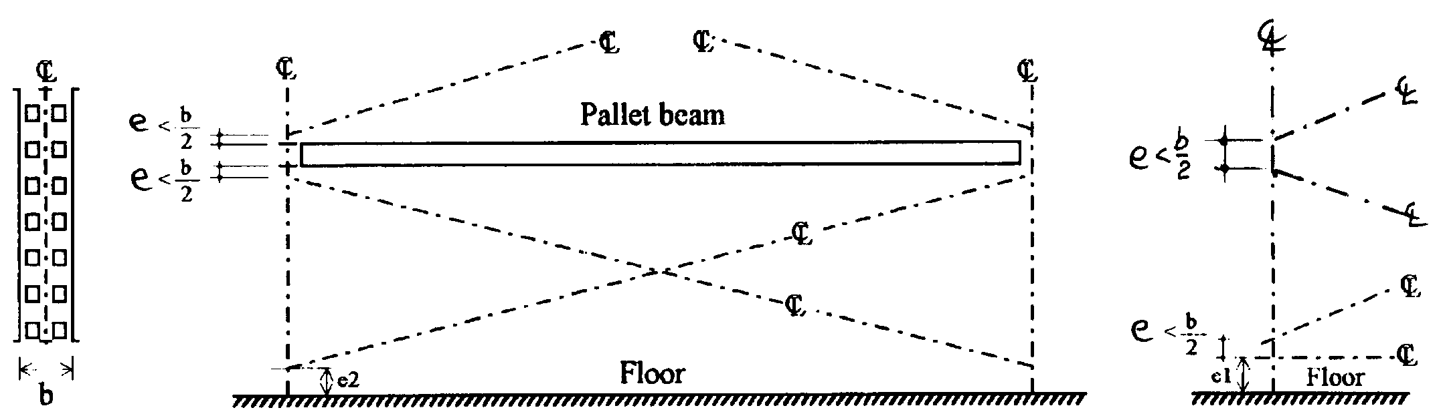

5

**Figure 1.6 Eccentricities in bracings**

**1.13.3 Eccentricities between beams and uprights**

The centroidal axis of the beam or shelf may not coincide with the centroidal axis of the upright. This results in an eccentricity in the cross-aisle direction which should be considered.

*Comment In conventional adjustable shelving, this eccentricity may generally be neglected. It may be important if, for example, the beams are connected to the outside of the upright frames.*

**1.14 General requirements for connections**

Except as required by subsequent clauses in these recommendations, connections shall be in accordance with ENV 1993-1-1 and ENV 1993-1-3.

Where beams or structural shelves provide down-aisle stability, provision shall be made to ensure that they cannot disengage from the upright when subjected to upward shear load. Such loads may be induced into an unloaded beam or shelf by bending due to sway. The design load for upward vertical shear, treated as an accidental overload, is defined in section 2.6.1.

**1.15 Identification of the performance of shelving installations**

All installations shall display, in one or more conspicuous locations, a permanent notice stating that the installation is designed according to FEM requirements and which shows the maximum permissible unit load and the maximum permissible bay load in clear legible print.

Where the permissible loads are not identical throughout the installation, these load notices shall be placed in such a way that the maximum permissible unit load is identified for each location throughout the structure.

**1.16 Shelving configuration**

Load application and configuration information (in the form of drawings if appropriate) shall be furnished with each installation one copy of which shall be retained by the user or owner and another by the manufacturer, distributor or other representative for use by any inspecting body. This information shall be retained for at least ten years.

If the use of the installation is permissible in more than one configuration, the permissible loads shall be presented as a function of the different relevant parameters (e.g. distance between beams). This information may optionally be furnished in a table. The user and owner shall be informed by conspicuous text on the drawings and/or tables that deviations from stipulations may impair the safety of the installation. The owner is responsible for all changes to the configuration which shall follow the drawings or tables and which should be carried out under the supervision of a competent person.

**2 SAFETY PHILOSOPHY, LOADS AND IMPERFECTIONS**

**2.1 General**

It should be verified by means of static analysis and/or tests that at both the ultimate limit state and the serviceability limit state:



1

where



2

**Note:**



3

**2.2 Methods of design**

The design of the structure or its parts may be carried out by one of the methods given in Chapter 4.

In all cases, the details of the members and connections should be such as to realise the assumptions made in the design without adversely affecting any other parts of the structure.

**2.3 Limit states**

**2.3.1 Ultimate limit state**

The ultimate limit state corresponds to the maximum load carrying capacity and is generally characterised by one of the following:

* Strength (including widespread yielding, rupture, buckling and transformation into a mechanism)
* Stability against overturning and sway
* Excessive local deformation
* Fracture due to fatigue

*Comment. This document contains no further reference to fatigue. It is therefore implicit that normal shelving systems are not subject to fatigue and that this document should not be used for the design of installations subject to many cycles of load or incorporating details which may be vulnerable to low cycle fatigue without proper consideration of the effect of repeated loading. Low cycle fatigue is likely to be significant in the case of pick-up and deposit stations or satellite rails. Suitable procedures for dealing with fatigue are given in Chapter 9 of ENV 1993, Part 1.1.*

**2.3.2 Serviceability limit state**

The verification of the serviceability limit state ensures the proper functioning of the elements under service conditions. In general, it is sufficient simply to consider deformations or deflections which affect the appearance or effective use of the structure.

**2.3.3 Requirements for deflections**

Shelving systems shall be so proportioned that the deflections are within the limits agreed between the client, the designer and the competent authority as being appropriate to the intended use and the nature of the handling equipment.

Recommended limits for deflections are given in section 2.3.4. In some cases more stringent limits (or exceptionally less stringent limits) will be appropriate to suit the use of the installation.

The deflections should be calculated making due allowance for any second-order effects and the rotational stiffness of any semi-rigid joints.

**2.3.4 Limiting values of deflection**

Under the loads defined in section 2.4 and the serviceability limit state combinations defined in section 2.7.2, the limiting values for deflections are as follows:

maximum vertical deflection in a beam: span/200

maximum twist in a beam (see section 5.11): 6 degrees

maximum vertical deflection at the edge of a shelf: span/200

maximum vertical deflection in the supporting structure of a walkway: span/250

sway at the top of the structure height/200 (with the actions arising from imperfections and any variable loads

(eg wind) but not placement loads)

In a cantilever, the deflection limit may be increased to span/100

Notes. 1. Sway is defined as the movement in addition to any initial out of plumb.

2. The limit of span/250 for structures supporting walkways is applicable to a load of 2.5 kN/m2 (section 2.4.8). If a higher load is specified, the deflection limit may be increased in proportion, but should not be more than span/200.

**2.4 Actions**

**2.4.1 Dead loads (permanent actions)**

**2.4.1.1 Definition**

Dead loads comprise the weight of all permanent construction, including walls, floors, ceilings, stairways and fixed service equipment.

**2.4.1.2 Weights of materials and constructions**

In estimating dead loads for the purposes of design, the actual weights of materials and constructions shall be used provided that, in the absence of definite information, values satisfactory to the authority having jurisdiction are assumed.

If the total self-weight of the structure is less than 5% of the total applied vertical load, the self-weight of the structure may be neglected.

**2.4.1.3 Weight of fixed service equipment**

In estimating dead loads for the purposes of design, the weight of fixed service equipment, such as sprinklers, electrical feeders, and heating, ventilating, and air conditioning systems, shall be included whenever such equipment is supported by structural members.

**2.4.2 Live loads (variable actions)**

**2.4.2.1 Definition**

Live loads are those loads produced by the use and exploitation of the structure and do not include environmental loads such as wind load, earthquake load, or dead load.

Live loads from other equipment connected to the structure shall be determined and taken into account in the design.

**2.4.2.2 Goods to be stored**

The end user, or the specifier in consultation with the end user, shall specify the maximum weight and gross dimensions of goods to be stored (e.g. the shelf load) and any special requirements regarding their distribution.

For global analysis it may be assumed by the designer that both the distribution of load in any bay and the distribution within the volume of the rack are uniform unless an alternative distribution is agreed in writing by the designer with the end user or specifier.

**2.4.3 Wind loads**

Wind loads shall be in accordance with the relevant National Standards.

When determining the limiting deflections for the proper functioning of automatic equipment, a lower value of wind load may be used with the agreement of the supplier of the equipment.

*Comment. 1. Further guidance on this point is given in document FEM 10.03.01.*

*2. When a shelving structure is exposed to wind, any individual row may be full while other rows are empty. Thus, each individual row of shelves (between adjacent aisles) shall be capable of resisting the full wind pressure, suction and wind friction. However, when treated as a complete installation, the assembled rows need not be capable of resisting more than the wind force calculated for the complete assembly. If the effect of permeability can be quantified (eg. by wind tunnel tests) it may be taken into account, otherwise the full installation should be considered to be impermeable to wind.*

**2.4.4 Earthquake loads**

Earthquake loads shall be in accordance with the relevant National Standards.

**2.4.5 Vertical placement loads**

In applications where unit loads are placed in position, the following minimum vertical placement loads shall be applied. The minimum vertical placement load is not intended to represent an impact load arising from misuse of the installation. It is a load which reflects the likely result of good practice in the placement and removal of unit loads from the system.

Load support beams or shelves or supporting arms (if any) and end connections shall be designed for an additional vertical placement load Qpv of 100% of the maximum unit load, placed in the most unfavourable position for the particular determination (moment or shear force). If a shelf is designed for more than 5 similar unit loads, this vertical placement load may be ignored.

*Comment. It is permissible to increase the design uniformly distributed load in order to obtain an approximate treatment of the placement load on shelving.*

When allowable loads are determined by test (see section 5), due allowance must be made for this downward placement load. No downward placement load need be applied when checking beam deflections or when designing upright frames and other components.

**2.4.6 Horizontal placement loads**

In applications where unit loads are placed in position, the following minimum horizontal placement loads (variable actions), Qph, shall be applied in both the cross-aisle and the down-aisle direction at the most unfavourable location. They shall be applied in one direction only, not in both directions simultaneously.

The minimum horizontal placement load is not intended to represent an impact load arising from misuse of the installation. It is a load which reflects the likely result of good practice in the placement and removal of unit loads from the system.

An accidental overload shall be taken into consideration according to section 2.6, but not at the same time as the horizontal placement load. Accidental loads are intended to reflect minor impacts in restricted areas. Neither placement loads nor accidental loads should cause permanent physical damage to the installation.

In general, Qph = 0.25 kN (variable action)

However, if there is no possibility of a ladder being leaned against the installation:

Qph = 0.05 kN

*Comment Horizontal forces can be caused by misuse of a shelving system when, for example, a ladder or other climbing device is placed against it in order to gain access to the goods. They may also arise when goods are pushed or slid into their intended place. The lower of the above values should only be used with caution.*

**2.4.6.1 Application of the horizontal placement load in the down-aisle direction**

In the down-aisle direction, the horizontal placement load arises only at the beam levels and serves to amplify the down-aisle sway caused by frame imperfections. In order to avoid creating unnecessary load cases, the point load Qph in clause 2.4.6 may be replaced by a total load of 2Qph distributed uniformly over all beam levels.

*Comment The intention is that combination of the placement load case with the frame imperfection load case should be considered and the worst case determined before carrying out the down-aisle analysis.*

**2.4.6.2 Application of the horizontal placement load in the cross-aisle direction**

In the cross-aisle direction, the most unfavourable location for the placement load may be:

(1) The top of the upright frame in order to maximise the forces in the bracing system.

For this case, the point load may be distributed between the beam levels as described in section 2.4.6.1.

(2) At a position that will maximise the cross-aisle bending moment such as mid-way between two bracing nodes of a braced frame.

For this case, the critical load location is generally in the lowest length of upright between bracing points. If the spacing of bracings is non-uniform, other locations should also be investigated. In order to determine the design bending moments, it is not necessary to carry out a global analysis of the complete upright frame. It is sufficient to add positive and negative bending moments of magnitude Qph/8, as shown in Fig. 2.1.

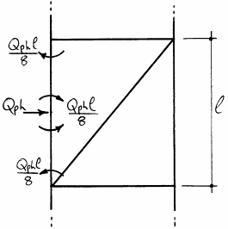

1

**Fig. 2.1 Cross-aisle bending moments**

(3) The mid-span of a beam in the horizontal plane in order to provide the maximum minor axis bending moment. This case need not be incorporated in the global cross-aisle analysis and the load Qph may be considered to be carried by a single shelf or a pair of beams in the horizontal plane through their neutral axis. Interaction with the vertical load causing Qph may be ignored.

If the installation is designed for loads to be rolled or slid into position, the placement loads Qph generated by the loading process shall be determined and allowed for in the design.

*Comment This Clause does not refer to live storage systems which are outside the scope of the document.*

**2.4.7 Floor and walkway loads**

Unless National Building Regulations require higher values, the following distributed or concentrated loads (whichever is most critical) shall be used in the design of floors or walkways.

(a) On floors and walkways intended for access only and not more than 1.2 m wide.

q = 2.5 kN/m2 (distributed load)

or Qf = 1.5 kN (concentrated load applied over a square 100 mm x 100 mm)

*Comment 1. The above loads represent the design load on any one bay. The overall load on the structure may be reduced such that q = 2.5 kN/m2 is used for the local design of beams and uprights and q = 1.0 kN/m2 for the verification of global stability.*

*2. There is no need to consider pattern loading on floors and walkways.*

(b) On stairs and floors wider than 1.2 m or intended for storage or on which trolleys may run.

q = 3.5 kN/m2 (distributed load)

or Qf = 3.0 kN (concentrated load applied over a square 100 mm x 100 mm).

The concentrated load shall be placed in the most unfavourable position.

Smaller design loads than those given above may only be used if there is a prominent notice fixed permanently to the installation which displays the maximum permitted floor load.

If the wheel loads from trolleys or order-picking equipment, multiplied by a factor of 1.2 to take account of the dynamic effect of wheel loads, exceed the above values, 1.2 times the actual wheel loads shall be used.

*Comments 1. The values given above are minimum design loads based on the philosophy that, if an area is available which could be used for storage, it will at some time become used as such. In areas with higher than average headroom, consideration should, therefore, be given to using greater design loads than those specified.*

*2. The designer should take into account the possibility of unequal wheel loads due to either uneven trolley loading or irregular floor surfaces or centrifugal forces.*

*3. Where moving equipment applies either acceleration or deceleration forces to the structure, these shall be taken into account as variable actions with the relevant load factor given in clause 2.7.3, Table 2.2.*

If the loads arising from stored materials or shelving systems supported by the floor exceed the above values, the actual load shall be used. Particular attention should be given to the concentrated loads applied by upright frames.

**2.4.8 Thrusts on handrails**

Stairway and floor handrails shall be designed to resist a thrust of 0.5 kN/m applied in any direction at the top of the railing unless National Regulations specify a higher loading.

If the possibility exists of these items being impacted by moving equipment, then consideration shall be given to the use of additional edge protection measures.

**2.4.9 Temperature loads**

In cold stores, due consideration shall be given to stresses in a shelving structure generated by temperature differences between the structure and the floor, especially during commissioning and decommissioning of the store.

**2.5 Actions arising from imperfections**

The influence of imperfections shall be considered in the analysis by taking due account of:

* frame imperfections according to section 2.5.1
* bracing system imperfections according to section 2.5.2
* member imperfections according to section 2.5.3.

Frame imperfections shall be included in the global analysis of the structure. The resulting forces and moments shall be used for member design.

Bracing system imperfections shall be included in the analysis of any assembly which incorporates bracing members. The resulting forces and moments shall be used for member design.

Member imperfections may be neglected when carrying out global analysis except in the case of sway frames with moment resisting connections in which one or more members subject to axial compression satisfies:



4

where NSd = the design value of the compressive force in the member

s = system length of the member in the plane of buckling

E = Modulus of Elasticity

I = second moment of area of the member about the axis of buckling

**2.5.1 Frame imperfections**

The effects of frame imperfections shall be considered in global analysis either by means of an initial sway imperfection or by a closed system of equivalent horizontal forces.

The effect of looseness of the beam or shelf to upright connector shall be included in the calculation

of the frame imperfection or, alternatively, it may be included in the connector moment-rotation relationship assumed for the global analysis (see Chapter 4).

The sway imperfection  shall be determined from



5

where nc = number of uprights in the down-aisle direction or number of connected frames in the cross-aisle direction

ns = number of beam and/or structural shelf levels

s = maximum specified out-of-plumb divided by the height.

 = looseness of beam or structural shelf to upright connector determined according to 5.6 (for unbraced frames only)

If, the effect of the looseness of the beam or shelf to upright connector is included in the modelling of the connection used in the global analysis,  may be set equal to zero in the above equations.

**Note** For braced frames,  = 0.

These initial sway imperfections apply in all horizontal directions, but need only be considered in one direction at a time.

If more convenient, the initial sway imperfections may be replaced by a closed system of equivalent horizontal forces. These equivalent horizontal forces should be applied at each level and should be proportional to the factored vertical loads applied to the structure at that level, as shown in Figure 2.2.

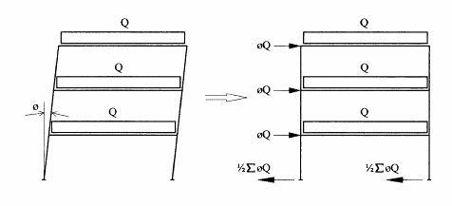

2

**Figure 2.2 Equivalent horizontal forces**

For the design of the base plate and floor fixings, the horizontal reactions at each base support should be determined using the sway imperfection  and not the equivalent horizontal forces. In the absence of actual horizontal loads, the net horizontal reaction is zero.

**2.5.2 Bracing system imperfections**

This clause is applicable to both upright frames and frames braced in the down-aisle direction.

The effects of imperfections in bracing systems which are required to provide lateral stability shall be considered by means of an initial geometric imperfection in the bracing system.

Both global imperfections according to 2.5.2.1 and local imperfections according to 2.5.2.2 should be considered. These are not additive.

**2.5.2.1 Imperfections in the vertical bracing system and its connections**

*Comment The imperfections described in this section are intended for use in global analysis.*

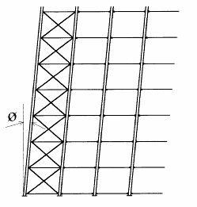

In the down-aisle direction, the initial sway imperfection shown in Fig. 2.3 shall be according to section 2.5.1 with nc equal to the number of connected frames in one row of bays.

In the cross-aisle direction, where frames are connected together (e.g. by top ties, frame spacers or by intermediate floors). The initial sway imperfection shall be according to section 2.5.1 with nc equal to the number of braced frames acting together and (1/5 + 1/ns) = 1.

**Figure 2.3 Global bracing imperfections**

**2.5.2.2 Local bracing imperfections**

*Comment The imperfections described in this section are intended for the design of the elements of the bracing system (first-order analysis only).*

For uprights without splices  = 1/400

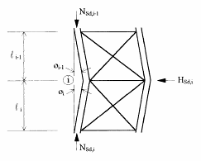

For uprights which incorporate splices  = 1/200.



6



7

**Figure 2.5 Local bracing**

**imperfections**

>

where nu = number of uprights per bracing system

For convenience, this initial geometric imperfection can be applied as a horizontal force HSd,i where

HSd,i = NSd,i-1  + NSd,i 

where HSd,i is summed over all connected uprights

and where NSd = design axial load in a member.

*Comments 1. If*  *=* *; NSd,i = NSd,i-1;*  *=* , *then HSd,i = 2NSd,i* 

*2. Local bracing imperfections give rise to self equilibrating systems of forces which are to be used in the design of the bracing members and their connections only.*

**2.5.3 Member imperfections**

Normally the effects of imperfections on member design shall be incorporated by using the appropriate buckling formulae given in ENV 1993-1-1.

Alternatively, for a compression member with axial compressive force NSd greater than the limiting value given in clause 2.5, the initial bow imperfection specified in ENV 1993-1-1, shall be included and second-order global analysis shall be used.

**2.5.4 Loading imperfections**

Imperfections in the placement of loads should be considered in cases where the design allows

significant misalignment in either the down-aisle or cross-aisle directions. For example, if the width of the unit load is not equal to the distance between its supporting beams, or if the centre of gravity of the load does not coincide with the centre of the shelf, unequal loading of the beams or shelves is possible as shown in Figure 2.5.

If the effect (stress, deformation etc) of loading imperfections at the limit of tolerance is less than 12% of the effect of the beam load, it may be ignored.

If the design and operation of the system encourages systematic eccentric alignment, then this shall be taken into account in the global analysis.

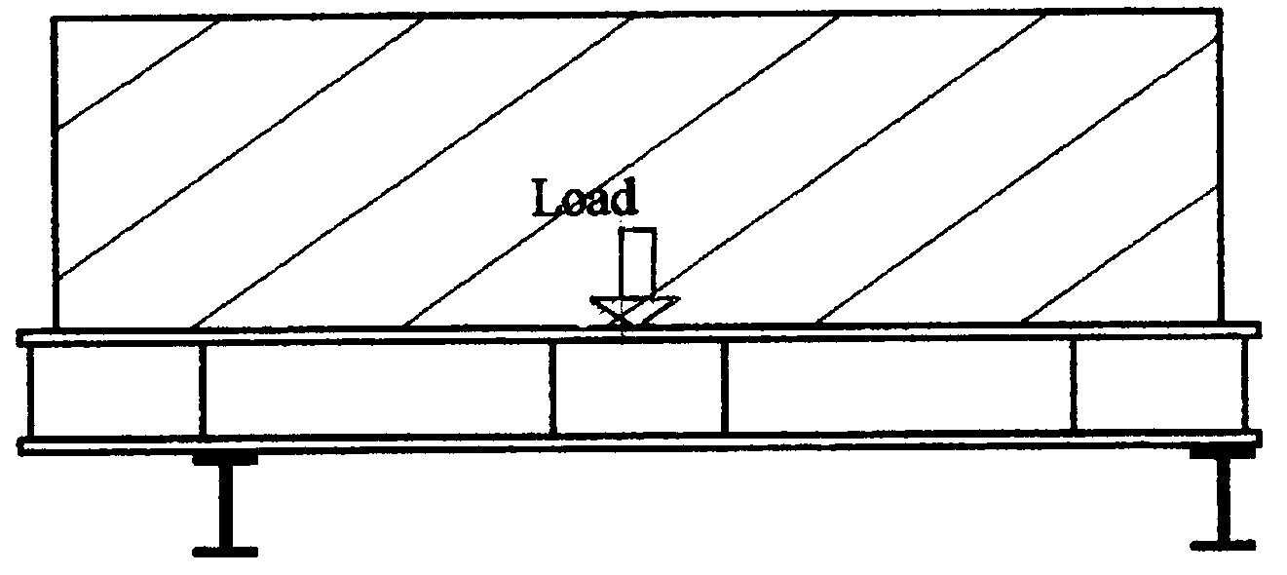

3

**Figure 2.5 Load eccentricity**

**2.6 Impact loads**

The live loads and placement loads specified in 2.4 may be assumed to include adequate allowance for ordinary impact conditions. Provision shall be made in the structural design for uses and loads that involve unusual vibration or dynamic forces.

**2.6.1 Accidental vertical load**

Structural components directly above a unit load shall be able to absorb the following accidental upward force Apv. In general, this force shall be applied at the end of a beam or structural shelf in order to verify that the connector does not disengage.

Apv = 0.5 Qu

but Apv ≥ 0.25 kN

and Apv ≤ 5.0 kN

where Qu = unit load.

The requirements for upward placement loads may be verified by calculation or by testing according to 5.7.

*Comment. Upward placement loads are accidental variable actions and are therefore considered with a load factor γA according to section 2.7.3*

**2.7 Safety factors and combination rules**

Goods to be stored together with their associated imperfections constitute a single action. Placement loads constitute a separate action.

Global imperfections and placement loads (section 2.4.6) should be combined but only in one direction at a time. There is no need to consider the possible combination of imperfections or placement loads in one direction with imperfections or placement loads in the other orthogonal direction.

**2.7.1 Combinations of actions for the ultimate limit state**

The design values of actions shall be combined using the following rules, whichever gives the larger value:

* considering only the most unfavourable variable action:



8

* considering all unfavourable variable actions which may occur simultaneously



9

* design for accidental load



10

where Gk = characteristic value of permanent action (dead load)

Qk,1 = characteristic value of one of the variable actions

Qk,i = characteristic value of a typical variable action

Ak = characteristic value of an accidental action

G = partial safety factor for permanent actions

Q = partial safety factor for variable actions

A = partial safety factor for accidental actions

**2.7.2 Combination of actions for serviceability limit states**

* considering only the most unfavourable variable action



11

· considering all unfavourable variable actions



12

where the notation is defined in section 2.7.1.

**Note** Placement loads do not need to be considered at the serviceability limit state.

*Comment In general, unless unusual conditions prevail, it may be assumed that the goods to be stored constitute the action with the largest effect.*

**2.7.3 Load factors**

The load factors  are given in Table 2.1.

*Comments 1. Certain quantities associated with levels of safety are given as 'boxed values' in the Eurocodes. The authorities are expected to assign definitive values to these quantities in National Application Documents. Here, the load and material factors are not boxed because*  ***it is intended that the load and material factors should be mandatory.***

*2. The statistical uncertainty regarding the magnitude of unit loads is considerably less than that for the conventional live loads in building construction (wind, snow, floor load etc). Consequently, unit loads have a load factor intermediate between that for live load and that for dead load.*

|  |  |  |  |  |  |  |
| --- | --- | --- | --- | --- | --- | --- |
| Load factor f | Ultimate  limit state | | | Serviceability  limit state | | |
| **Permanent actions** **G**  - with unfavourable effect  - with favourable effect |  |  |  |  |  |  |
|  | 1.3 |  |  | 1.0 |  |
|  |  |  |  |  |  |
|  | 1.0 |  |  | 1.0 |  |
|  |  |  |  |  |  |
| **Variable actions** **Q**  live loads  unit shelf loads  placement loads |  |  |  |  |  |  |
|  | 1.5 |  |  | 1.0 |  |
|  |  |  |  |  |  |
|  | 1.4* |  |  | 1.0 |  |
|  |  |  |  |  |  |
|  | 1.4 |  |  | 1.0 |  |
|  |  |  |  |  |  |
| **Accidental actions**  A  GA  QA |  |  |  |  | | |
|  | 1.0 |  |  | | |
|  |  |  |  | | |
|  | 1.0 |  |  | | |
|  |  |  |  | | |
|  | 1.0 |  |  | | |
|  |  |  |  | | |

* If the warehousing system includes for the weighing of all unit loads and the rejection of all unit loads weighing more than the design load of the installation, the load factor for unit loads may be reduced to 1.3.

**Table 2.2 Load factors** **f**

**2.7.4 Material safety factors**

The material safety factors M for ultimate limit state and serviceability limit state verifications are given in Table 2.2.

|  |  |  |  |  |  |  |
| --- | --- | --- | --- | --- | --- | --- |
| Material factor M | Ultimate  limit state | | | Serviceability  limit state | | |
| Resistance of class 1, 2 or 3 cross-section  Resistance of upright and class 4  cross-sections  Resistance of member to buckling  Resistance of connections  Resistance of connections subject to testing and quality control  (e.g. beam end connectors) |  | 1.0 |  |  | 1.0 |  |
|  |  |  |  |  |  |
|  | 1.1 |  |  | 1.0 |  |
|  |  |  |  |  |  |
|  | 1.1 |  |  | 1.0 |  |
|  |  |  |  |  |  |
|  | 1.25 |  |  | 1.0 |  |
|  |  |  |  |  |  |
|  | 1.1 |  |  | 1.0 |  |
|  |  |  |  |  |  |

**Note:** For classification of cross-sections see section 5.3 of ENV 1993-1-1.

**Table 2.2 Material safety factors** **M**

*Comment. Class 4 cross-sections are those in which it is necessary to make specific allowances for the effects of local buckling when determining their moment resistance or compression resistance. In general, cold-formed steel uprights, because of all kinds of difficulties, should be considered to be class 4 but beams will generally fall within classes 1 to 3.*

**2.8 Shelving systems braced against the building structure**

If the shelving systems are braced against the building structure, the two structures will impose forces upon each other. These forces should be calculated and the owner of the building or the owner's representative shall be informed of these forces and their locations.

**3. MEMBER DESIGN**

**3.1 General**

The design of cold-formed steel members shall be in accordance with ENV 1993-1-3 “Cold-formed thin gauge members and sheeting” of Eurocode 3 modified where necessary to take into account perforations. This Chapter repeats sufficient of the clauses of ENV 1993-1-3 to make possible the design of the majority of conventional members of shelving installations and adds the necessary modifications to make possible the design of perforated uprights.

It is implicit that the design of perforated members requires testing. However, this is not intended to restrict the development of analytical procedures (eg using finite elements) for predicting the performance of members containing regular arrays of holes or slots. Where rational analysis can be shown to be sufficient, it may be used to replace the relevant test procedures.

**3.2 Calculation of section properties**

The following paragraphs make reference to groups of section properties which are defined thus:

Gross section properties are properties of the gross section without any reduction for perforations or local buckling. Gross section properties are generally used in global calculations for internal forces and deflections. The system line of the structure should be taken as the line through the centre of gravity of the gross cross-section.

Minimum section properties are the properties of a perforated element corresponding to the gross cross-section with the maximum reduction for the effect of the perforations. The reduction for the effect of perforations is defined below.

Effective section properties are the reduced section properties taking account of local buckling. They are used in strength calculations and may be calculated for non-perforated members according to Appendix D or determined by stub column tests according to section 5.3.

**3.2.1 Effect of corner radii**

In general, section properties should be calculated taking proper account of corner radii.

Notional plane widths bp and effective widths beff shall be measured from the mid-point of the corner as shown in Fig. 3.1.

Radiused corners may be treated approximately if r ≤ 5t and r/bp ≤ 0.15. In this case, the section is first considered to be made up of plane elements with sharp corners and then the section properties are reduced as follows:

Area Ag′ = Ag (1 - δ) A′eff = Aeff (1 - δ)

Second moment of area Ig′ = Ig (1 - 2δ) I′eff = Ieff (1 - 2δ)

Warping constant Iw′ = Iw (1 - 4δ)

where Ag′, A′eff, Ig′, I′eff, Iw′ are reduced properties taking account of the rounding of corners



1

with n = total number of corners

m = number of flat elements

bj = flat width of element j measured on the centre line of the element

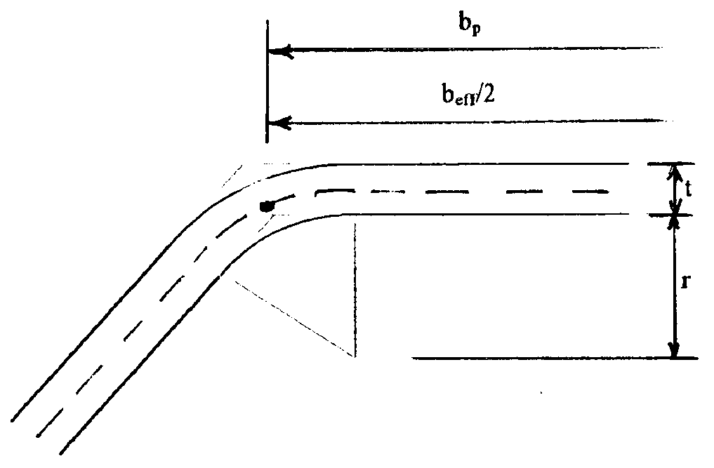

1

**Fig. 3.1**

The following section properties may always be computed on the assumption of sharp corners with no reduction for perforations or for the effective widths of elements of the cross-section in compression:

IT = St Venant torsional constant of the gross cross-section

yo = distance along the y-axis from the shear centre to the centre of gravity of the gross cross-section

iy,iz = radii of gyration of the gross cross-section about the y and z axes respectively

io = polar radius of gyration of the gross cross-section about the shear centre.

**3.2.2 Effect of perforations**

In the case of non-staggered holes, the minimum cross-section corresponds to the minimum section length reduced by the holes in any cross-section at right angles to the direction of stress in the member as shown in Fig. 3.2(a).

In the case of staggered holes, the minimum cross-section corresponds to the minimum section length as above or to the gross cross-section reduced by the cross-sectional areas of all holes in any zig-zag line extending progressively across the member less s2t/(4p) for each gauge space in the chain of holes as shown in Fig. 3.2(b), whichever gives the lowest value.

where s is the staggered pitch, ie the spacing of the centres of two consecutive holes in the chain measured parallel to the member axis

p is the spacing of the same two holes measured perpendicular to the member axis

In the case of inclined slots, the minimum section shall be the gross section reduced by the projection of the slot onto the cross-section as shown in Figure 3.2(c).

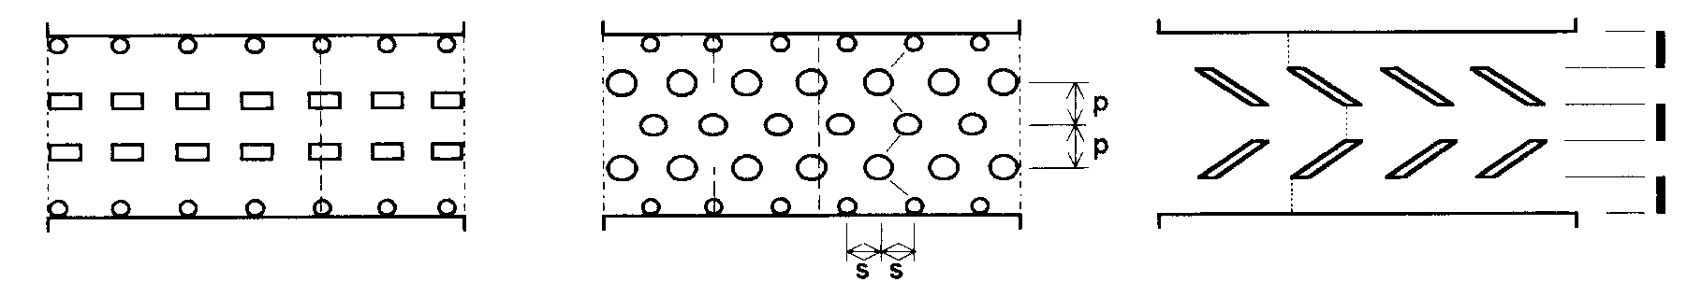

2

(a) non-staggered holes (b) staggered holes (c) inclined slots

**Fig. 3.2 Determination of the minimum cross-section**

**3.2.3 Effect of cross-section distortion**

Compression members of open cross-section are subject to three buckling modes, which are, in order of wavelength,

· local buckling

· distortional buckling

· lateral torsional buckling

For members of intermediate effective length, as are generally encountered in the upright frames of typical shelving systems, the distortional mode is likely to be the most critical. If the upright is perforated, its performance with respect to distortional buckling shall be determined by test. If the upright is not perforated, there are two cases to consider:

Case 1 The distortion mode is controlled by simple lips.

For sections of the type shown in Fig. 3.3, which generally have four folds, the procedures given in Appendix D for the design of edge stiffeners may be deemed to include the distortional mode as well as the local buckling mode.

Case 2 General case of the distortional mode

For sections typified by Fig. 3.4 which generally have more than four folds and where the distortional mode is not controlled by simple lips, the strength with regard to the distortional mode shall be determined by rational analysis which includes for member imperfections or by testing according to section 5.4.

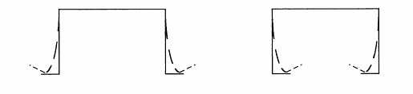

3

**Fig. 3.3 Distortional mode controlled by simple lips**

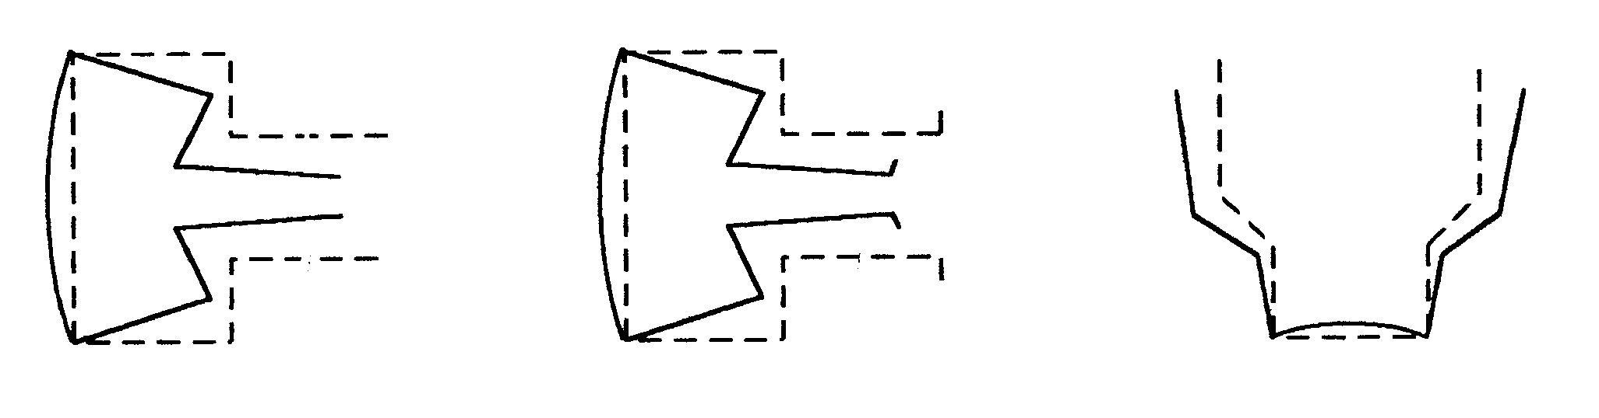

4

**Fig. 3.4 Distortional mode not controlled by simple lips**

Suitable methods of rational analysis include:

· second-order finite element analysis

· second-order finite strip analysis

· second-order generalised beam theory

*Comment 1. Distortional buckling is extremely sensitive to the end conditions (fixed or simply supported with respect to the distortional mode) and great care shall be taken to ensure that the boundary conditions in either analysis or testing correspond to those in the prototype member.*

*2. The wavelength for distortional buckling is significantly longer than that for local buckling. This means that distortional buckling is not usually identified by a conventional stub-column test. Furthermore, if a stub-column test exhibits a distortional failure mode, it is unlikely that the length is sufficient to determine the minimum distortional buckling load.*

**3.3 Effect of local buckling**

Thin walled elements in compression are prone to local buckling. When calculating the load bearing capacity and stiffness, the effect of local buckling shall be taken into account by using the effective cross-sectional properties calculated on the basis of the effective width of individual elements in compression. Suitable procedures for compression elements without perforations are given in Appendix D.

Compression elements with perforations shall be designed on the basis of tests on the parent member.

*Comment Compression elements supported on two longitudinal edges may be assumed to be fully effective if the breadth to thickness ratio*



2

*The corresponding expression if only one edge is supported is*



3

*For elements in uniform compression, limiting values of bp/t, below which no consideration of local buckling is necessary, for various values of the yield strength fy are as follows:*

|  |  |  |
| --- | --- | --- |
| *fy*  *(N/mm2)* | *limiting bp/t* | |
| *two edges supported* | *one edge supported* |
| *220*  *235*  *250*  *275*  *280*  *320*  *350*  *355* | *39.5*  *38*  *36.5*  *35*  *35*  *32*  *31*  *31* | *13*  *12.5*  *12*  *11.5*  *11*  *10.5*  *10*  *10* |

**3.4 Flexural members**

The design of cold-formed shelving members in bending can be influenced primarily by the following:

local buckling

web crippling

lateral buckling

inelastic behaviour

shear lag

flange curling

torsion

*Comment Beams of open cross-section, in which the plane of bending is not a plane of symmetry, are subject to a combination of bending and torsion and are also particularly prone to lateral buckling. They are also restrained, to some extent, by the loads that they support. The strength and stiffness of such beams are best determined by testing.*

**3.4.1 Moment of resistance of members not subject to lateral buckling**

The following condition shall be satisfied:



4

The bending properties of perforated members shall be determined by testing according to section 5.10.

The calculation of the section properties of non-perforated members shall, in general, be based on the effective cross-section determined according to the rules given in Appendix D.

The moment of resistance Mc,Rd corresponding to first yield on the compression side of the section is given by



5

where Weff = section modulus of the effective cross-section

M = according to section 2.7.4

When yielding first occurs on the tension side of the section, the plastic reserves of the tension zone may be utilised until the compressive stress reaches fy.

A conservative value of Mc,Rd in the latter case can be obtained by basing the effective cross-section on the compressive stress = fy = fyb.

If the conditions given below are met, plastic reserves in the compression zone may also be utilized.

(a) The member is not subject to twisting, lateral, torsional, or torsional-flexural buckling. Distortion of compressed parts of the section is prevented.

(b) The effect of cold-forming is not included in determining the design yield stress fy, i.e. fy = fyb.

(c) The ratio of the depth of the compressed portion of the web to its thickness (hc/t) does not exceed 1.11√(E/fy)

(d) The shear force Vsd does not exceed



6

(e) The angle between any web and the vertical does not exceed 30 degrees.

If the conditions (a)-(e) are met, the design strength Mc,Rd  may be based on a maximum compression strain of εc = Cy fy/E (No limit is placed on the maximum tensile strain)

where Cy  is a factor determined as follows:

1. Doubly supported elements without intermediate stiffeners:



7

2. Singly supported elements and stiffened elements:

Cy = 1

In determining the cross-sectional parameters, allowance shall be made for the effective width of plate elements. Mc,Rd shall be calculated considering equilibrium of stresses, assuming an ideally elastic-plastic stress-strain curve which is the same in tension as in compression, assuming small deformations and also assuming that plane sections before bending remain plain during flexure.

Combined bending and web crippling shall be checked by the provisions of section 3.4.8.

Hot-rolled section beams may be designed to carry the full plastic moment of resistance



8

where Wpl = plastic section modulus

provided that the relevant requirements in ENV 1993-1-1 are satisfied.

Biaxial bending caused by either a non-symmetric effective section or by inclination of the principal axes shall be taken into account.

*Comment 1. Biaxial bending usually requires an iterative treatment which can normally be limited to the first iteration step.*

*2. Mc,Rd may be determined by test according to section 5.11*

**3.4.2 Sections with slender flanges**

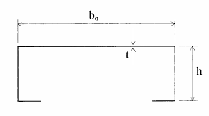

5

**Fig. 3.5**

If Lm/bo < 20 or bo/t > 250 hw/bo, shear lag and flange curling render conventional calculation procedures invalid. In such cases reference may be made to ENV 1993-1-3. Testing is usually necessary.

where bo = width of flange

Lm = distance between points of zero bending moment.

t = net thickness of flange

hw = depth of supporting webs

*Comment This clause means that shelves will normally require to be designed on the basis of tests.*

**3.4.3 Members subject to bending and torsion**

When warping stresses arise as a result of torsional effects, design should preferably be on the basis of tests or, alternatively, to clause 5.7 of ENV 1993-1-3.

*Comment The proper combination of bending and warping stresses is difficult. The effects of typical unit loads in restraining torsion can be taken into account and, in the usual case of a beam with a symmetrical or closed section, the torsional stresses arising from eccentric loading may be ignored. For unsymmetrical beams of open cross-section, testing is usually necessary.*

**3.4.4 Lateral torsional buckling of beams**

The design strength Mb,Rd of beams subject to lateral torsional buckling may be determined either by full scale tests according to section 5.11 or by calculation as follows:



9

The calculation of Mcr shall be based on the gross cross-section (for sections which are symmetrical about the minor axis, see Appendix F of this document which is taken from ENV 1993-1-1) using an effective length equal to the system length of the beam.

*Comment Fig. 3.6 gives guidance on whether or not typical beam sections may be subject to lateral torsional buckling.*

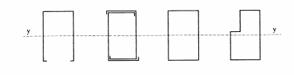

6

**Fig. 3.6(a) Examples of beams for which lateral torsional buckling is not likely to be critical**

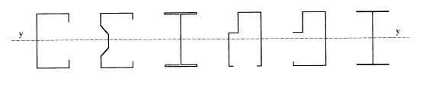

7

**Fig. 3.6(b) Examples of beams for which lateral torsional buckling is likely to be critical**

**Note**: In all cases, the unit loads sitting on the beams are likely to influence lateral buckling; see section 5.11.

**3.4.5 Design resistance with respect to shear**

3.4.5.1 Webs without intermediate stiffeners

For a single web subject to shear force, the following condition shall be satisfied:



10

M = according to section 2.7.4.

|  |  |  |
| --- | --- | --- |
|  | τw/fy for web without  stiffener at support | τw/fy for web with  stiffeners at support  (e.g. a cleat) |
|  |  |  |

**Table 3.1 Characteristic values of mean shear stress τw**

*Comment Table 3.1 gives two values of τw, one for a web without a stiffening device at the support and one for a web with such a stiffener. If the values for a stiffened web are to be used, the stiffener at the support shall prevent distortion of the web and be designed to carry the full support reaction force.*

**3.4.5.2 Webs with longitudinal intermediate stiffeners**

For elements with longitudinal stiffeners, the design value of the shear stress τw shall be obtained from Table 3.1 using a slenderness parameter w given by



11

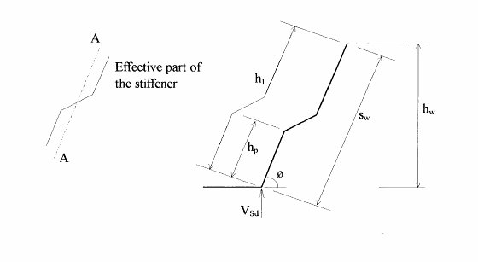

8

**Fig. 3.7 Notation for web stiffeners**

**3.4.6 Design strength of beams with respect to web crippling**

**3.4.6.1 General**

This clause is only valid when there is no twisting of the section at the point of application of the load. If the load is not applied at the web-flange intersection (see Fig. 3.8), or if an unsymmetrical section is allowed to twist freely, the member shall be designed on the basis of tests.

(1) In order to avoid local buckling or crippling in a flat or stiffened web subject to a concentrated load or a support reaction, the design value of the locally transmitted load must not exceed the value given in section 3.4.6.2 for a section with a single web or the value given in section 3.4.6.3 for any other case.

(2) In each case, the following condition shall be verified:



12

where

RSd = design force due to concentrated load or support reaction

Ra,Rd = design crippling resistance of a single web as given in either section 3.4.6.2 or 3.4.6.3 as appropriate.

(3) Where the load is applied through a cleat which has been designed to carry the entire locally transmitted load, it is not necessary to consider the possibility of web crippling.

(4) The effect on web crippling forces of unequal spans and/or unequally distributed loading should be considered.

(5) For built-up I-beams or similar sections, the connection between the two elements should be positioned as close as possible to the flange of the beam.

**3.4.6.2 Web crippling in sections with a single web**

(1) The loads to cause local crushing of the webs of beams at support points or points of application of concentrated loads shall be evaluated using the equations given in Table 3.2.

(2) The equations in Table 3.2 apply to members with:

hw/t ≤ 200

r/t ≤ 6

In these relationships and the equations in Table 3.2:

hw is the overall web depth

t is the web thickness

r is the internal bending radius adjacent to the point of application of the load

 is the actual length of the concentrated load or support reaction

Ra,Rd is the concentrated load resistance of a single web

 is the distance from the end of the beam to the load or reaction

C is a constant with the following values:

C1 = 1.22 - 0.22k

C2 = 1.06 - 0.06r/t ≤ 1.0

C3 = 1.33 - 0.33k

C4 = 1.15 - 0.15r/t ≤ 1.0 but not less than 0.5

C5 = 0.7 + 0.3 (/90)2

where k = fy/228 and where fy is the yield strength in N/mm2 = fyb

 = the angle in degrees between the plane of the web and the plane of the bearing surface and where 450 ≤  ≤ 900.

 = according to section 2.7.4

|  |  |
| --- | --- |
| Type and position of loading | Total web resistance Ra,Rd |
| Single load or reaction  c < 1.5hw Load or reaction near or at free end    9 |  |
| Single load or reaction  c > 1.5hw Load or reaction far from free end      10 | Stiffened and unstiffened flanges    18 |
| Two opposite loads or reactions e < 1.5hw  c < 1.5hw Loads or reactions near or at free end    11 | Stiffened and unstiffened flanges    19 |
| Two opposite loads or reactions e < 1.5hw  c > 1.5hw Loads or reactions far from free end    12 | Stiffened and unstiffened flanges    20 |

*  When b/t > 60, the factor [1 + 0.01(b/t)] may be increased to [0.71 + 0.015(b/t)]

** When b/t > 60, the factor [1 + 0.007(b/t)] may be increased to [0.75 + 0.011(b/t)]

**Table 3.2 Load or reaction capacity for shapes having single thickness webs**

**3.4.6.3 Web crippling in sections with more than one web**

(1) The loads to cause local crushing of the webs of sections with more than one web at support points or points of application of concentrated loads shall be evaluated using the following equations:



21

 = according to section 2.7.4

(2) The notation for the above equations is given above, together with Fig. 3.8 and:

r < 10t

a = bearing length in design expression (see below)

(3) The above equations are valid for members with:

sw/t ≤ 200 for unstiffened webs

sw = length of web (Fig. 3.7)

The web shall extend beyond the inside edge of the support by a distance of at least 40 mm.

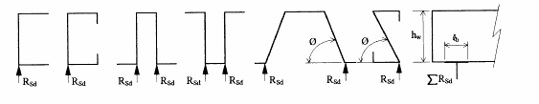

13

# Fig. 3.8 Notation for web crippling

(4) The values of  and a depend on the category of load as follows:

Category 1: • End support reaction where the member extends beyond the inside edge of the support a distance < 1.5 hw.

• Loads applied so close to a support that the clear distance between the edge of the load and the edge of the support < 1.5 hw.

• concentrated loads near the tip of a cantilever where the distance from the end of the cantilever to the nearest edge of the load < 1.5 hw.

For category 1 loads:  = 0.57

a = 10 mm

Category 2: • All intermediate supports

• End support reaction where the member extends beyond the inside edge of the support a distance > 1.5 hw.

• Loads situated more than 1.5 hw from a support or an end of a cantilever.

For category 2 loads: 

• if the vertical shear forces on either side of the load differ by less than 20%: 

• if the vertical shear forces on either side of the load differ by more than 30%:  = 10 mm

• if the vertical shear forces on either side of the load differ by between 20% and 30%:  may be found by interpolation between the above cases.

**3.4.6.4 Design of stiffened webs with respect to web crippling**

For profiles with longitudinal stiffeners (folds) in the web, the design value of the support reaction, Ra,Rd, is determined by multiplying the value according to 3.4.6.1 or 3.4.6.2 by the factor κa,s where



22

where emax, emin = greatest and least distances between the centre line of the web and the straight line joining the points of intersection of the system lines of the web and flanges.

b1 = width of loaded flange

hp = distance from loaded flange to nearest fold.

The above expression is valid for folds such that eccentricity on both sides of the web system line is obtained including the case of emin = 0. If this is not the case, or if the constraint on emax/t is violated, the load bearing capacity shall be determined by testing.

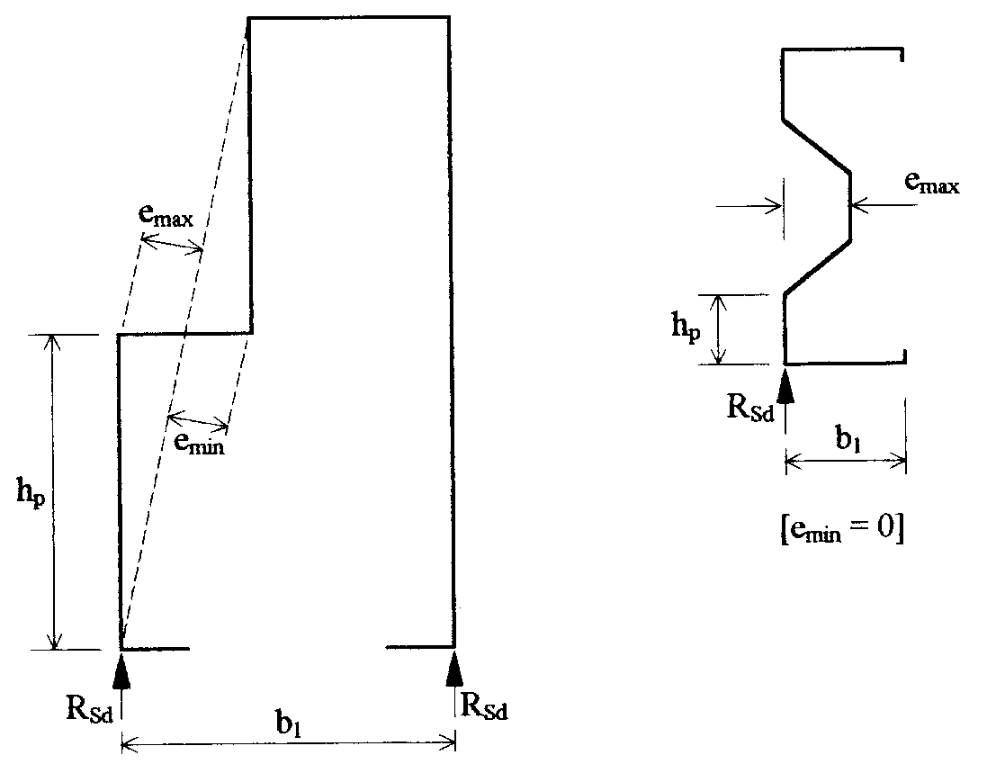

14

**Fig. 3.9 Notation for stiffened webs**

**3.4.7 Combined bending moment and shear force**

At supports or beneath concentrated loads, where the web is not reinforced by cleats or similar strengthening, the combination of bending moment and concentrated load is generally decisive.

For webs with cleats or similar stiffeners, it should be verified that



23

where MSd,VSd are design values of bending moment and shear force

Mc,Rd = design moment of resistance (section 3.4.1)

Vw,Rd = design shear resistance (section 3.4.5).

**3.4.8 Combined bending moment and concentrated load**

It shall be verified that



24

MSd, VSd = design values of bending moment and concentrated load (support reaction)

Mc,Rd = design moment of resistance (section 3.4.1)

Ra,Rd = design value of load bearing capacity with respect to a concentrated load or support reaction force (section 3.4.6).

**3.5 Compression members**

Non-perforated compression members may be designed by either testing or calculation.

The design procedure for perforated compression members shall take proper account of the presence of regular arrays of holes or slots. Three alternative procedures are available:

(1) Design by testing according to sections 5.3 and 5.4.

(2) A fully theoretical procedure which takes rational account of the perforations (eg by using finite elements) together with local, global and distortional buckling and imperfections.

**Note:** When designing perforated members by calculation, it is essential to consider the possibility of the local buckling of the strip of metal between two adjacent slots or large holes.

(3) The following calculation procedure, which is based on the use of the mean experimentally-determined stub column strength Aeff.mfy, modified if necessary for distortional buckling.

(a) A distortional buckling test shall be carried out according to section 5.4.6 on a column length equal to a suitable distance between bracing nodes to give a mean strength value Nbd,Rd.

(b) The nominal strength Nb,Rd at this column length, in the absence of distortional buckling, shall be determined on the basis of the mean stub column strength calculated using the nominal values of yield stress, thickness and effective cross-section and taking account of lateral torsional buckling in accordance with sections 3.5.2 and 3.5.3 with  = 1.0 and with a buckling length equal to the length of the tested member.

(c) The ratio  = Ndb.Rd/Nb,Rd is then determined.

(d) The characteristic stub column strength shall then be modified to take account of distortional buckling using:



25

(e) The calculation shall then be continued according to sections 3.5.2 and 3.5.3.

**3.5.1 Compression members without global buckling**

Under uniform compression, the following condition has to be verified:



26

where



27

 = according to section 2.7.4

*Comment It is implicit in this clause that neutral axis shift need not be taken into account in the design of the uprights of typical shelving structures.*

**3.5.2 Design strength with respect to flexural buckling**

If a global second-order analysis is carried out with initially curved members according to ENV 1993-1-1 clause 5.5.1.2(4), member buckling may be ignored in subsequent calculations, i.e. the buckling stress reduction factor  = 1.

The design buckling resistance Nb,Rd shall be determined as follows:



28

**3.5.2.1 Buckling curves**

Four buckling curves, (i.e. relationships between design stress and slenderness) are available, depending on the type of cross-section and the plane of buckling. The buckling curves are each associated with a value of the imperfection factor α (see section 3.5.2) as follows:

|  |  |  |  |  |
| --- | --- | --- | --- | --- |
| Buckling curve  Imperfection factor α | a0  0.13 | a  0.21 | b  0.34 | c  0.49 |

The appropriate buckling curve for a particular section may be determined from Fig. 3.10.

Built-up closed sections shall be checked using either:

(a) The basic yield strength fyb of the flat sheet material out of which the member is made by cold-forming, with buckling curve b.

(b) The average yield strength fya of the member after cold-forming, determined in conformity with the definition given in section 1.8 with buckling curve c.

**3.5.2.2 Buckling length**

The buckling length  for a given member which is an element of a system shall be determined as the length of a column of the same cross-section and with both ends pinned which has the same Euler critical load as the system under consideration.

If the axial forces and bending moment in the plane of buckling of a member have been determined on the basis of a second-order analysis, they are already enhanced by second-order effects and then it is not necessary to determine the buckling length. Such members should be checked with the buckling length equal to the system length in order to take account of the member imperfections.

The determination of the buckling length which follows is applicable to the members of braced frames and frames for which no second-order analysis is available.

The buckling length  of a member in compression may be determined by rational analysis or testing giving due regard to the behaviour of the complete frame and the nature of the restraints provided at connections of bracing members or other restraining elements. If the buckling length has not been determined by global analysis, the following values of the effective length factor K may be used, where

 = KL

and L = system length (i.e. length between bracing points relevant to the buckling mode under consideration)

|  |  |  |  |
| --- | --- | --- | --- |
| Type of cross-section | | Buckling about | |
| y - y | z - z |
|  | if fyb is used | = 0.34 | = 0.34 |
| if fya is used | = 0.49 | = 0.49 |
|  | | = 0.21 | = 0.34 |
|  | | = 0.34 | = 0.34 |
|  | | = 0.34 | = 0,34 |
|  | | = 0.49 | = 0.49 |

**Note** For other types of section not shown above, α may be chosen to correspond to the nearest similar section.

**Fig. 3.10 Imperfection factor α for different types of cold-formed section**

(a) For any member with both ends held in position with regard to the buckling mode under consideration, K = 1.

(b) For the bottom length of an upright in a braced upright frame in the cross-aisle direction

Provided that (i) Bracing members are connected to both flanges of the upright

(ii) Bracing eccentricities satisfy the requirements of section 1.13.2

(iii) A baseplate is fitted to the upright

(iv) The floor is concrete.

Then K = 0.9

L = height from floor to second node point (h in Fig. 3.11(a) and (b)).

If all of the above conditions except (iii) or (iv) are satisfied

then K = 1.0.

*Comment In a braced frame, if the bottom node is not near the floor, it may be necessary to consider the length between the floor and the first node as being free to sway.*

(c) For all other parts of the upright in a braced upright frame in the cross-aisle direction

K = 1.0

L = height between node points (hp in Fig. 3.11(a) and (b)).

*Comment The situation shown in Fig. 3.11(c) arises frequently and special care should be taken with the stability of the unbraced upper portion of the uprights.*

(d) For horizontal and diagonal bracing members in an upright frame

Provided that the bracing member is welded with a fillet weld of length at least 20 mm to both flanges of the uprights,

then K = 0.9.

for all other cases, K = 1.0.

*Comment If the connections at the ends of a bracing member do not coincide with its centre line, the member should be designed for combined axial load and bending.*

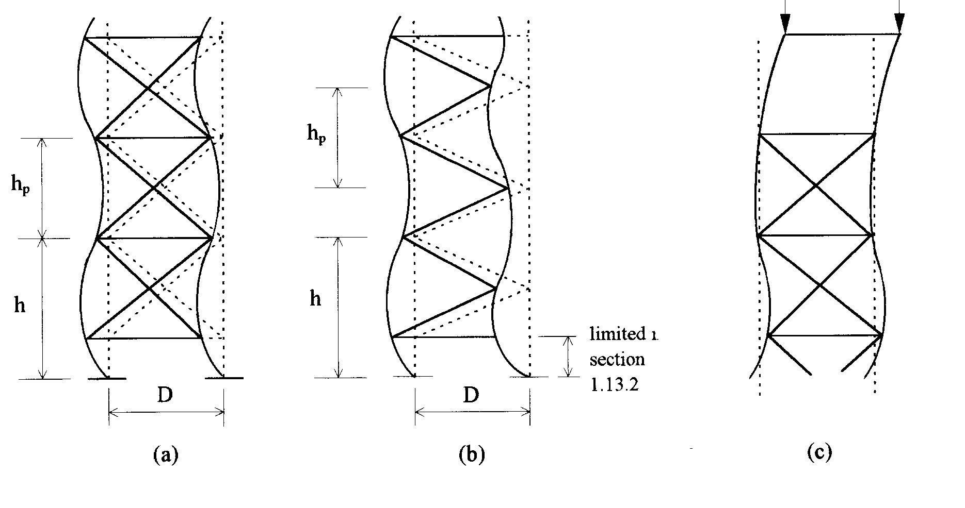

20

**Fig. 3.11 In-plane buckling modes for braced frames**

(e) For frames braced in the down-aisle direction (spine braced frames)

The factor K is the same as that for the cross-aisle direction given in (b) and (c) above.

For the bottom column length, there are three cases to consider (see Fig. 3.12)

Case 1: The bracing nodes do not coincide with the beam nodes:

L = height to first floor beam (h in Fig. 3.12(a))

Case 2: The bottom beam is at a height above the floor similar to the height between adjacent beams

L = height from floor to first beam (h in Fig. 3.12(b))

Case 3: The bottom beam or bracing node is close to the floor:

L = height from floor to the second beam or the beam above the bracing node (h in Fig. 3.12(c)).

For other column lengths

L = height between beams

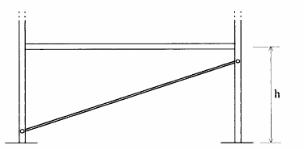

21

(a) Case 1. The bracing nodes do not coincide with the beam nodes

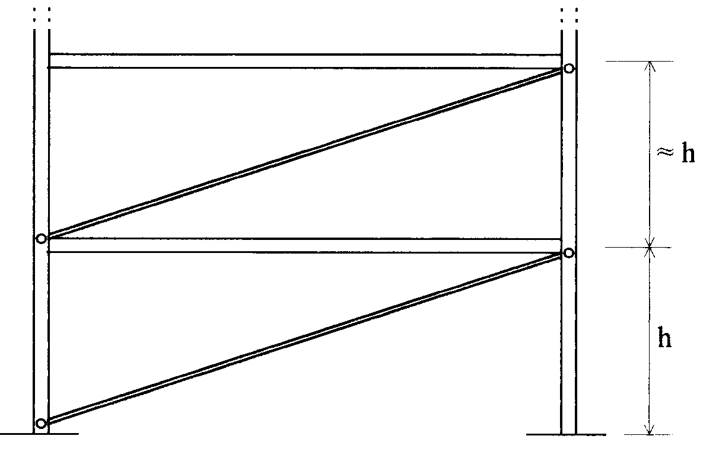

22

(b) Case 2. The height of the bottom beam above the floor is similar to the height between adjacent beams

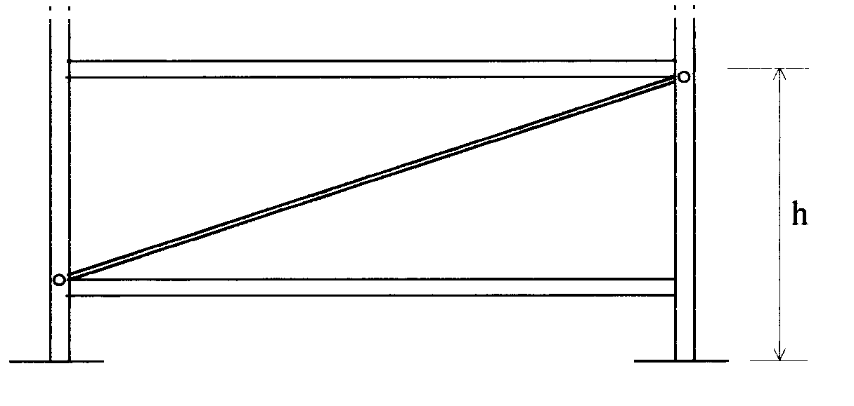

23

(c) Case 3. The bottom beam or bracing node is close to the floor

**Fig. 3.12 Frames braced in the down-aisle direction**

*Comment In a braced frame, if the bottom node is not near the floor, it may be necessary to consider the length between the floor and the first node as free to sway.*

(f) For frames unbraced in the down-aisle direction

When the second-order analysis is carried out according to Appendices A and B, overall stability is taken into account in the enhanced bending moments and it is therefore conservative to design using K = 1 with values of L given in (e) above.

(g) For uprights partially braced in either the down-aisle or cross-aisle direction, a second-order global analysis shall be carried out in order to determine the bending moment distribution in the upright. In combination with bending moments obtained in this way, the buckling length of the member may be taken to be equal to the system length.

**3.5.3 Torsional and torsional-flexural buckling**

**3.5.3.1 General**

Torsional buckling is usually only critical for point-symmetric open sections. Mono-symmetric and non-symmetric sections are generally subject to torsional-flexural buckling.

In addition to checking for torsional-flexural buckling, it is generally necessary to check also for flexural buckling about the weaker principal axis.

**3.5.3.2 Design strength with respect to torsional and torsional flexural buckling**

The design buckling resistance Nb,Rd corresponding to torsional or torsional-flexural buckling shall be determined by using the expressions given in section 3.5.2 by substituting the lesser of Ncr,T or Ncr,FT for Ncr in the calculation of . Column curve b (α = 0.34) may be used.



29

critical force for torsional-flexural buckling

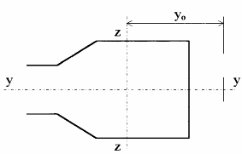

24

and where Ncr,y is the axial force in the member when the shelving structure is at its elastic critical load in the down-aisle direction. This may be determined by second-order global analysis according to Chapter 4.

Ag = area of the gross cross-section

i02 = iy2 + iz2 + y02

E = modulus of elasticity

G = shear modulus **Fig. 3.13**

 = 1 - (y0/i0)2



30

*Comment The designer should use his judgement when estimating LeT depending on whether the beam end connectors and/or structural shelves and the bracing members in the upright frame provide effective or partial warping restraint. In general, it is difficult to make this judgement and testing (see section 5.4) should be considered unless the connections clearly provide full warping restraint.*

*The theory for the effective length gives:*

*LeT = 1.0 × distance between bracing points when the connections provide full torsional restraint*

*LeT = 0.5 × distance between bracing points when the connections provide full torsional restraint and full warping restraint.*

*However, in practice, it is difficult to obtain full torsional and full warping restraint.*

*The examples in Fig. 3.14 may offer some guidance:*

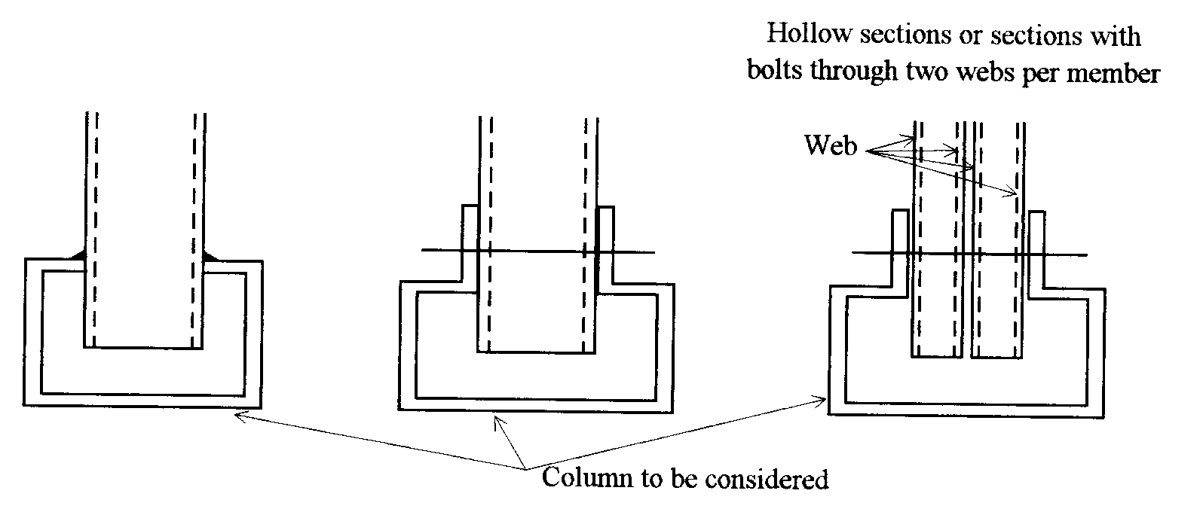

25

(a) for end connections similar to the above situations, which may be regarded as providing large warping restraint and torsional restraint:

LeT may be taken as 0.7 × distance between bracing points.

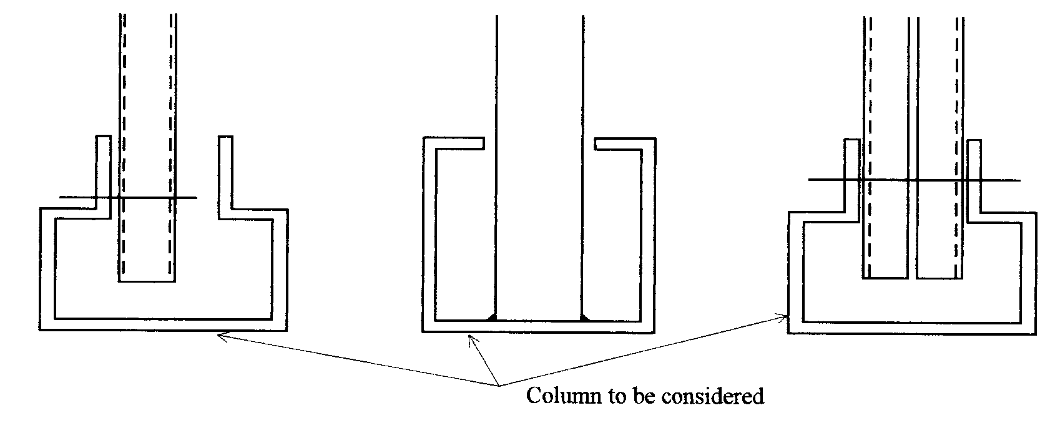

26

(b) for end connections similar to the above situations, which may be regarded as providing partial warping restraint and torsional restraint:

LeT shall be taken as 1.0 × distance between bracing points.

**Fig. 3.14 Examples of bracing member connections**

**3.6 Combined bending and axial loading**

**3.6.1 Bending and axial compression**

For members in combined compression and bending, the following condition shall be satisfied:



31

where NSd, MSd are due to the design loads and Nc,Rd and Mc,Rd are according to sections 3.5.2 and 3.4.1.

**3.6.2 Bending and axial compression without lateral-torsional buckling**

In addition to satisfying section 3.6.1, members subject to combined bending and axial compression shall also satisfy



32

 and  are equivalent uniform moment factors (including the shift moment) for flexural buckling, see section 3.6.3(2).

If the stress resultants arise as a result of a second-order analysis with global imperfections, ky and/or kz = 1 as appropriate.

If the stress resultants arise as a result of a second-order analysis with both global and local imperfections,  and/or  = 1, as appropriate, provided that there is no effect due to distortional buckling.

Aeff = the effective area of the cross-section when subject to uniform compression (see Fig. 3.15(a) and section 3.6.3(3))

Weff,y = the effective section modulus of the cross-section when subject only to moment about the y-y axis (see Fig. 3.15 (b) and section 3.6.3(3))

Weff.z = the effective section modulus of the cross-section when subject only to moment about the z-z axis (see Fig. 3.15(c) and section 3.6.3(3))

**Note:** the above formulae may result in negative values for μy and μz

**3.6.3 Bending and axial compression with lateral torsional buckling**

(1) In addition to satisfying section 3.6.2, members for which lateral-torsional buckling is a potential failure mode shall also satisfy:



33

 is an equivalent uniform moment factor for lateral-torsional buckling (see (2))

kz, Aeff, Weff.y and Weff.z are as in section 3.6.2

 = the smallest of  and  from section 3.5.2 and of the reduction factors corresponding to the distortional and torsional flexural buckling modes.

 = reduction factor for lateral-torsional buckling from section 3.4.4.

 = slenderness ratio for flexural buckling. The flexural buckling length may be taken to be the maximum vertical spacing of the beams.

If Weff.yfy is determined by test according to section 5.10 (Fig. 5.10.1(b)), with free rotation of the ends of the test specimen and with the specimen length greater than or equal to the upright length in the prototype, χLT may be set equal to 1.

(2) The equivalent uniform moment factors  shall be obtained from Fig. 3.16 according to the shape of the bending moment diagram between braced points as follows:

factor: moment about axis: bracing to axis:

 y-y y-y

 z-z z-z

 y-y z-z

(3) In practice, resistance values in the above formula may be determined by test as follows:

Aefffy may be determined as the characteristic value of resistance obtained from stub-column tests according to section 5.3.

Wefffy, Wefffy may be determined as the characteristic value of resistance obtained from bending tests according to section 5.10 using the appropriate configuration.

Aefffy may be determined as the characteristic value of resistance obtained from compression tests on upright sections according to section 5.4.5 or by calculation based on stub column tests (see section 5.3) provided that it can be shown that distortional buckling does not occur (see section 3.5).

|  |  |  |
| --- | --- | --- |
| a) Uniform compression | b) Bending about y-y axis | c) Bending about z-z axis |
| 27 | 28 | 29 |
| Aeff  eN,z  here: eN,y = 0 | Weff,y | Weff,z |

**Note:** c = compression side t = tension side.

**Fig. 3.15 Calculation of section properties as used in section 3.6**

|  |  |
| --- | --- |
| Moment diagram | Equivalent uniform moment factor |
| end moments    30 | 34 |
| moments due to in-plane lateral loads    31 | 35 |
| moments due to in-plane lateral loads plus end moments    32 | 36 |

**Fig. 3.16 Equivalent uniform moment factors**

**3.6.4 Bending and axial tension**

3.6.4.1 Tension only

The following should be satisfied for a member subject to tension only

NSd ≤ Nt,Rd

NSd = tensile force due to design load

Nt,Rd = the minimum of



37

Amin = gross cross-sectional area net of holes according to section 3.2.2

with  = 1.1 and  = 1.25

3.6.4.2 Combined bending and tension

For members in combined bending and tension, the following condition shall be satisfied:



38

where MSd and NSd are design values of moment and tensile force respectively and the resistance terms are defined in sections 3.6.4.1 and 3.4.1.

If the bending moment capacity is determined by plastic design according to section 3.4.1, the interaction formula given in ENV 1993-1-1 may be used.

**3.7 Design of splices**

(1) Splices shall have the same strength as the weaker of the connected members, or shall be designed for a concentric compressive force NSd and a bending moment Mj,Sd:

They may be designed by calculation as follows, or by testing according to section 5.14.



39

where  is as in section 3.5.2

Aeff = area of the effective cross-section of the weaker member

Weff = modulus of the effective cross-section in bending of the weaker member

 = distance between the point of inflection in buckling and the splice or end connection.

 = effective length



40

where Asp = net cross-sectional area of the splice

Msp = moment of resistance of the splice.

(2) Splices and connections should be designed in such a way that load can be transmitted to the effective portions of the cross-section.

(3) When the constructional details at the ends of a member are such that there is doubt regarding the point of action of the load, a suitable eccentricity shall be assumed in the design.

**Note:** Splices which do not have adequate stiffness may have an adverse effect on the stability of the structure. See Chapter 4.

**3.8 Design of baseplates**

Every upright shall be fitted with a baseplate and a means of positively locating one to the other shall be provided. In this section approximate methods of design for baseplates are presented.

In the design of baseplates for hand-loaded shelving systems, it is sufficient to consider only axial loads.

**3.8.1 Effective Area, Aeff**

The design of a baseplate is made assuming that the bearing pressure on the effective area of the baseplate is uniformly distributed over the effective area. In Fig. 3.17 the effective area is indicated by the shaded portion, where



41

where tb = thickness of the baseplate

fy = design strength of the baseplate

and fcd = design strength of the floor material for contact pressure (see section 3.8.4).

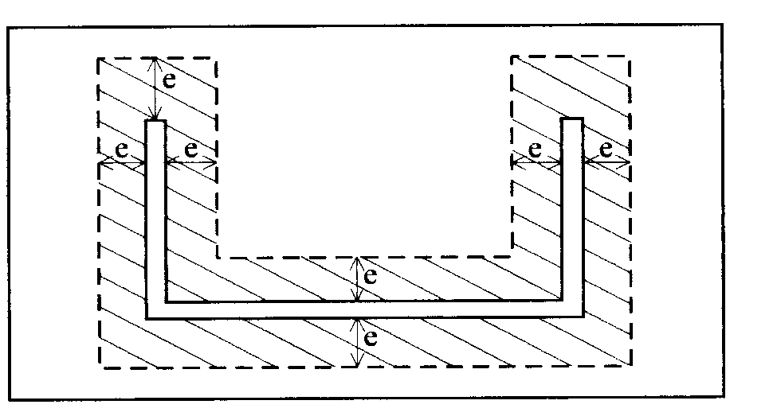

33

**Fig. 3.17 Effective area for baseplate design**

When the distance from the upright face to the edge of the baseplate is less than e, a reduced value of e equal to the distance from the upright to the edge of the baseplate shall be used.

**3.8.2 Baseplates supporting axially loaded columns**

When the column is centrally loaded the design load, VSd, must satisfy the relationship:



42

in which Aeff is the effective area of the baseplate defined in section 3.8.1.

**3.8.3 Floor Materials**

**3.8.3.1 Concrete Floors**

In the design of the baseplate, the design strength of the concrete for contact pressure, fcd, may conservatively be based upon the characteristic cylinder strength, fck, so that:

fcd = 

where fck = characteristic compressive cylinder strength for concrete

γm = partial material factor for concrete = 1.5

thus fcd = 0.67 fck

When the grade of concrete is not known, and a visual inspection indicates that the material is sound, the concrete may be taken to be in strength class 16/20 according to Eurocode 2 for which:

fck = 16 N/mm

Otherwise tests shall be made to determine the actual strength of the concrete.

**3.8.3.2 Bituminous Floors**

Values of allowable long term stresses, fc, for bituminous floors are given in Table 3.3, for a variety of types. Two figures are given for each material. The lower of the two shall be used when the material is not properly identified and there is uncertainty about its type. The higher value may be used if the material has been positively identified, either by expert visual inspection, or by test.

If the supplier of the floor material can provide sound evidence to justify higher values of the allowable long term compressive stress, then such values may be considered.

The relationship between the design stress for the ultimate limit state, fcd, and the allowable long term stress, fc, is:

fcd = 1.5 fc

The figures given in Table 3.3 relate to the contact pressure permitted on the top layer, to be used in the design of the baseplate. It is noted that all layers of the floor construction are required to resist the load from the baseplate.

|  |  |  |  |
| --- | --- | --- | --- |
| **Floor Type** | | **fc(2)**  **N/mm2** | **fc(3)**  **N/mm2** |
| **Group** | **Top layer** |  |  |
|  | Conventional asphalt concrete | 0.3 | 0.8 |
| Hot bituminous asphalt | Asphalt concrete with polymer modified binder | 0.3 | 0.8 |
|  | Porous asphalt impregnated with a sand/ cement mixture | 0.3 | 0.8 |
|  | Stone mastic asphalt | 0.3 | 0.8 |
| Asphalt emulsion | Asphalt emulsion + cement + aggregate | 0.3 | 4.0 |
| Cold bituminous asphalt | Open structure, on little stability | 0.3 | - |
| Mastic asphalt | Thermoplastic and visco-elastic | 0.3 | - |

**Notes to Table:**

1. The values given in this table are related to the top surface and are valid for temperatures less than 250C at floor level.

2. The lower value of fc is to be used if the floor material has not been positively identified.

3. The higher value of fc may be used when the floor material has been positively identified.

**Table 3.3**  **Allowable contact pressures for bituminous industrial floors**

**3.8.3.3 Other Floor Materials**

In the case of floors which are neither bituminous nor made from concrete, the advice of the supplier of the floor material, concerning its bearing strength, should be sought. In assessing the characteristic strength of the material, due consideration should be given to the possibility of creep occurring and to the influence of temperature on the behaviour of the material. Attention should be given not only to the surface layers, but also to any sub layers of the floor whose performance may influence the behaviour of the baseplate.

**4. GLOBAL ANALYSIS OF SHELVING SYSTEMS**

**4.1 General**

The design of a shelving system is verified in two stages. In the first stage a global analysis of the structure must be made in order to determine the distribution of internal forces and displacements. In the second stage, individual elements of the structure must be checked to ensure that they have adequate resistance in the ultimate limit state, and that unacceptable deformations do not develop in the serviceability limit state.

The actions to be used for global analysis are specified in clause 2.4. In particular, the shelf loads are specified in clause 2.4.2.2.

For the purpose of global analysis, system lines coinciding with the centroidal axes of the gross cross-section of the members should be used. In general, gross section properties should be used for global analysis (see section 3.2.2).

Shelving systems are usually fabricated from cold-formed sections and, therefore, elastic methods of global analysis are usually the most appropriate. However, non-linear connection behaviour may be incorporated in the analysis provided that the non-linear characteristic used is based on test results which demonstrate adequate rotation capacity. Elastic-plastic analysis may be used if the sections undergoing plastic hinge action satisfy the criteria given in ENV 1993-1-1 and ENV 1993-1-3 for plastic design including the ductility requirements specified in these codes.

Although the shelving system is a spatial structure it is assumed that, for the purposes of global analysis, it can be treated as comprising a set of plane frames lying in the vertical planes parallel and perpendicular to the aisles, and in the horizontal plane, each of which is initially taken to operate independently. Imperfections in one plane may be neglected in the global analysis of the other plane. However, in member design, account must be taken, however, of effects in one plane which impinge on the behaviour in another, using appropriate interaction equations.

The procedures in this Chapter apply to both unbraced and braced installations as described in section 1.5.

**4.2 Design criteria**

**4.2.1 Loads**

Shelving structures should be designed for the loads defined in Chapter 2.

**4.2.1.1 Load factors**

Both the ultimate and serviceability limit states should be considered using the load factors defined in section 2.7.

**4.2.2 Design procedure**

The analysis of a shelving system may be undertaken by considering first the down-aisle direction and then the cross-aisle direction. In order to design the uprights, the forces arising from these two

analyses should be combined using the interaction formulae given in section 3.6. Other elements may be designed on the basis of one or other plane frame analysis as appropriate.

**Note** The design of the uprights involves combining the axial load arising from the stored materials etc, enhanced by any additional axial loads arising from placement loads etc, with bending moments about both axes of the section. However, in accordance with section 2.5.1, sway imperfections and placement loads need only be considered in one direction at a time.

**4.2.2.1 Load combinations for analysis in the down-aisle direction**

In the down-aisle direction, the structure should be analyzed for the following loads in combination:

• Dead load

• Imposed load from stored materials

• Imposed load from walkways or floors

• Actions arising from imperfections in the down-aisle direction

In considering imposed loads from stored materials, the worst loading pattern should be considered for each of the following criteria:

• Overall stability in the down-aisle direction

• Bending and buckling of the uprights

• Deflections and mid-span bending moments in beams and/or shelves

• Moments in beam or shelf to upright connectors

For overall stability in the down-aisle direction, it is sufficient to consider the fully loaded structure with the actions arising from imperfections as specified in section 2.5.

For the design of the uprights, it is usually sufficient to consider the structure to be fully loaded with the exception of a single unloaded beam or shelf near the middle of the structure at the lowest level as shown in Fig. 4.1(a). In braced or partially braced systems, an alternative loading pattern giving rise to single curvature in the uprights should also be considered as shown in Fig. 4.1(b).

**Notes** 1. If the lowest beam is near the ground, it may be more critical to omit the load from a single beam at the second level and the case shown in Fig. 4.1(c) should also be considered.

2. This analysis gives rise to primary axial loads and down-aisle bending moments in the uprights.

3. Pattern loading may induce a reversal of bending moment in the beam or shelf to upright connections. When this occurs, proper consideration shall be given to the stiffness and strength of the connector in the reverse direction. Section 5.5.1 requires that connectors should have a reverse capacity of at least 50% of the capacity in the usual direction of loading. Unless a larger capacity is justified by tests, the reverse capacity assumed in design should therefore be restricted to this value.

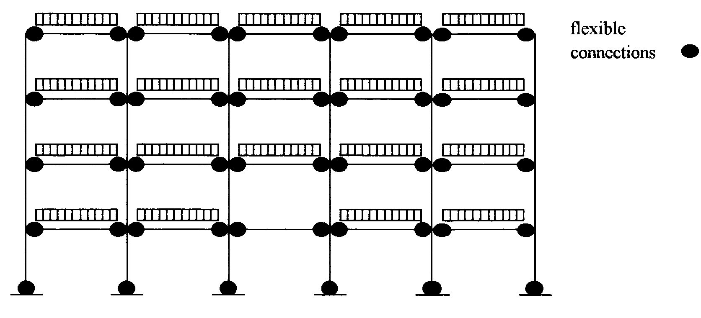

1

(a) Typical case for an unbraced installation

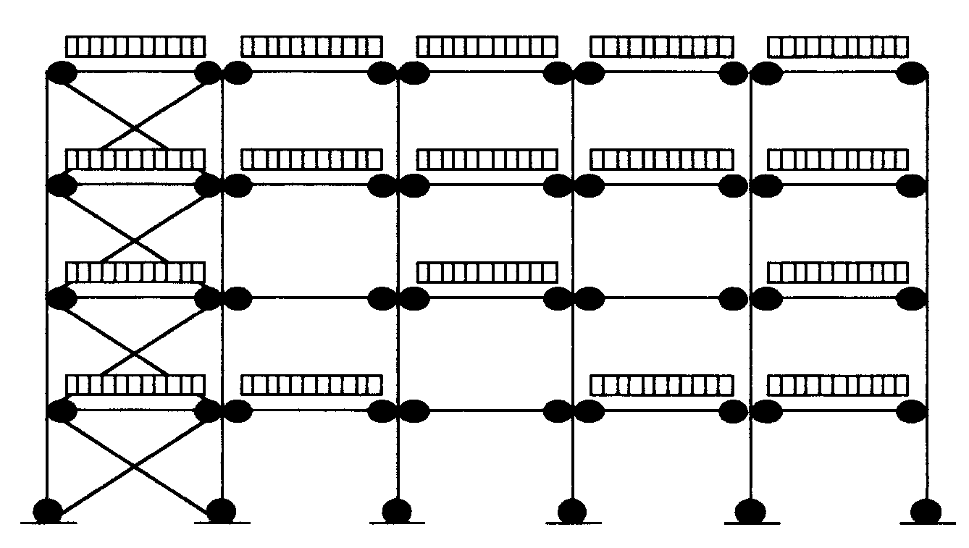

2

(b) Typical case for a braced installation

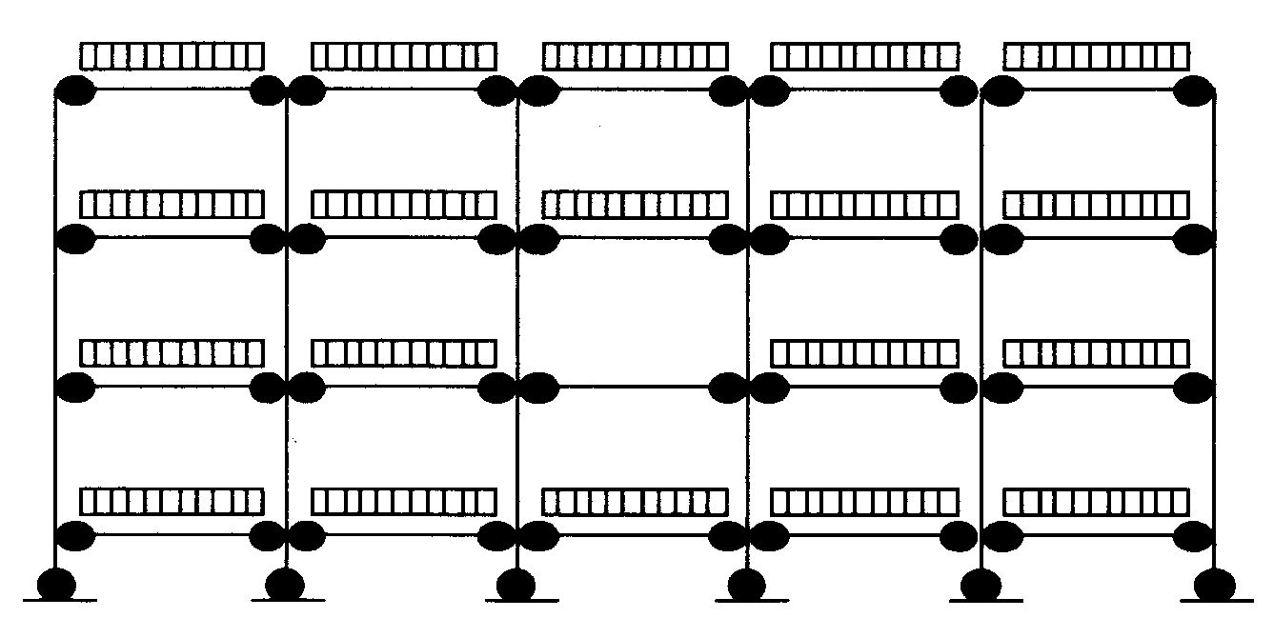

3

(c) Additional case when the lowest beam is near the ground

**Fig. 4.1 Pattern loading for down-aisle analysis**

**4.2.2.2 Load combinations for analysis in the cross-aisle direction**

In the cross-aisle direction, the structure should be analyzed for the following loads in combination:

• Dead load

• Imposed load from stored materials (including placement loads

according to Chapter 2)

• Imposed load from walkways or floors

• Actions arising from imperfections in the cross-aisle direction.

**Notes** 1. There is no need to consider pattern loading for these load combinations.

2. This analysis gives rise to cross-aisle bending moments and secondary axial loads in the uprights.

**4.2.3 Sway limit in the down-aisle direction**

It shall be verified that, for a structure of total height h, the sway of the fully loaded structure with the actions arising from the imperfections as specified in section 2.5 (but not the placement loads specified in section 2.4.6) shall be less than:

The sway limit for the serviceability limit state defined in section 2.3.4.

Where required by frame classification according to section 4.3.3, this analysis shall take into account second-order effects.

**Note** sway is defined as being the movement in addition to any initial out of plumb.

**4.3 Global analysis**

**4.3.1 Analysis of braced and unbraced shelving systems in the down-aisle direction**

The stability in the down-aisle direction shall be demonstrated by a rational analysis which takes account of the following factors.

• The destabilizing effect of axial compressive loads in the uprights (second-order effects)

• The moment-rotation characteristics of the beam or shelf to upright connections

• The moment rotation characteristics of the upright to floor connections

• The shear stiffness of the bracing system and its connections

• The moment rotation characteristics of splices in the uprights

• Actions arising from down-aisle imperfections as specified in section 2.5.

**Note:** If it is not possible to calculate the shear stiffness of the bracing system and its connections, this shall be determined by a test similar to that described in section 5.9.

Typical mathematical models are shown in Figures 4.2 and 4.3.

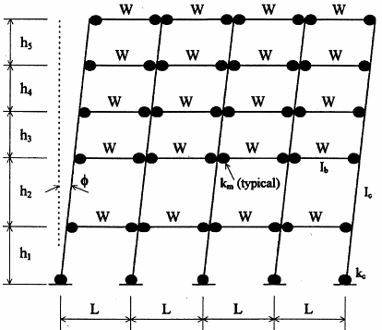

4

(a) Typical unbraced installation showing initial out of plumb ()

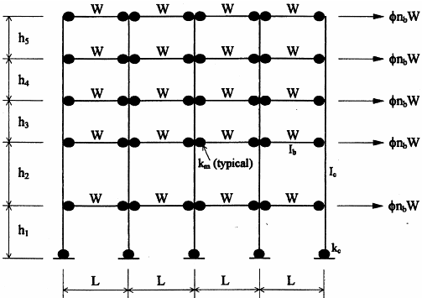

5

(b) Equivalent loading system for the unbraced installation

**Fig. 4.2 Structural model for the down-aisle stability of an unbraced installation**

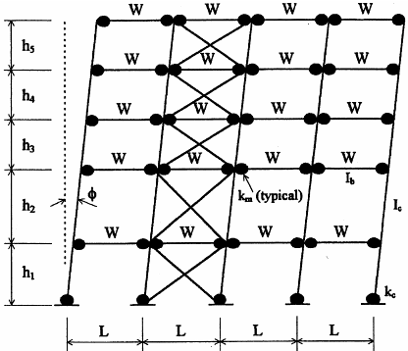

6

(a) Typical braced installation showing initial out of plumb ()

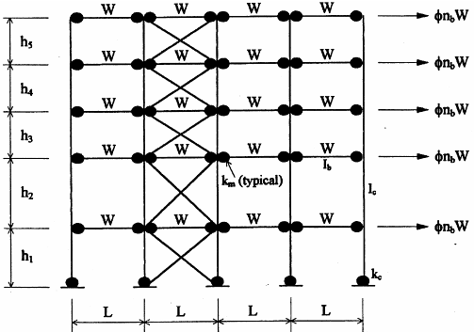

7

(b) Equivalent loading system for the braced installation

**Fig. 4.3 Structural model for the down-aisle stability of a braced rack**

**Notes** 1. Bracing members introduce additional axial forces into the adjacent uprights which should be considered in the design of these members.

2. Plan bracing or the shelves themselves will also transfer horizontal loads in the down-aisle direction back to the plane of the vertical spine bracing and thereby introduce additional axial force into the adjacent uprights.

3. These two eventualities are often taken into account by providing an additional braced frame adjacent to the plan bracing.

4. Shelving systems may be propped in the down-aisle direction against the building or other substantial structure. If advantage is taken of this in the design, the force in the prop or props should be calculated and the prop and supporting structure designed accordingly. (see also section 2.9).

If the models shown in Figs 4.2 and 4.3 are used, the bending moments at the beam end connectors and at the ends of the beams may be corrected to allow for the finite thickness of the uprights.

**4.3.1.1 Moment-rotation characteristics of beam end connectors**

In general, the moment-rotation characteristics of the beam or shelf to upright connections shall be determined as design values of stiffness and moment of resistance by test according to sections 5.5 or 5.13 respectively.

Alternatively, a non-linear moment-rotation relationship may be used as defined in section 4.3.3.2.

**4.3.1.2 Moment-rotation characteristics of the connection to the floor**

It is safe to ignore the stiffness of the upright to floor connection and to assume a pinned joint.

If the stiffness of the floor to upright connection is to be included in the analysis, it shall be determined by test according to section 5.8 with an axial load appropriate to the installation being designed.

If, for the range of axial loads up to the design load of the upright, the variation of design ultimate moment or stiffness with axial load is no greater than ± 10% of the mean value, the mean value may be used in the design of the rack. When there is a greater variation than this, then the values of failure moment and stiffness corresponding to the design axial force shall be used.

Alternatively, a more sophisticated model may be used which takes more detailed account of the variation of stiffness and strength with axial load.

**4.3.2 Analysis of braced and unbraced systems in the cross-aisle direction**

The stability in the cross-aisle direction shall be demonstrated by a rational analysis which takes account of the following factors:

• The shear flexibility of the bracing system including the flexibility of the connections between the uprights and the bracing members. This should be determined by test according to section 5.9.

• The moment-rotation characteristics of splices in the uprights

• The moment-rotation characteristics of the upright to floor connections

• The overall stability of the braced frame

• Actions arising from imperfections in the cross-aisle direction as specified in section 2.5.

**Note:** It is usual and safe to assume a pinned connection between the uprights and the floor. A non-zero moment-rotation characteristic may only be used if it is assured that full contact with the floor will be maintained.

A typical mathematical model is shown in Figure 4.4.

**Note**: Shelving structures may be propped in the cross-aisle direction against the building or other substantial structure, as shown in Fig.C1 in Appendix C. If advantage is taken of this in the design, the force in the prop or props should be calculated and the prop and supporting structure designed accordingly (see section 2.9).

**4.3.3 Global analysis**

For the purpose of global analysis, the system lines coincide with the centroids of the gross cross sections.

**4.3.3.1 Frame classification**

Frame classification is based on the elastic critical load ratio VSd/Vcr where

VSd is the design value of the vertical load on the frame

Vcr is the elastic critical value of the vertical load for failure in a sway mode.

(1) If VSd/Vcr ≤ 0.1, a frame may be classified as non-sway, i.e. its response to in-plane horizontal forces is sufficiently stiff for it to be acceptably accurate to neglect any additional internal forces or moments arising from horizontal displacement of the nodes. In such a case, a first-order analysis is sufficient.

Any other frame shall be classified as a sway frame and the effects of the horizontal displacement of its nodes taken into account in its design.

**Notes** 1. Methods of estimating Vcr with sufficient accuracy for frame classification are given in Appendices A, B and C.

2. Unbraced and partially braced shelving structures are invariably classed as sway frames in the down-aisle direction and therefore require consideration of second-order effects.

(2) Except when section 2.5 imposes local second-order effects in the global analysis, if 0.1 < VSd/Vcr ≤ 0.3, a level 2 analysis may be used in which second-order effects are treated indirectly.

(3) If VSd/Vcr > 0.3, a level 1 analysis is required in which second-order effects are treated directly.

**Note:** The limit at which an accurate second-order analysis becomes mandatory is more generous than that in ENV 1993-1-1. This is because shelving structures have semi-rigid joints and generally have a regular construction. In these circumstances, the agreement between the exact and approximate methods is much improved so that the range of validity of the approximate methods may be increased.

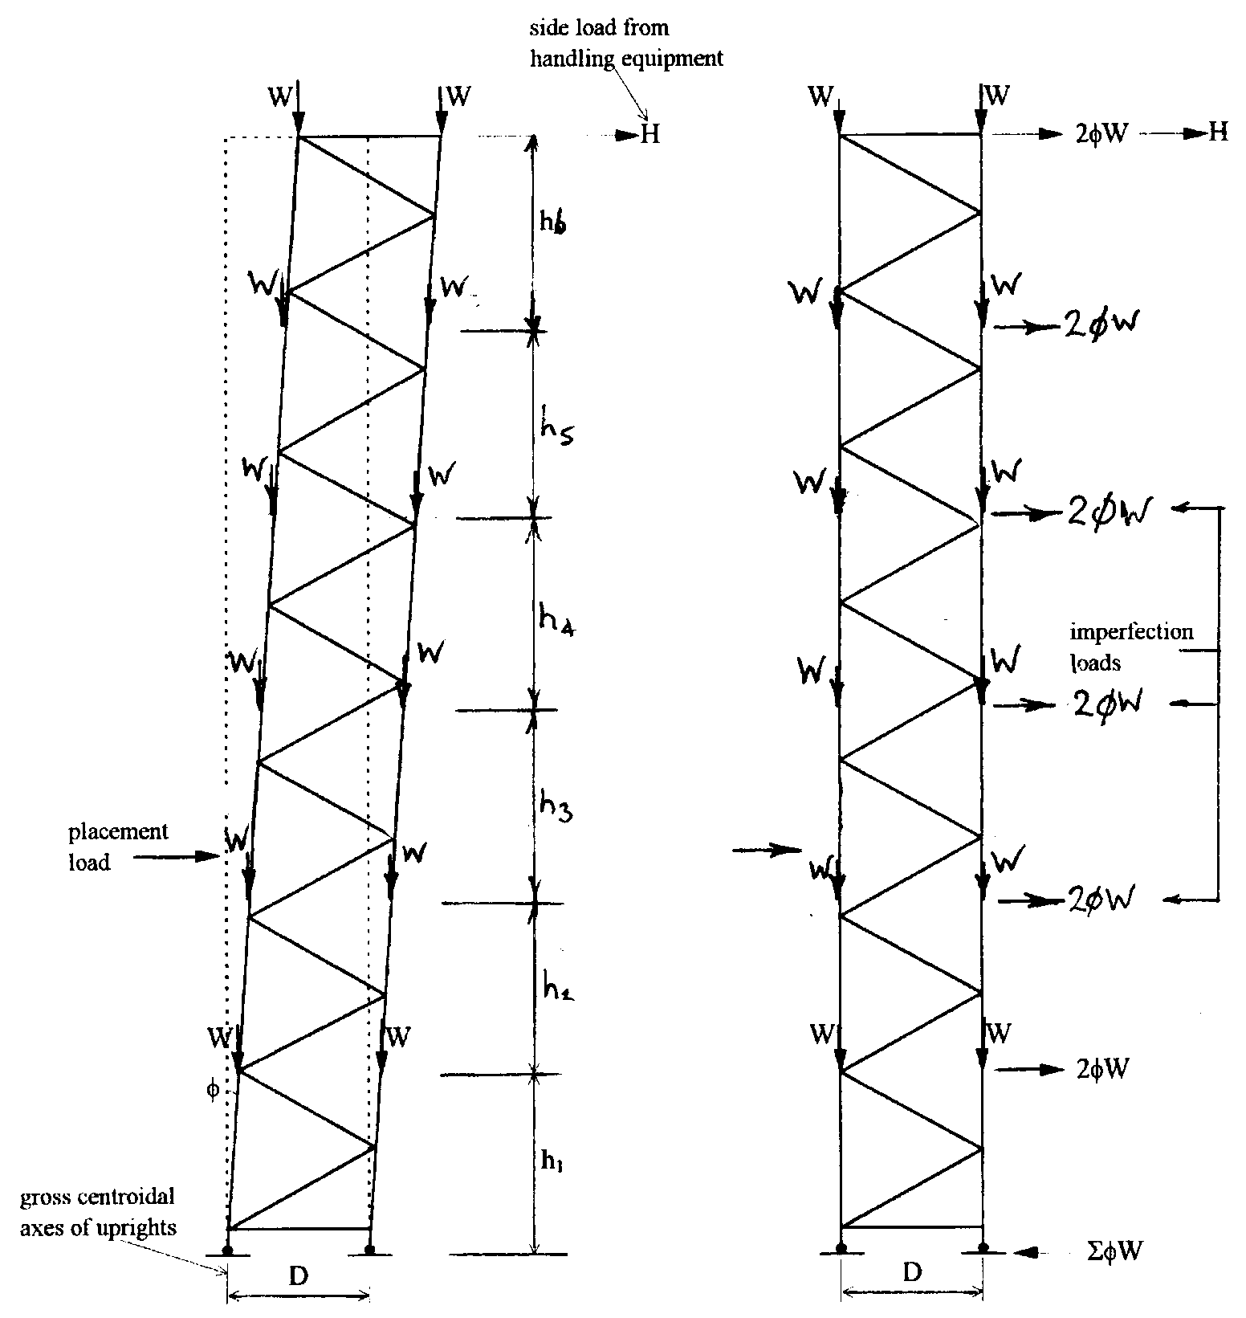

8

(a) sway imperfection  (b) equivalent horizontal loads

**Fig. 4.4 Structural models for the cross-aisle stability of braced frames**

**Note:** The internal bracing members may have reduced stiffness as required by clause C2 of Appendix C.

**4.3.3.2 Methods of global analysis**

A comprehensive analysis of a complete frame or, in a long installation, of a representative number of bays, in either the down-aisle or cross-aisle direction may be carried out in one of two ways:

• Level 1: Using second-order elastic or elastic-plastic analysis in which the structural components are represented by prismatic members and the connections have appropriate moment-rotation characteristics.

There are two alternative treatments of the flexibility of the beam- or shelf-end connectors:

(1) The beam or shelf to upright connectors may be modelled as rotational springs of constant stiffness. In this case, the looseness of the connectors shall be incorporated in the frame imperfections according to clause 2.5.1).

(2) The beam or shelf to upright connectors may be modelled as non-linear rotational springs. In this case, the looseness of the connectors may either be incorporated in the global analysis by including an appropriate initial looseness in the non-linear spring characteristic or it shall be incorporated in the frame imperfections according to clause 2.5.1.

When second-order global analysis is used, in-plane buckling lengths for the non-sway mode may be used for member design.

Alternatively, for a compression member, the initial bow imperfection specified in clause 5.5.1.2(4) of ENV 1993-1-1 may be included in the analysis and the member designed with an increased buckling reduction factor χ according to section 3.6.1 or 3.6.2.

*Comment This may be compulsory, see section 2.5.*

• Level 2: Using first-order elastic analysis in which the structural components are represented by prismatic members and the connections by springs and in which the second-order effects are treated indirectly by the following method:

Using amplified sway moments whereby the sway moments found by a first order elastic analysis are increased by multiplying them by the ratio:



1

where VSd and Vcr are defined in section 4.3.3.1

When the amplified sway moments method is used, in-plane buckling lengths for the non-sway mode may be used for member design.

**Note:** When using a level 1 analysis with an initial bow in the uprights, it is sufficient to include this bow in the uprights of the lower two storeys only. It is also usually sufficient to introduce two additional nodes per member as shown in Fig. 4.5.

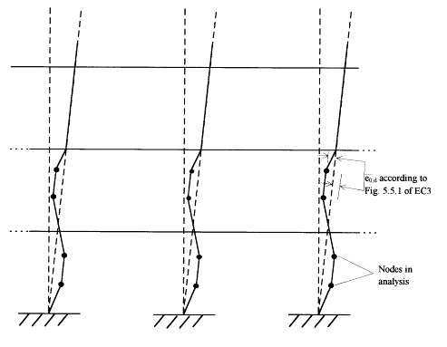

9

**Fig. 4.5 Incorporation of initial bow in second-order analysis**

**4.3.4 Simplified methods of analysis for stability in the cross-aisle direction**

An appropriate level 2 method is described in Appendix C which is based on the amplified sway moments method. It is applicable only to frames which are fully braced or which have battens at a regular spacing.

**4.4 Design of beams**

For the purpose of beam or shelf design, the span of the beam may be taken as the distance between the faces of the uprights. Bending moment distributions arising from a global analysis based on system lines may be curtailed at the face of the upright for both beam and connector design.

**4.4.1 General**

(a) Ultimate limit state

Beams shall satisfy the requirements of section 3.4 when they are subject to the loads given in Chapter 2.

**Note:**  Section 3.4 considers the conditions under which the unit loads offer lateral restraint to the beams.

(b) Serviceability limit state

Recommended deflection limits are given in section 2.3.4.

**4.4.2 Loads on beams**

In general, the loading on beams may be considered to be uniformly distributed. For situations where this assumption is invalid, the following coefficients may be used to convert the actual loading arrangement into an equivalent uniformly distributed load:



2

where W = total load on beam

L = span of beam (may be taken to be the distance between the faces of the uprights for the purpose of this calculation)

Values of the above coefficients for some symmetrical load patterns are given in Table 4.1.

*Comments. 1. The mid-span bending moment is not affected by sway moments.*

*2. The designer should always be alert to identify special cases of stored materials which may impose additional loads on the beams.*

Where beams carry axial loads as part of a bracing system, they shall be checked for this load case both with unit loads on the beam and for buckling without unit loads with an effective length equal to the span 'L'.

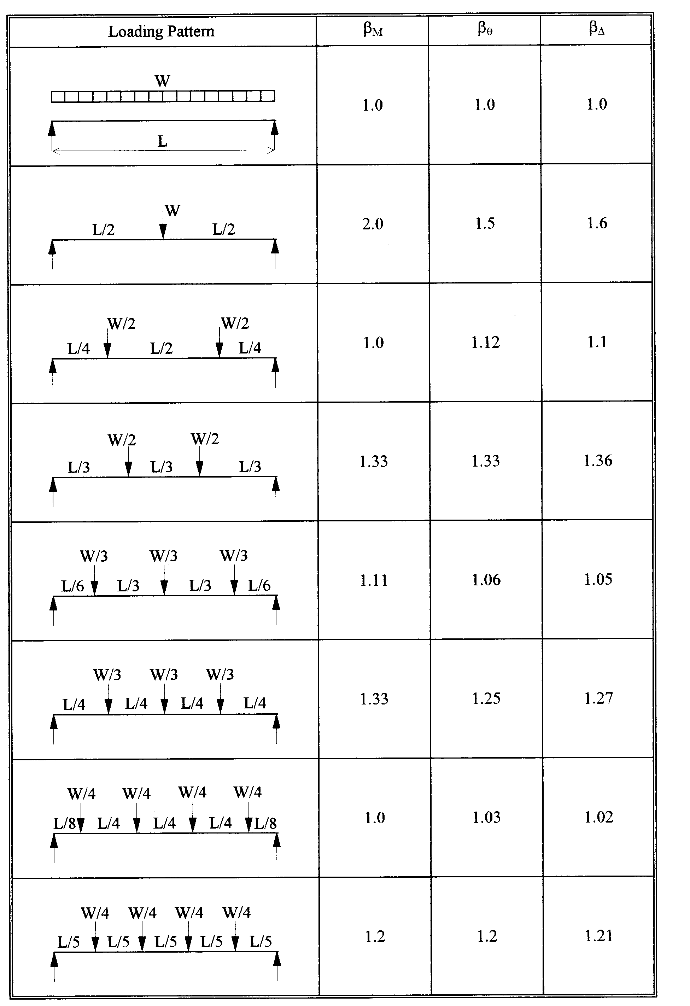

10

**Table 4.1 Beam load coefficients**

**4.4.3 Design bending moments for beams**

If the restraining effect of the beam end connector is taken into account, then the design moments may be taken directly from the results of a second-order analysis at the design load factor.

In frames which are braced against sway, a linear analysis will provide a satisfactory estimate of the bending moment in the beam in the ultimate load condition.

In frames which sway, the design bending moments at the centre of the beam may be obtained from a linear analysis.

**4.4.3.1 Redistribution of bending moments in the case of elastic analysis**

If an elastic analysis with linear connector behaviour shows that the ultimate moment of resistance of one or both beam end connections is exceeded, the bending moment in the beam and the associated beam end connector may be redistributed by up to 15% of the end moment, as shown in Fig. 4.6, provided that:

(a) The bending moment at mid-span is also redistributed in order to maintain static equilibrium

(b) after redistribution, the bending moments at the ends of the beam do not exceed the ultimate moment of resistance.

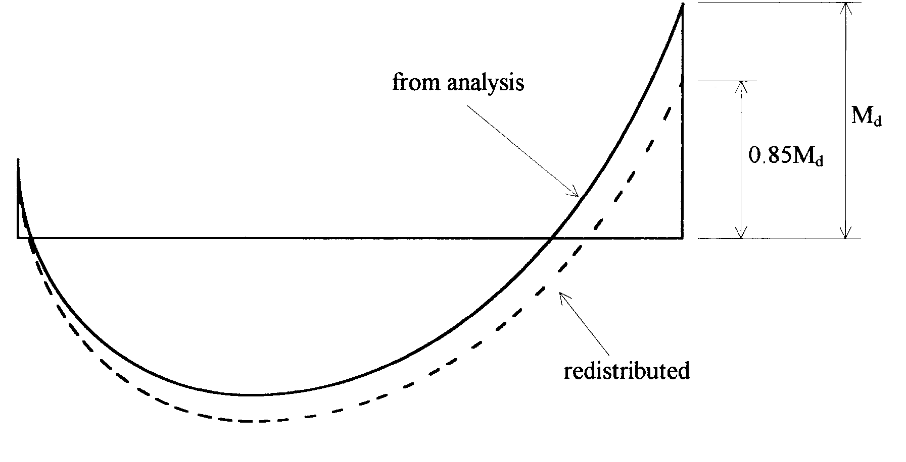

11

**Fig. 4.6 Redistribution of beam moments**

*Comment For convenience in computer programming, this effect may be simulated by incorporation a 15% increase in the strength of the beam end connector together with a corresponding reduction in the strength of the beam.*

**4.4.3.2 Approximate design**

A conservative approach to the design of a symmetrically loaded beam section is to take the design moment at mid-span as



3



4

Wd = total design load on beam

L = span between faces of the uprights

h = storey height

kb = stiffness of beam to column connector

Ib = second moment of area of beam

Ic = second moment of area of upright

which corresponds to the weakest beam in the installation.

**4.4.4 Design shear force for beams**

In shelving systems which are braced against sway, the design shear force for the beam and beam end connector may be obtained from a first- or second-order analysis.

In systems which are free to sway, the design shear force may be computed directly from a second-order analysis.

If a first-order analysis is used, the shear forces in the beam due to sway should be amplified by the factor



5

where VSd = the design value of the vertical load on the frame

Vcr = the elastic critical value of the vertical load for failure in a sway mode.

The design shear force is the aggregate of the amplified sway shear force and that due to the vertical loads on the rack.

In installations of regular construction and loading, when the bases are pinned, the design shear force is given conservatively by



6

In installations of regular construction and loading, when the bases are semi-rigid, the design shear force is given conservatively by



7

where  = sway imperfection

ns = number of beam levels

**4.4.5 Deflection of beams**

In the serviceability limit state the maximum deflection of any beam may be obtained from a first- or second-order analysis which takes due account of pattern loading.

For installations of regular construction and loading, the maximum deflection of a beam may be taken to be



8

where Wser = the total serviceability load per beam

and the other symbols used are defined in sections 4.4.2 and 4.4.3.

*Comment The model used for the above expression is shown in Figure 4.7 and is generally conservative. Alternatively, if deflections are calculated from a global analysis of the complete structure at the serviceability limit state, the design should be based on the beam which gives the maximum deflection.*

**4.5 Design of beam end connectors**

Beam end connectors must satisfy the following conditions at the ultimate limit state:

• The design bending moment in the beam end connector must not exceed the bending resistance of the beam end connector.

• The design shear force in the beam end connectors must not exceed the shear resistance of the beam end connector.

Plastic design of the beams is permitted, even if global stability is justified on the basis of elastic design, provided that proper consideration is given to the rotation capacity of the beam end connector.

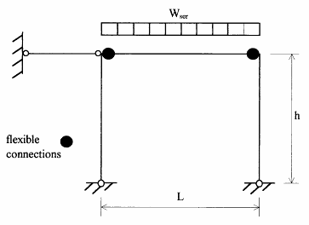

12

**Figure 4.7. Model for the approximate calculation of beam deflection**

**4.5.1 Design bending moments in beam end connectors**

For installations which are braced against sway, the design bending moment for the beam end connector may be calculated using either a first-order or a second-order analysis.

For installations which are free to sway, the bending moments in the beam end connector may be obtained directly from the second-order analysis.

If the bending moment in the beam end connector is taken from a global anlaysis, the value at the face of the upright, not at the system line, may be used for design.

If a linear analysis is used, then the moments in the beam end connector due to sway must be increased by the factor β defined in section 4.4.4.

The connector must be designed for the aggregate of the amplified sway moments and those due to vertical loads.

Conservatively, the beam end connector moments may be estimated in a standard shelving system by assuming that, under sway loading, points of inflection occur in beams and uprights at the mid-points of all panels.

For a structure with pinned bases, the design moment for the beam end connector is:



9

and when the base connections of the structure are semi-rigid, with a stiffness of at least the beam connector stiffness, the design moment for the beam end connector may be taken conservatively as:



10

**4.5.2 Design shear force for beam end connectors**

The design shear force for the beam end connector is the same as that for the beam as given in section 4.4.4.

**4.6 Design of uprights**

**4.6.1 General**

It shall be verified that, at the ultimate limit state, uprights satisfy the requirements of sections 3.5 and 3.6 when subject to the loads given in Chapter 2.

**4.6.2 Design axial forces and bending moments**

The axial forces and bending moments calculated for the ultimate limit state may be used directly in the appropriate interaction formulae given in section 3.6 but account must be taken of any out-of-plane effects which arise from the overall behaviour of the structure.

*Comment The design axial force in a member is the vertical force due to the applied loading augmented by any additional effects due to sway in both directions which may, in turn, be augmented by the influence of imperfections, placement loads, second-order effects etc (see clause 2.7). This axial force should be combined with the design bending moments about both axes.*

*The critical design case for an upright may be complicated by the fact that second-order effects in one plane may be enhanced by second-order effects in the other plane. In general, it is not necessary to take this interaction into account. Thus, the design axial load for an upright may be enhanced by second-order effects with imperfections in one plane and second-order effects without imperfections in the other plane. If this design results in a higher axial load than that used in the relevant second-order analysis, there is no need to repeat this analysis.*

In a braced structure, the axial forces and bending moments arising from a linear analysis at the ultimate limit state may be used directly in the interaction formulae. The critical uprights in braced frames are those adjacent to the bracing.

**Note:** The axial forces in the uprights of braced bays are influenced by overturning moments due to frame imperfections etc. This will increase the axial load in one upright and may give rise to an uplift force at the foot of the other upright. This uplift force must be resisted by the holding down bolts in the base plate.

For structures which are free to sway in the down-aisle direction, the down-aisle bending moments in the upright are due to imperfections operating in the down-aisle direction, amplified by second-order effects, together with pattern loading.

**4.7 The Design of Shelf to upright connections.**

The purpose of this exercise is to check that the horizontal resistance in tension of shelf to upright connections is sufficient to adequately restrain the uprights when such connections are an integral part of the down-aisle bracing system. To do this an analysis model is used in which the uprights are given a sinusoidal bow imperfection, over the height of the rack. The magnitude of the bow imperfection, eo, is



11

where 

and nr = number of linked columns

L = height of the rack

The analysis model is based on the number of bays over which the bracing pattern repeats, but is not less that 5. For a rack which is braced every five bays, the model has six columns, and the bow imperfections are symmetrically arranged as shown in figure 4.8. The columns are pinned at the top and at the base and linked at intermediate levels by the shelves through the connections which are under investigation.

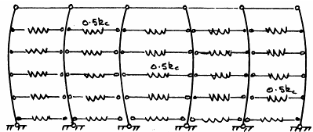

13

**Fig. 4.8 5-bay model for analysing tension connections**

The values of the spring constants are half the measured stiffness of the joint at each side of a shelf, kc, as measured by the test procedure in section 5.17. The arrangement for the five-bay model in Figure 4.8 is typical of any system in which the number of bays over which the bracing pattern repeats is an odd number. For a system in which the bracing pattern repeats every 7 bays, a 7-bay model should be used.

The arrangement for six bays is shown in Figure 4.9 and is typical where the number of bays over which the bracing repeats is an even number. For a system in which the bracing pattern repeats every 8 bays, an 8-bay model should be used. In such cases the central upright remains straight.

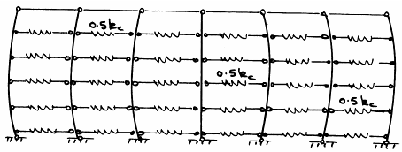

14

# Fig. 4.9 6-bay model for analysing tension connections

The uprights in the structural model are assumed to be equally loaded with an axial load N. A second order elastic analysis is repeatedly carried out to find the value of the axial load (N=Nmax), at which the design value of the tensile strength of the shelf to upright connection is reached. This is determined by the test in 5.17.

The maximum permitted design axial load for any upright in the shelving system is then defined as,



12

**5 TESTS**

**5.1 General**

**5.1.1 Purpose of Tests**

It is expected that tests will be carried out for the purpose of obtaining basic performance data to be used in design (Design Tests) and for the purpose of quality assurance, once production is under way (Quality Assurance Tests) to ensure that product specifications are being continuously achieved.

The tests described in this section may be carried out for either purpose.

(a) ***Design Tests***

Design tests will normally be carried out as part of the process of design and development in order to obtain basic data and to confirm the theoretical or practical performance of the component or assembly. Design tests need only be repeated when there is a significant change in the specification of the product, and the frequency of testing is that described in section 5.1.3.

Not all of the design tests specified in section 5 are mandatory. Table 5.1.1 lists the tests with the section in the code of practice from which each originates and gives an indication of the status of each test.

Any value of strength, stiffness or deformation to be determined shall be derived from at least three experimental results. The test components shall be taken from normal production stock, selected at random from different production batches, and fully finished in accordance with their normal specification. Notwithstanding this, manufacturers may select material grades which are close to the nominal yield stress.

(b) ***Quality Assurance Tests***

Quality Assurance tests shall be carried out by the manufacturer on a regular basis as part of a quality assurance scheme that ensures that the product conforms to its design specification at all times. In general it will be sufficient to check, on a regular basis, that the material specification is correct and that the finished product is in conformity with the product drawings. Manufacturers will not be required to carry out all the tests described in section 5 for quality assurance purposes, with the following two exceptions:

(i) *Section 5.2 Materials*

Where a manufacturer is carrying out his own tests to determine the mechanical properties of the steel he is using, these tests must be made on a regular basis, and in accordance with sections 1.8.3(c) and 1.8.5.

If the test results from an individual coil or batch of sheets indicate a yield stress less than the design value, or a ratio of ultimate tensile stress to yield stress less than 1.05, or if a specimen fails the bend test, a further group of three tests shall be carried out on the same material.

Unless all three of these additional specimens pass the bend test, the coil or batch of sheets shall be rejected.

The characteristic value of the yield stress for the four tests shall be determined. If this value is greater than the design yield stress, the coil or batch of sheets may be accepted. If this is not the case, either the material shall be rejected or the performance data of the resulting product shall be reduced accordingly.

|  |  |  |  |
| --- | --- | --- | --- |
| **Section** | **Title** | **Source section** | **Status** |
| 5.2 | Materials tests | 1.8.5 | Mandatory* |
| 5.3 | Stub column tests | 3.5 | Mandatory** |
| 5.4 | Compression tests on uprights | 3.5 | Non-mandatory |
| 5.4.6 | Distortional buckling check | 3.5 | Mandatory |
| 5.5 | Bending tests on beam end connectors | 4.5 | Mandatory |
| 5.6 | Looseness tests on beam end connectors | 2.5.1 | Mandatory*** |
| 5.7 | Shear tests on beam end connectors | 4.5 | Mandatory |
| 5.8 | Tests on floor connections | 4.3 | Non-mandatory |
| 5.9 | Tests for shear stiffness of frames | 4.3 | Mandatory |
| 5.10 | Bending tests on upright sections | 3.5 | Mandatory |
| 5.11 | Bending tests on beams | 2.3.4 | Mandatory† |
| 5.12 | Tests on shelves | 6.5 | Mandatory |
| 5.13 | Bending tests on shelf to upright connections | 6.5.2 | Mandatory‡ |
| 5.14 | Tests on upright splices | 3.7 | Non-mandatory |
| 5.15 | Impact tests | 1.10 | Non-mandatory |
| 5.16 | Full scale tests | 6.5.5 | Non-mandatory |
| 5.17 | Tensile tests on shelf to upright connections | 6.3.1 | Non-mandatory |
| * Mandatory only for steels with no recognised mechanical specification.  ** Mandatory for perforated sections only.  *** Mandatory unless the bending test on beam end connectors is carried out using the  portal test so that the looseness is incorporated in the moment-rotation relationship.  † Mandatory only in respect of beams of open cross-section which are not symmetrical  about a vertical axis.  ‡ Mandatory unless the design assumes a pinned connection between shelf and upright. | | | |

**Table 5.1.1 Status of tests for design purposes**

(ii) *Section 5.5 Bending Tests on Beam End Connectors*

*or section 5.13 Tests on shelf to upright connections*

All manufacturers shall carry out bending tests on beam end connectors and shelf to upright connections on a regular basis to check that the characteristic stiffness, strength and rotation capacity of current production is being maintained. The frequency of these tests shall be adjusted to sense the effects of tool changes, material changes, or other modifications, which may affect the performance of the connector.

The results of such tests shall be accumulated and treated statistically, in accordance with section 5.1.3, in order to obtain the characteristic values. Where at least 20 test results have been accumulated over a long period, the oldest of those in excess of 20 which are more 12 months old shall be discarded.

Individual results for the moment of resistance of the beam end connector or shelf to upright connection shall be accepted provided they exceed the characteristic value adopted for the design.

Individual results for the stiffness of the beam end connector or shelf to upright connection shall satisfy the relationship:

kd + 2s ≥ kti ≥ kd - 2s

in which:

kti = observed value of the stiffness

kd = design value of the stiffness

s = standard deviation of the accumulated results.

When an individual result does not satisfy one of these conditions, a set of design tests shall be made on at least three connectors selected from the same production batch, and the characteristic values for strength and stiffness shall be derived in accordance with this section.

If the characteristic values so obtained satisfy the design requirements, then the batch may be accepted. If this is not the case, either the batch shall be rejected, or the performance data of the product shall be reduced.

**5.1.2 Requirements**

(a) ***Execution of Tests***

The performance of experimental assessments shall be entrusted only to organisations where the staff is sufficiently knowledgeable and experienced in the planning, execution and evaluation of tests.

The testing laboratory shall be adequately equipped and the testing organisation shall ensure careful management and documentation of all tests.

(b) ***Support Conditions***

The test conditions shall reproduce the normal support conditions which are present in the real construction. If this is not so, the testing engineer shall demonstrate that the chosen conditions lead to conservative results.

(c) ***The Application of the Load***

The test load shall be applied in such a manner that no abnormal influence on, or prevention of deformations can occur.

(d) ***Increments of the Test Load***

The loads shall either be applied incrementally or continuously. When the load is applied incrementally, the first four increments shall be increments of approximately 5% of the expected failure load, and the remaining increments shall be chosen so that the behaviour that is under observation is clearly defined. Deformations at critical points on the test structure shall be observed when they have stabilised.

When the load is applied continuously, the rate of loading shall be slow enough to ensure that static conditions prevail. Deformations shall be observed at regular intervals, and frequently enough to define the behaviour clearly.

(e) ***Measuring Accuracy***

The accuracy of the measuring equipment shall be appropriate for the quantities being measured and shall be better than  2% of the value to be measured.

(f) ***Assembly of Test Specimens***

Test specimens should be assembled in accordance with the manufacturer's normal practice, but in such a way as to represent the worst case. For instance, bolts should be tightened only to the lowest torque likely to be used in practice.

(g) ***Test Reports***

For each test series, formal documentation shall be prepared giving all the relevant data, so that the test series could be accurately reproduced. In particular, in addition to the results of the tests, the specimens should be fully and accurately described in terms of dimensions and material properties and the production process. Any observations made during the tests should also be recorded.

*Comment: The following may serve as a check list for the information to be recorded:*

*1 Date of manufacture*

*2 Product drawing numbers for the components under test*

*3 Details of the production and assembly process*

*4 Material specification for the components under test*

*5 Date of testing*

*6 Actual dimensions of test components*

*7 Actual material properties of test components*

*8 Details of the test arrangement (dimensions, support conditions, connections, etc)*

*9 Measurements made during the test (load, deflection, rotation, strain, etc)*

*10 Observations regarding the onset of visible deformations (buckling, tearing, etc)*

*11 Mode of failure*

*12 Photographic evidence of the test in progress.*

# 5.1.3 Interpretation of Test Results

The following rules shall be used when interpreting the results of tests.

(a) ***Definition of Failure Load***

The test component shall be deemed to have failed when:

(i) the applied test loads reach their upper limit, and/or

(ii) deformations have occurred of such a magnitude that the component can no longer perform its design function.

(b) ***Corrections to Test Results***

Raw test results shall be adjusted to account for differences between the actual thickness of the material used in the test and the nominal thickness specified by the manufacturer, and to account for the difference between the yield stress of the material in the test sample and the minimum yield stress guaranteed by the manufacturer. The way in which such adjustments are to be made depends upon the nature of the test being made, and is described for each test separately in sections 5.3 to 5.18.

When samples are prepared for tensile tests to determine the yield stress of the material, they must always be cut from an undamaged region of the test piece, away from heat affected zones, and away from bends in the section and from other areas where cold working effects may influence the result. Alternatively the test pieces may be cut from the original coil, before cold forming.

(c) ***Derivation of Characteristic Values***

After the individual results of a group of tests have each been corrected for variations in thickness and yield stress, the characteristic value of the parameter being measured, Rk, shall be calculated as follows.

Rk = Rm - ks s

in which:

Rm = the mean value of the adjusted test results

Rm = 

Rni = individual test result, corrected for thickness and yield stress

n = number of tests results in the group 

s = the standard deviation of the adjusted test results

s = 

ks = coefficient given in Table 5.1.2 below.

|  |  |
| --- | --- |
| **n** | **ks** |
| 3  4  5  6  7  8  9  10  15  20  30  40  50  100 | 3.15  2.68  2.46  2.33  2.25  2.19  2.14  2.10  1.99  1.93  1.86  1.83  1.81  1.76  1.64 |
|  | |

**Note*:***  this table represents the 95% fractile at a confidence level of 75%.

## Table 5.1.2

(d) ***Characteristic Values for a Family of Tests***

A family of tests shall consist of a series of tests in which one or more design parameters (eg. span, thickness) is varied. This section enables a family of test results to be treated as a single entity.

In order to carry out the evaluation of the characteristic strength, it is necessary to have a suitable expression which defines the relationship between the test results and all the relevant parameters in the test series. This design expression may be based on the appropriate equations of structural mechanics or on an empirical basis.

The more accurately the design expression reflects the mean measured strength, the more favourable will be the values resulting from the evaluation. The coefficients in the design expression may be adjusted in order to optimise the correlation.

The design expression is considered to be the mean value of the test results. The standard deviation sn is calculated for the whole test series after first normalising the test results by dividing each result by the corresponding value in the design expression. The characteristic strength Rk for a particular set of parameters within a family is given by:

Rk = Rm (1 - k sn)

where:

Rm = value given by the design expression

k = value given in Table 5.1.2 with n = total number of tests in the family

sn = standard deviation of the normalised test results.

**5.2 Materials**

**5.2.1 Tensile Tests**

Tensile tests shall be carried out in the direction of rolling on samples of material taken from normal production, for the purpose of estimating the nominal yield stress of the material used in production, or to establish the actual yield stress of the material used in a test sample, for the purpose of correcting test results.

In all cases, the method of carrying out the tensile tests shall be that specified in EN 10002-1 *Tensile Testing of Metallic Materials*. When the purpose of the tensile test is to determine the minimum properties of material used in production, the frequency of testing shall be in accordance with section 1.8.5.

**5.2.2 Bend Tests**

Bend tests may be carried out to demonstrate that material used in production has adequate ductility. The test shall be carried out on samples taken from normal production, and after cold reducing if such a process is utilised to obtain increased mechanical properties. The bend test shall be carried out in accordance with ISO 7438-1985E *Metallic Materials - Bend Test*.

The bend test shall be carried out at ambient temperature and the transverse bend test piece shall withstand being bent through 180o in the direction shown in Figure 5.2.1, around an inside diameter equal to twice the thickness of the bend test specimen, without cracking on the outside of the bent portion.

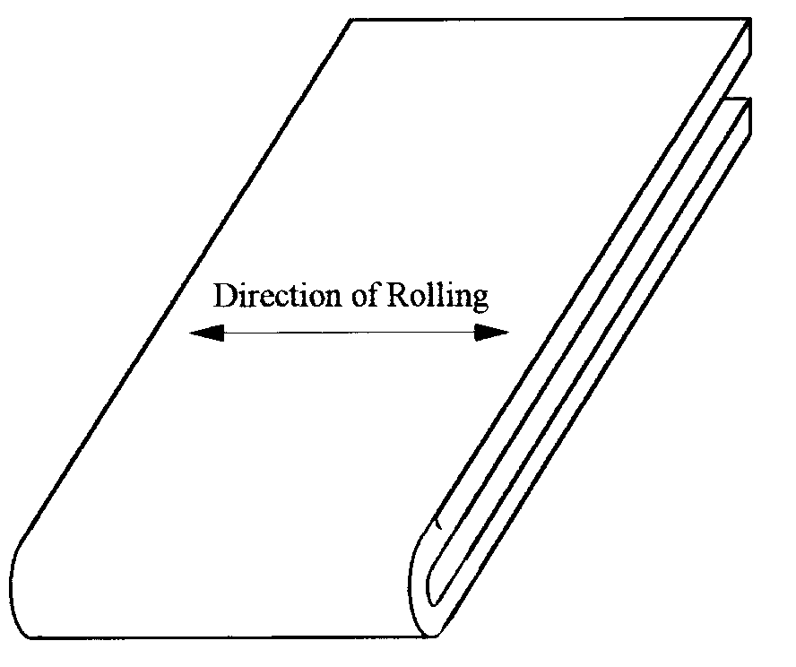

1

**Figure 5.2.1** **Transverse bend test piece after bending**

The sample shall be deemed to have satisfied the requirements of this standard, if a visual inspection of the test piece shows no cracking on the outer surface of the 180o bend away from the ends. Some local cracking, near the bend but extending no more than 1mm from the edge of the test piece, is admissible.

The frequency with which this test shall be made is the same as that required for tensile tests, and described in section 1.8.5.

**5.3 Stub column compression test**

**5.3.1 Purpose of the Test**

The purpose of the test is to observe the influence of such factors as perforations and local buckling on the compressive strength of a short column. This test cannot be used to observe the influence of distortional buckling.

**5.3.2 Test Arrangement and Method - Alternative 1**

(a) The test specimen is shown in Figure 5.3.1. Its length shall be greater than three times the greatest flat width of the section (ignoring intermediate stiffeners). It shall include at least five pitches of the perforations.

(b) If the buckling length of the specimen exceeds twenty times the least radius of gyration, supports may be provided so that the strut is effectively divided into lengths equal to or less than twenty times the least radius of gyration.

(c) The specimen shall be cut normal to the longitudinal axis, midway between two sets of perforations.

(d) Base and cap plates may be bolted or welded to each end of the stub upright. The section may be adjusted for springback (distortion of the shape of the cross-section after cutting due to residual stresses) by welding to the baseplate. The axial load may be transmitted to the base and cap plates via pressure pads typically 30mm thick. The pressure pads shall protrude at least 10mm beyond the perimeter of the upright section. Small bolts or screws may be used to locate the base and cap plates in position on the pressure pads. The pressure pads shall have a small indentation drilled to receive a ball bearing, as shown in Figure 5.3.1.

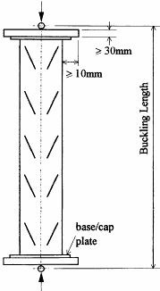

2

**Figure 5.3.1** **Stub column test arrangement**

*Comment: The diameter of the ball bearing is not critical; Table 5.3.1 shows diameters typical of what is currently used in practice*

|  |  |
| --- | --- |
| Expected Failure Load in kN | **Ball Diameter in mm** |
| 50  100  200  300  450  800  1250 | 10  15  20  25  30  40  50 |

## Table 5.3.1

The specimen shall be placed in the test machine and loaded axially through the ball bearing at each end. The position of the ball bearings in relation to the cross section shall be the same at both ends of the column, but may be adjusted to give the maximum failure load.

The load shall be increased until the specimen has buckled and will accept no more load. This load will be recorded as the failure load.

*Comment: The ball bearing should be on the line of symmetry of the section if there is one. The initial position may be the centre of gravity of either the minimum or the gross cross-section, or some point between them. Further tests may be carried out to optimise this position, which shall be taken to be the point through which the centroidal axis passes, for the purposes of design. The characteristic failure load should be based on a series of tests with the same load position.*

**5.3.3 Test Arrangement and Method - Alternative 2**

In order to carry out this test, it is necessary to use a compression testing machine in which at least one of the loading platens permits rotational adjustment about two horizontal axes and which can be clamped into position as required..

The preparation of the stub column specimens for this test method is the same as in section 5.3.2 except that, in paragraph (d), no indentations are required in the pressure pads.

The procedure is to mount the test specimen with the centroid of its gross cross-section positioned centrally in the testing machine with one loading platen free to rotate in order to take up any lack of alignment of the end plates of the specimen. A small holding load is then applied in order to bring the adjustable loading platen of the machine just into full bearing with the end plates of the specimen. The adjustable platen is then clamped into position.

The load is then increased in increments up to failure and the maximum load carried is recorded.

**5.3.4 Corrections to the observations**

The observed failure loads shall be adjusted to take account of the actual thickness and yield stress of the test sample, so that:

Rni = 

in which, for the specimen:

Rni = the corrected failure load for test number (i)

Rti = the observed failure load for test number (i)

ft = the observed yield stress for the specimen

fy = the nominal yield stress

tt = the observed thickness for the specimen

t = the design thickness

 = 0 when 

 = 1.0 when 

 = 1 for t ≥ tt

 = 1 for t < tt if 

 = 2 for t < tt if 

where:



 = 4.0 for stiffened elements

 = 0.43 for unstiffened elements

for  the value of  shall be determined by linear interpolation

where bp is the notional plane width.

**5.3.5 Derivation of the Results**

The characteristic failure load, Rk, shall be derived in accordance with section 5.1.3 and the effective area of the cross-section, Aeff, calculated from:

Aeff = 

For sections without perforations, provided that the results of the stub column tests are close to the theory, and provided also that no distortional buckling is present, a buckling curve may be derived in accordance with section 3.5.2.

**5.4 Compression tests on uprights**

**5.4.1 Purpose of the Test**

The purpose of this test is to determine the axial load capacity of the upright section for a range of effective lengths in the down-aisle direction, taking account of out of plane buckling effects and the torsional restraint provided by the bracing and its connection to the uprights. This section also describes a test to determine the influence of the distortional buckling mode.

*Comment: The results of this test series provides a column curve which is a plot of the buckling reduction factor*  *and the non-dimensional slenderness ratio . The value of  is always obtained from the slenderness corresponding to the out-of-plane buckling mode = (L/i), even when the failure mode is a distortional, torsional flexural or in-plane buckling mode. The purpose of this is to allow the column curve to be used in the design and relating buckling loads to down-aisle buckling lengths alone. It may be noted that it is conservative in that no account is taken of the restraining effects of the beam end connectors.*

**5.4.2 Test arrangement**

The test arrangement comprises a frame assembly using the maximum frame width specified for the product, in which one of the two uprights is loaded axially, as shown in Figure 5.4.1. The bracing pattern, the bracing sections and the bracing connections shall be the standard ones used with the product. The loaded upright shall be loaded through ball bearings and fitted with base and cap plates as described in section 5.3.2, except that the upright section shall not be adjusted for spring-back in any way. The line of action of the load may be chosen to give the optimum result, as described in section 5.3.2.

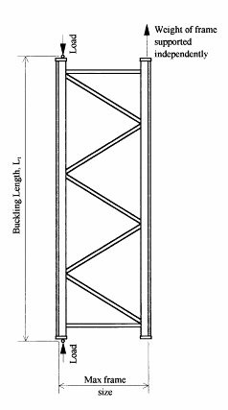

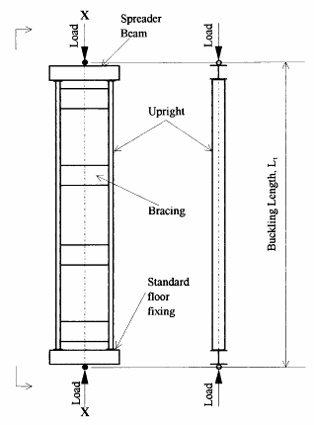

**Figure 5.4.1**

**Note:** the spreader beams may not rotate about the longitudinal x-x axis

Erreur! Signet non défini.**Figure 5.4.2**

## Alternative arrangements for compressive tests on uprights

*Comment: When a particular upright may be used with a variety of bracing arrangements, this test should be carried out with the least effective arrangement likely to be used in practice. If this is not done, the test results may be taken to be valid only for the tested arrangement and more effective alternatives.*

Many shelving end frames are manufactured as a complete unit comprising two uprights and a bracing system. To obtain a column curve relating failure stress to down-aisle slenderness, and as an alternative to the test method set out above, a complete frame assembly may be tested in compression in the arrangement shown in Figure 5.4.2.

*Comment: In some shelving systems the presence of the shelf provides significant torsional restraint to the upright. In such cases, short lengths of shelf, free of external restraint, may be connected to the test frame.*

**5.4.3 Test Method**

The upright shall be tested in a range of lengths, the smallest of which shall just allow a single bracing panel. The longest length shall correspond to a non-dimensional slenderness ratio,  = 1.50, for down-aisle buckling (see section 5.4.4), and at least three other test lengths shall be chosen approximately equally spaced between these two extremes. In the test, the load shall be increased to failure. The failure mode shall be noted.

Comment: For short lengths of upright, care must be taken to ensure that the chosen bracing arrangements gives the worst case.

**5.4.4 Corrections to the Observations**

Corrections to each observed value of failure load shall be made in accordance with the provisions of section 5.3.4 with the following addition.

The observed failure loads shall be adjusted to take account of the actual thickness and yield stress of the test sample so that:



1

in which:



2

and in which:



3

where λ = the slenderness ratio corresponding to the observed mode of failure

and all other terms are as defined in section 5.3.4.

**5.4.5 Derivation of the Column Curve**

All compression test results shall be considered in this section, including the results of the stub column tests described in section 5.3. This procedure provides an alternative method of determining the characteristic value of the effective area of the cross-section, Aeff to that specified in section 5.3. In general it will not give the same value because the statistical treatment and the number of test results taken into account are different.

As the effective cross-sectional area Aeff resulting from the following procedure is not known at the beginning of the procedure, an arbitrary value of the cross-sectional area must be used and, for convenience, this will be the gross area Ag.

The procedure is as follows:-

(i) For each test, including the stub column tests, the values of the stress reduction factor χni, and the non-dimensional slenderness ratio  should be computed, where:



and 

in which Rni = adjusted failure load for test number i.

fy = nominal yield stress.

 = slenderness ratio based on the gross cross-section.

(ii) A graph should be plotted of  against .

(iii) A suitable expression should then be chosen for  to represent the locus of mean values of the test results, . The choice of expression for is arbitrary, but it shall be asymptotic from below to the elastic buckling curve,  .

The more accurate the expression chosen for the experimental results, the more favourable will be the derived characteristic values.

It is also permitted to draw in a smooth curve to represent the locus of the mean values of the experimental results, as an alternative to using an algebraic expression, and to process the results on piecemeal basis. This curve must also be asymptotic to the elastic buckling curve.

(iv) The individual values, , should be normalised by dividing each one by the corresponding mean value, . The standard deviation, s, of these normalised values may then be calculated.

(v) The unadjusted (based on the arbitrary cross-sectional area Ag) characteristic value of the stress reduction factor, , should then be calculated using:

 

in which ks is given in section 5.1.2 based on the total number of test results, including the stub column tests. It should be noted that this curve will not normally pass through unity at zero slenderness because Aeff is not yet determined.

(vi) The effective area, Aeff , of the section is then given by,



where  is the value of  at the stub column slenderness.

(vii) Finally, the characteristic value of the stress reduction factor, , is calculated where,



for values of  given by,



where 

**5.4.6 Check for the Effects of Distortional Buckling**

To check whether buckling in the distortional mode significantly influences the behaviour of the upright, three compression tests on uprights with a length equal to the length of the single bracing panel closest to 1 metre shall be made.

The results of these tests shall be corrected for yield stress and thickness in accordance with section 5.4.4.

The average of the corrected values shall be taken as the experimental compressive strength Ndb,Rd used in section 3.5 (3) to determine the column curve.

If significant twisting is observed at the ends of the specimen, it is permissible to restrain the ends of the specimen in order to resist this twisting provided that this does not offer any additional resistance to distortion of the section.

**5.5 Bending tests on beam or shelf end connectors**

**5.5.1 Purpose of the Test**

The purpose of the test is to determine the stiffness and the bending strength of the beam or shelf end connector. The structural behaviour of the upright and connector assembly is critical to the behaviour of the complete structure. It is influenced by a large number of factors, particularly:

* the type of the upright;
* the thickness of the upright;
* the type of beam or shelf;
* the position of the beam on the connector;
* the method of connecting the beam to the connector;
* the bracket type;
* the properties of the materials used.

All combinations of these factors, which occur in the design of the structural system, shall be tested separately, unless it can be reasonably demonstrated that interpolation of results provides a conservative estimate of performance.

For each upright and connector assembly, a number of nominally identical tests shall be made so that the results may be interpreted statistically in accordance with section 5.1.3.

In a large family of uprights, connectors and beams, at the discretion of the Engineer, it may be possible to omit tests on certain combinations of upright, beam and connector where the results can be reliably predicted by interpolation.

**5.5.2 Test Arrangement**

(a) A short length of upright shall be connected to a relatively very stiff testing frame at two points with a clear distance, h, between them where:

hc < beam connector length + 2 x column face width.

Over this distance there shall be no contact during the test between the upright and the testing frame.

A short length of beam shall be connected to the upright by means of the connector to be tested, and beam locks shall be in place. Typical examples of suitable test arrangements are shown in Figure 5.5.1.

(b) Sideways movement and twisting of the beam end shall be prevented by a lateral restraint which, however, allows the beam component to move freely in the direction of the load. Alternatively, a pair of connectors may be tested in parallel.

(c) The load shall be applied at 400mm from the face of the upright by an actuator at least 750mm long between pinned ends, as shown in Figure 5.5.1.

(d) The rotation may be measured by:

(i) displacement transducers bearing onto a plate tack-welded to the beam close to the connector, but with enough clearance to allow for connector distortion (Gauges C1 and C2 in Figure 5.5.1), or

(ii) by an inclinometer connected to the beam close to the connector.

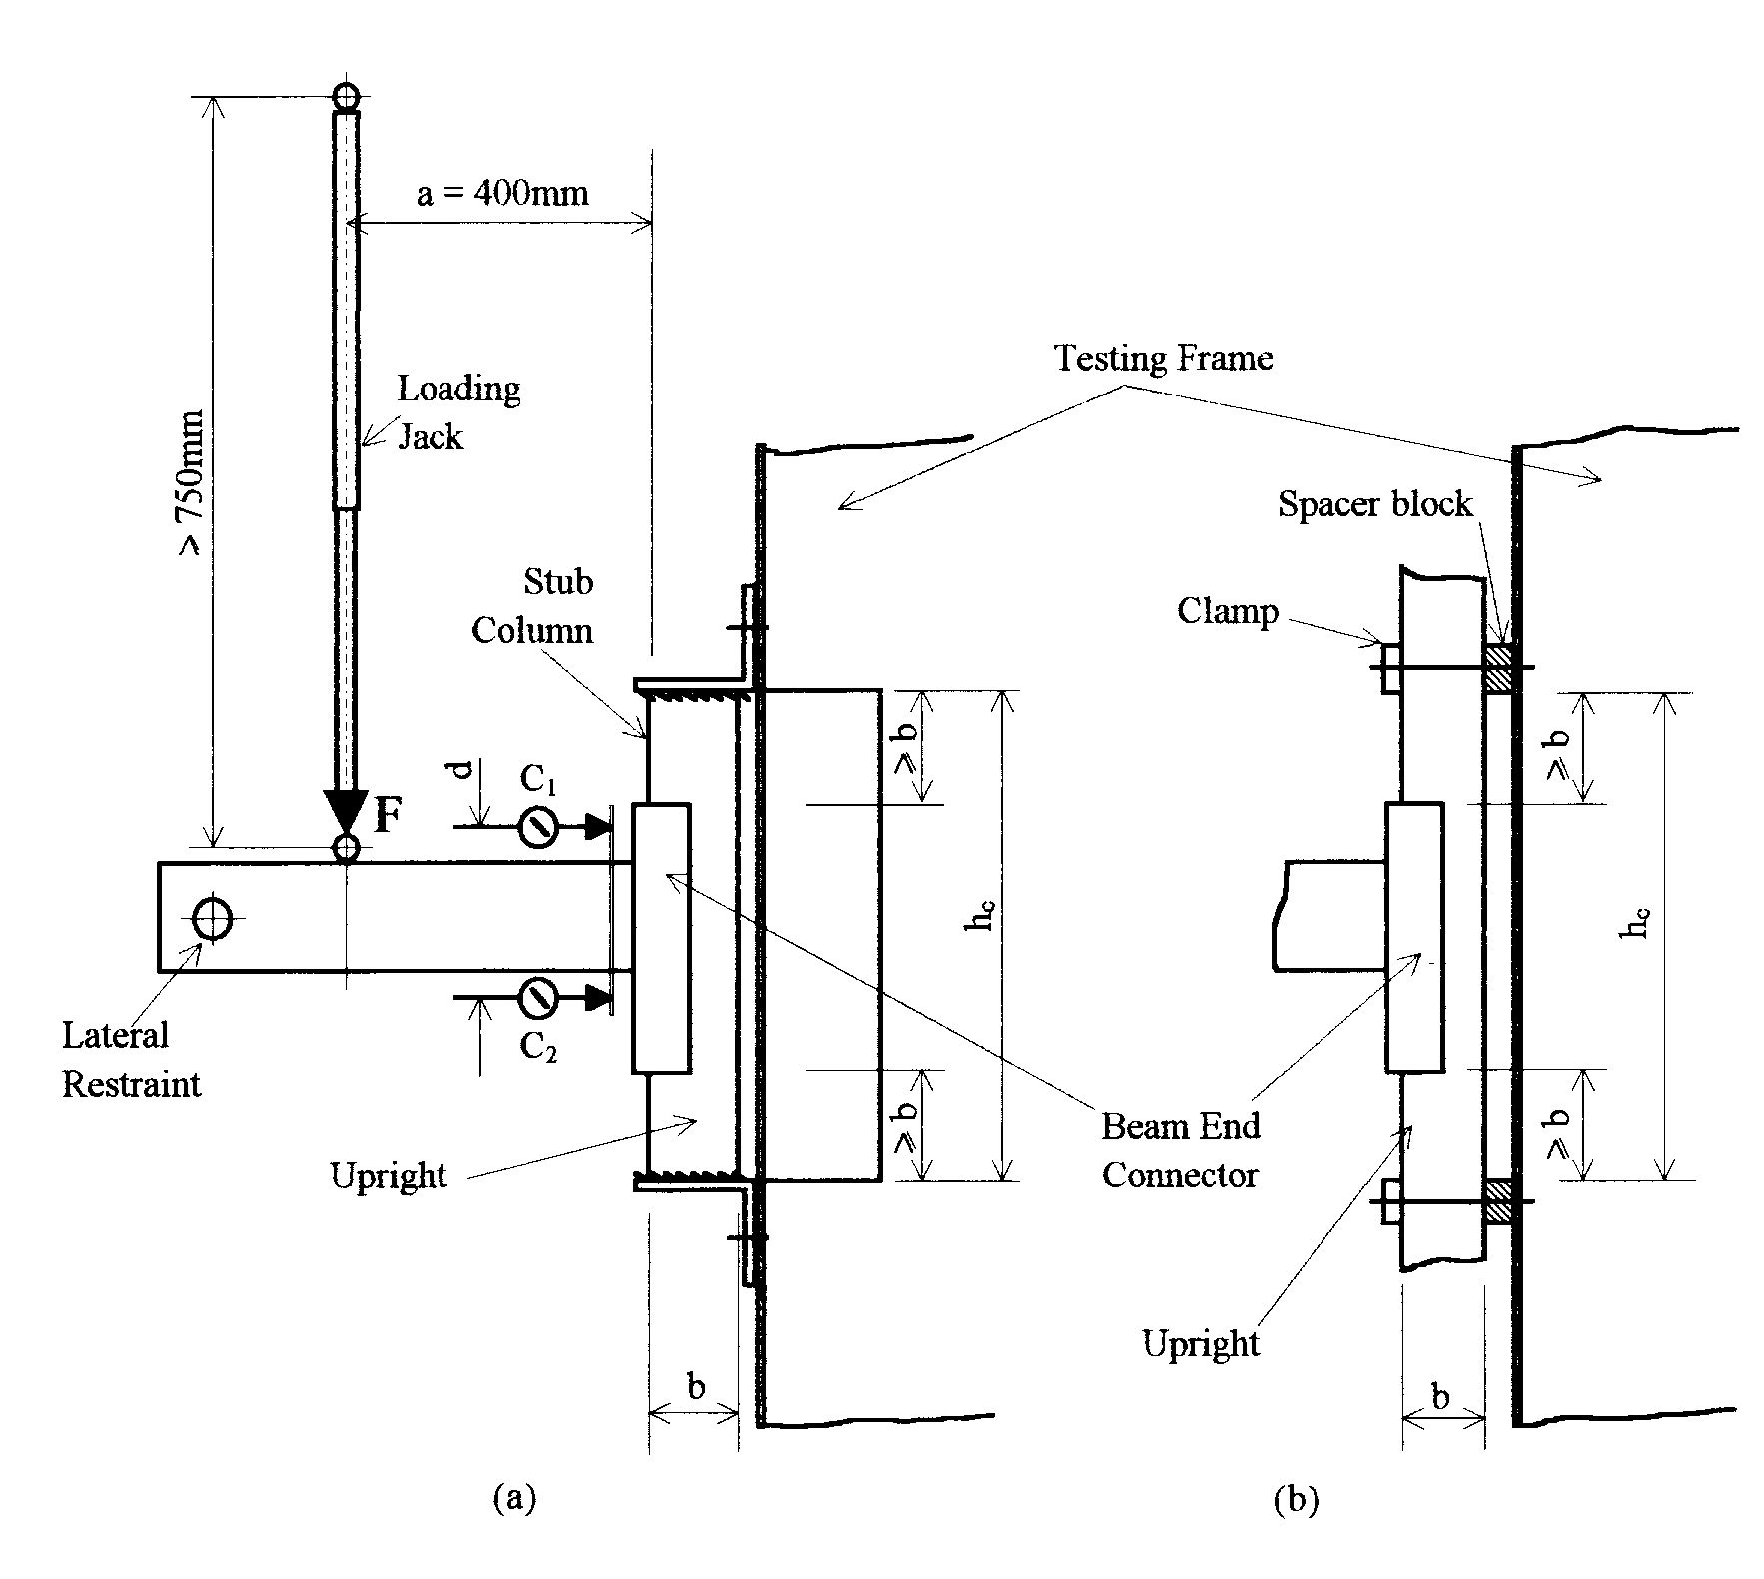

3

***Figure 5.5.1*****Arrangement for beam end connector bending test**

**(alternative methods of supporting the upright are shown)**

**5.5.3 Test Procedure**

The tests described here load the connector vertically downwards in shear. If tests in the reverse direction show results for stiffness and strength which are less than 50% of the values measured in these tests, then the actual figures shall be measured for use in design.

Separate values for the stiffness and strength shall be obtained for both right and left hand connectors and the mean value used in design.

An initial load, F, equal to 10% of the anticipated failure load may be applied to the assembly and then removed as a preload in order to bed in the components. The gauges should then be reset. The load, F, shall then be increased gradually until the maximum load is reached and the connection fails. The rotation of the connection shall be observed and, for each test, a plot of the moment M and the rotation  shall be made, in which:

**Erreur! Signet non défini.** M = a F

and  = 

where:

a = lever arm for the load F

d = distance between the gauges C1 and C2 as shown in Figure 5.5.1.

 = deflection measured by gauge C1

 = deflection measured by gauge C2

**5.5.4 Derivation of the Results**

The failure moment, Mti, shall be taken to be the maximum observed moment, as indicated in Figure 5.5.3.

For each upright and connector assembly, the characteristic failure moment Mk shall be calculated in accordance with section 5.1.3. The design moment for the connection is then MRd, where:

MRd ≤ 

in which:

 **Erreur! Signet non défini.**= partial safety factor for connections, defined in section 2.7.4.

**Note:** It is permissible to choose any value of the design moment less than or equal to the allowable maximum in order to optimise the possibly conflicting requirements for stiffness and strength. Thus, by reducing the design strength, it is possible to achieve a greater design stiffness, as shown below.

**5.5.4.1 Procedure to derive a bi-linear moment-rotation relationship**

A bi-linear relationship consists of a rotational stiffness together with a design strength chosen as described in section 5.5.4.

The rotational stiffness of the connector shall be obtained as the slope kti of a line through the origin which isolates equal areas between it and the experimental curve, below the design moment, MRd, as shown in Figure 5.5.3, provided that:



*Comment: This provision is designed to limit the difference between the rotation at failure assumed in the model and that indicated by the test, to 15% in cases where the connector behaves non-linearly.*

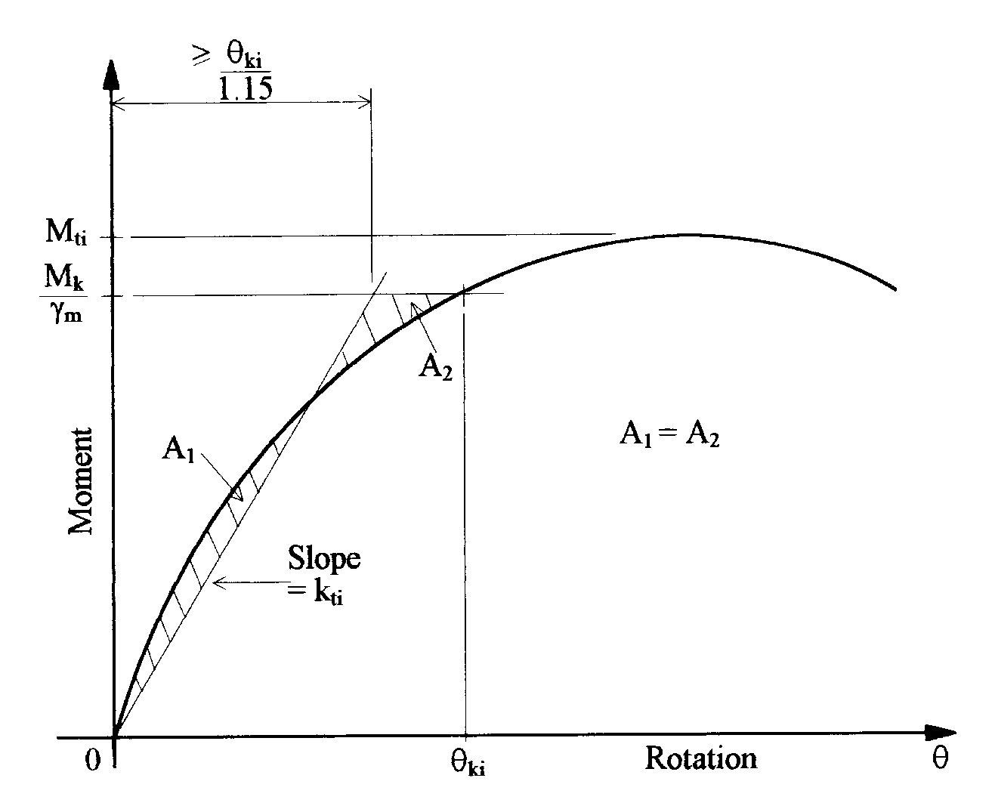

4

**Figure 5.5.3 Derivation of connector stiffness**

The design value, kd, of the connector stiffness shall be taken as the average value, km where:

km = 

**5.5.4.2 Procedure to derive a multi-linear curve**

Where the proposed method of analysis can accept a multi-linear moment-rotation curve, the first step is to derive an average curve from the results of the tests on the relevant beam and connector combination. The results for left and right hand connectors may be taken together.

The average curve is obtained by plotting the mean value of the rotation at each moment increment up to the value of the design moment MRd. This yields a single curve for the connection type, linking moment and rotation as shown by the full line in Fig. 5.5.4.1.

In the case of the cantilever test, if the looseness is to be omitted from the calculation of the frame imperfections in section 2.5.1, the looseness measured in accordance with section 5.6 shall be added to the average moment rotation curve, obtained as above, as a horizontal or near horizontal line.

The required multilinear curve may be obtained by replacing the average curve by a series of straight lines which always lie below it, as illustrated by Fig. 5.5.4.2.

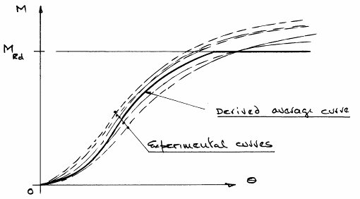

5

**Figure 5.5.4.1** **Derivation of the 'average' moment-rotation curve**

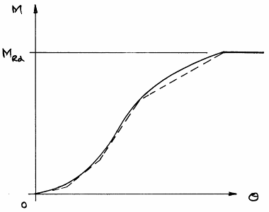

6

**Figure 5.5.4.2** **Typical linearisation of the average curve**

**5.5 Material properties**

The yield stress and thickness of the materials of the upright and connector shall be determined and the Engineer shall be satisfied that these are acceptably close to the nominal values before the test results shall be accepted.

**5.6 Looseness tests on beam end connectors**

**5.6.1 Purpose of the Test**

The purpose of the test is to obtain a value of the slackness and looseness of the connection, for use in the design calculations as required in section 2.5.1.

**5.6.2 Test Arrangement**

The same test arrangement as that used for the measurement of beam end connector strength and stiffness, and described in section 5.5, shall be used, except that the loading jack shall be double acting and capable of applying the load in the reverse direction, or counterbalancing dead weights shall be used to obtain the same effect.

**5.6.3 Test Method**

The load, F, shall be slowly increased until the moment at the connector (= 0.4.F) reaches a value equal to 10% of the design moment MRd defined in section 5.5.4. The deflections shall be observed. The load shall then be reduced and then reversed until a negative moment of 0.1 MRd is applied. The load shall then be removed. Figure 5.6.1 shows a typical output from such a test.

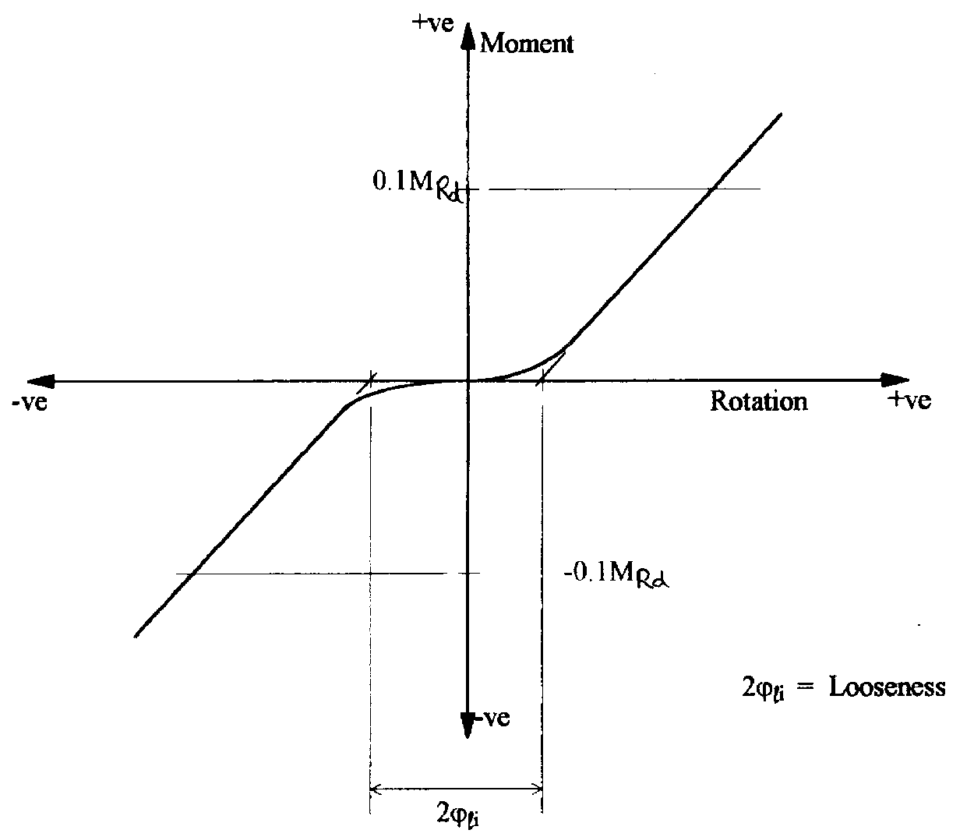

7

## Figure 5.6.1

The looseness shall be measured by extrapolating the linear parts of the moment rotation curves towards the origin until they intersect the rotation axis, as shown in Figure 5.6.1. The difference between the two intersection points so obtained is equal to double the looseness for the connector.

**5.6.4 Corrections to the Observations**

No corrections need be made to the observations to account for thickness or strength variations.

**5.6.5 Derivation of Results**

The looseness  shall be taken to be the mean value of the test results.

**5.7 Shear tests on beam end connectors and connector locks**

**5.7.1 Purpose of the Test**

The purpose of the test is to measure the shear strength of the connector and of the connector lock. All combinations specified in section 5.5.1 shall be tested.

**5.7.2 Test Arrangement**

The test arrangement comprises a short length of upright connected rigidly to a relatively infinitely stiff frame, with a length of beam section attached to it by means of the connection to be tested, as shown in Figure 5.7.1. The load shall be applied to the connection by a pin-ended jack, placed a distance *b* from the face of the upright and as close to it as possible. The free end of the beam shall be restrained by a pinned support 400 mm from the face of the upright, as shown in Figure 5.7.1. This support shall be mounted on a mechanical screw, or hydraulically, and adjusted in the vertical direction so that the beam remains horizontal during the test.

To test the connector lock, the test piece shall be installed in the inverted position and, in addition to the loading shown in Figure 5.7.1, a constant load of 500N shall be applied to the top surface of the beam in a direction normal to the face of the upright, such as to pull the beam end connector away from the face of the upright. The purpose of this force is to take away horizontal slop in the assembly and to thereby create the worst condition for the connector lock.

**5.7.3 Test Method**

To measure the strength of the beam end connector or of the lock, the beam shall be loaded, as indicated in Figure 5.7.1, until the maximum load Fti, is reached. The strength of the connector, Rti, shall be taken as:

Rti = Fti 

**5.7.4 Material Properties**

The yield stress and thickness of the materials of the upright and connector shall be determined and the Engineer shall be satisfied that these are acceptably close to the nominal values before the test results shall be accepted.

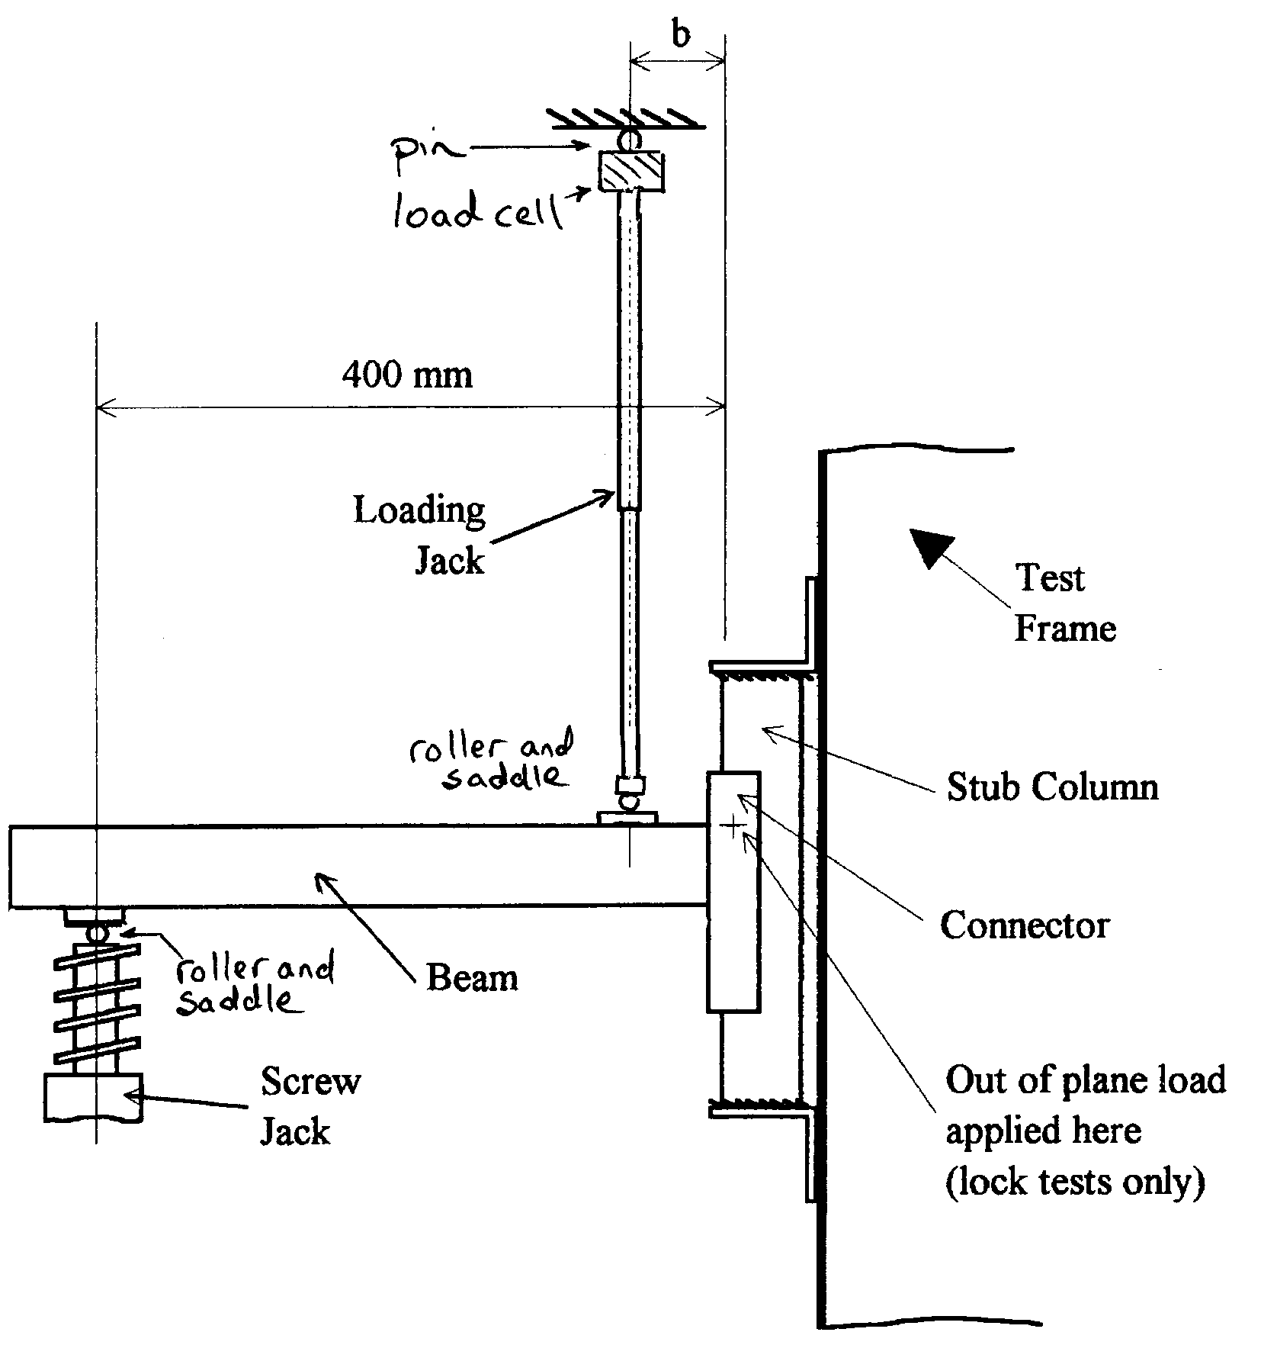

8

**Figure 5.7.1 Arrangement for the beam end connector shear test**

**Note:** The loading and screw jacks shall be aligned with the centre of gravity of the beam and the load applied across the full width of the top surface of the beam.

**5.7.5 Derivation of Results**

The characteristic value of the shear strength of the shear connector and the connector lock shall be determined in accordance with section 5.1.3(c).

**5.8 Tests on floor connections**

**5.8.1 Purpose of the Test**

The purpose of the test is to measure the moment rotation characteristics of the connection between the upright and floor for a range of axial loads up to the maximum design strength of the upright. Tests should be made at axial loads equal to 0.25Fsd, 0.5Fsd, 0.75Fsd and 1.0Fsd, where Fsd is the design load for the column.

**5.8.2 Test Arrangement**

An acceptable test arrangement is shown in Figure 5.8.1, but alternatives may be used, provided they accurately model the real structural condition.

The test arrangement comprises two lengths of upright section, not more than 600mm long, fitted with baseplates, and bearing onto a concrete cube to represent the floor surface, as shown in Figure 5.8.1. Standard baseplates shall be used in this test and they shall be connected to the concrete cube using the fixings adopted for the structure they are supposed to represent. If the baseplates have floor fixings, then the cube strength of the concrete used in the test shall be the same as that used in the floor in practice. Tests carried out using concrete in strength class 16/20 may be used for any sound concrete floor the concrete strength of which is not known. The tests may be made using other materials corresponding to the actual floor material when it is not concrete, provided the test conditions faithfully represent those in practice.

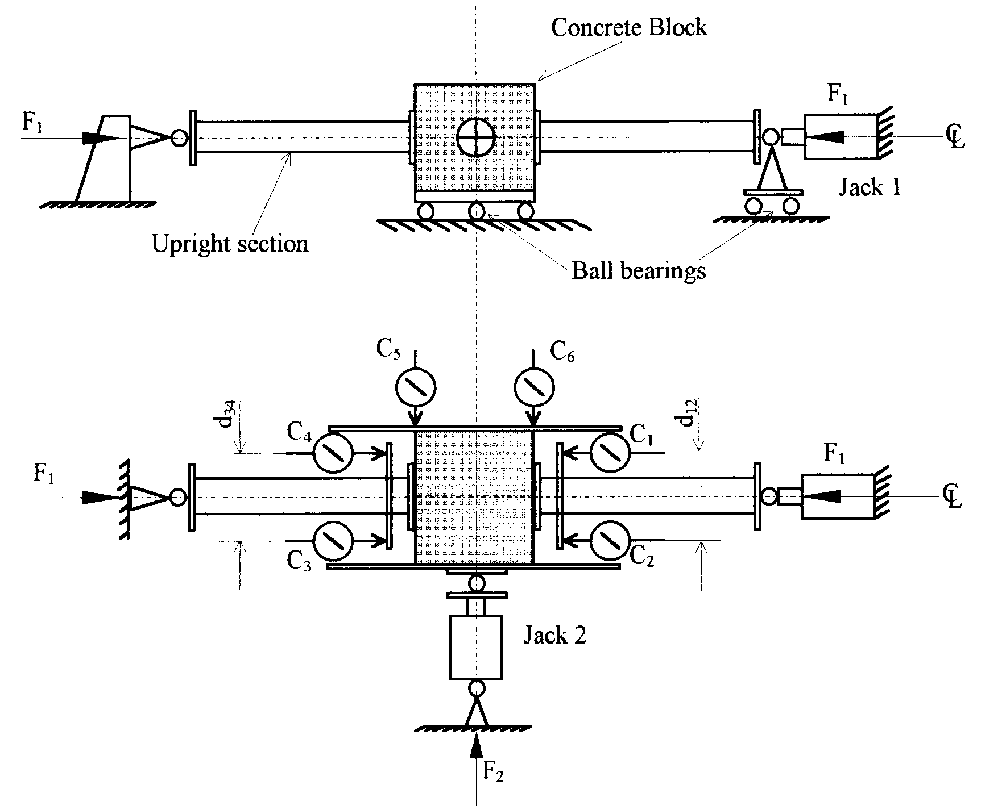

9

## Figure 5.8.1 Test arrangement for floor connections

The concrete cube shall have parallel faces and shall allow a clearance of at least 50mm all round the baseplate. It shall be mounted on rollers, ball bearings or a well lubricated surface so that it is

free to move in the horizontal plane, but restrained from rotating about the vertical axis. Displacement transducers shall be fitted to measure the horizontal movement of the concrete cube and the rotation of the column bases relative to the surface of the concrete. A suitable arrangement is shown in Figure 5.8.1.

The uprights shall be cut normal to their longitudinal axes and the faces of the cube on which the uprights bear shall be parallel, so that the axes of both uprights coincide with the line of action of the load.

**5.8.3 Test Method**

Initially Jack 2 shall be disengaged and 20% of the full test load applied to the specimen with Jack No 1. Any tendency of the concrete block to move away from the centre line of the test assembly shall be noted and Jack No. 2 placed so as to act in the direction of the misalignment.

The load in Jack No. 1 shall then be reduced to a nominal value which keeps all the components in contact, and the transducers zeroed. The load in Jack No. 1 shall then be increased to its full value and held constant at that value. The displacements shall be observed, and then the load in Jack No. 2 shall be increased and further displacement observations shall be made until this load reaches its maximum.

The system of forces is shown in Figure 5.8.2.

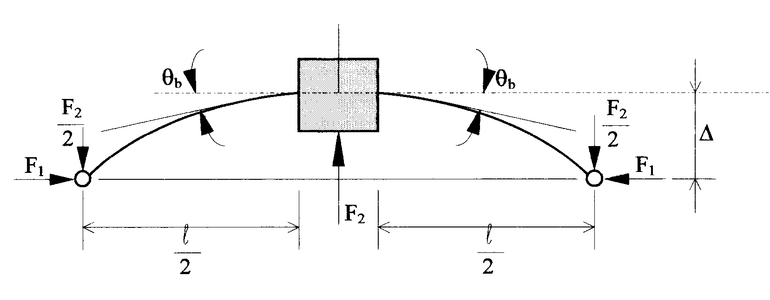

10

## Figure 5.8.2 Forces and deflections in the test on floor connections

The moment applied to the baseplate, Mb, and the rotation of the baseplate, b, shall be calculated as follows:

Mb = 

 = 

in which F1 and F2 are the loads applied by Jacks 1 and 2 respectively and  to  are the displacements at positions 1 to 6 respectively. Also,

 = 

and d12 and d34 are defined in Figure 5.8.1.

The calculation of the failure moment and the stiffness of the connection shall be in accordance with section 5.5.3(i).

**5.8.4 Corrections to the Observations**

No corrections are specified for the results of this test, but the engineer should consider the consequences of any significant variations in the mechanical and geometric properties of the test assembly away from the nominal values. This is especially true of the baseplate itself.

**5.8.5 Derivation of the Results**

The design values of the ultimate moment of resistance and the stiffness of the baseplate connection shall be calculated in the manner indicated in section 5.5.4 for beam end connectors, for each value of the axial load.

**5.9 Tests for the shear stiffness of upright frames**

**5.9.1 Purpose of the Tests**

The purpose of the tests is to determine the transverse shear stiffness per unit length of the frame structure in order to be able to assess its stability and to assess the shear strength of the frame.

**5.9.2 Test Arrangement**

The test sample shall be a frame assembly with a number of bracing panels loaded in the manner shown in Figure 5.9.1.

In the case of triangulated frames, at least three panels should be used, as shown in Figures 5.9.1(a) and (b). For battened frames, the test structure should be a whole number of panels in length, and fitted with stiff pin-ended struts at its ends to hold the uprights in position. A two panel frame is shown in Figure 5.9.1(c).

The frame should be placed in the horizontal plane between rollers which coincide with the points of intersection of the bracing members. The positions of the rollers should be adjusted so that the frame just fits snugly between them with no looseness.

One leg of the frame shall be pinned at one end so that it is prevented from moving horizontally, as at point X in Figure 5.9.1, and the load applied along the centroid of the other leg, at point Y in Figure 5.9.1.

If the arrangements for the test result in an unsymmetrical configuration, the load should be applied first in one direction and then in the other and the average stiffness taken for the purposes of analysis.

*Comment: The total load applied in this test is low so that, provided that the test in the first direction causes no visible damage, the reverse load may be applied to the same test specimen.*

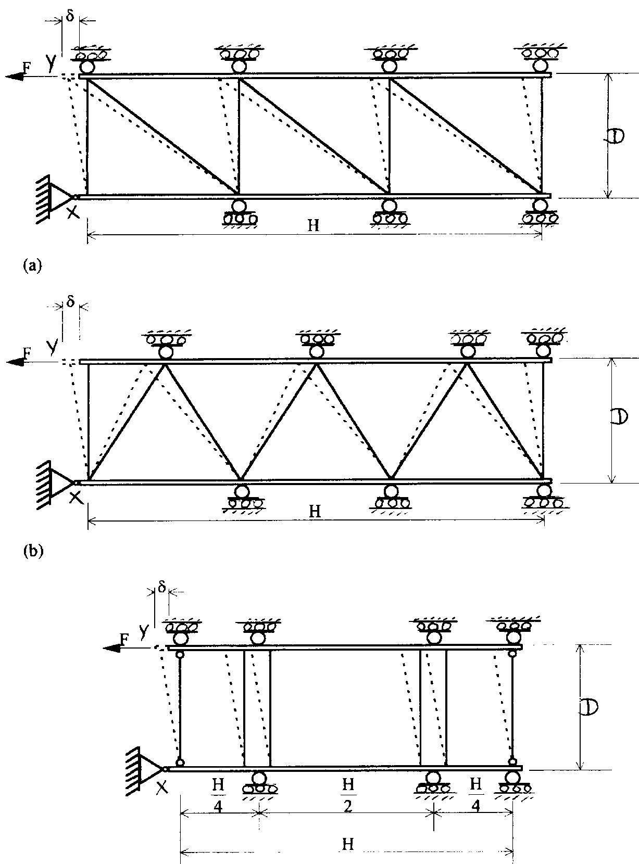

11

(c)

## Figure 5.9.1 Test arrangements for measuring the shear stiffness of

**battened or braced frames**

Where the product utilises a range of frame widths, this test shall be made on the widest frame. Where a range of panel widths or bracing gates are utilised in practice, the test shall be made on the longest panel width or bracing gate. If there is a danger of the bracing members in the frame buckling during the test due to induced loads, then it is permissible to introduce strengthening

members which are pinned at both ends and which do not contribute to the shear stiffness of the frame.

*Comment: The configuration of the frames under test, shown in Figure 5.9.1 is designed to cater for tall frames with many bracing panels. In cases where the frame will only be used with a small number of battens or bracing panels. The whole frame may be tested in its normal configuration.*

**5.9.3 Method of Test**

The load, F, shall be increased in increments up to a sufficient level to give at least three points on the essentially linear portion of the load-deflection curve. The corresponding deflection,  shall be measured during the test, and a graph plotted of F against .

The slope, kti, of the linear portion of the load deflection curve shall be measured, as shown in Fig. 5.9.2, and the transverse shear stiffness of the frame, Sti, shall be calculated from



in which H is the length of the frame, and D is the distance between the centroidal axes of the upright sections, as indicated in Figure 5.9.1.

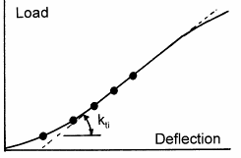

12

**Figure 5.9.2 Load-deflection curve**

**5.9.4 Corrections to the Observations**

No corrections are required.

**5.9.5 Derivation of Results**

The design value of the transverse shear stiffness for the frame shall be taken to be the average value from at least three tests.

*Comment: The design value of the transverse shear stiffness measured by this test is SD, in Appendix C.*

**5.10 Bending tests on upright sections**

**5.10.1 Purpose of the Test**

The purpose of the test is to determine the moment of resistance of an upright section about its major and minor axes of bending.

**5.10.2 The Test Arrangement**

The test shall be carried out by loading the upright section in four point bending as shown in Figure 5.10.1(a). The span, L, of the upright shall be such that:



in which D is the depth of the upright being tested.

The test may be made to measure the bending strength of the upright about either the major or minor axis. When the test is made to determine the bending strength about the axis of symmetry, then a complete frame shall be tested with the two upright sections linked together by the normal bracing system, with the section free to twist at the supports, as shown in Figure 5.10.1(b). This test arrangement permits lateral torsional buckling effects to occur which are similar to those developed by the upright in its normal mode of use. If, however, it is required to measure the bending properties of the section alone, and to suppress lateral torsional buckling effects, then the upright sections should be fixed together at intervals along their length in the manner shown in Figure 5.10.1(c), prior to testing. When the test is made to determine the strength in the plane of symmetry, then only one section need be tested but in the two aspects shown in Figure 5.10.1(d) and (e).

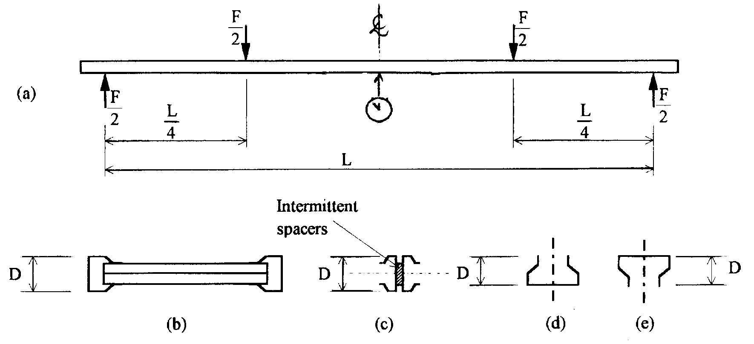

13

## Figure 5.10.1

**5.10.3 The Test Method**

The load shall be applied in increments up to failure to the quarter points of the span through spreaders large enough to prevent any local crushing of the section.

**5.10.4 Corrections to the Observations**

The failure moment measured in the test shall be adjusted to take account of variations in thickness and yield stress, as follows:

Mni = 

Mti = 

in which, for the specimen:

Fti = the observed load at failure for test number (i)

Mni = the corrected failure moment for test number (i)

Mti = the observed failure moment for test number (i)

ft = the observed yield stress for the specimen

fy = the nominal yield stress

tt = the observed thickness for the specimen

t = the design thickness

 = 0 when 

 = 1.0 when 

 = 1 for t ≥ tt

 = 1 for t < tt if 

 = 2 for t < tt if 

where:



and  is defined in Appendix D.

For 

the value of  shall be determined by linear interpolation.

**5.10.5 Derivation of Results**

The characteristic value of the moment of resistance shall be calculated in accordance with section 5.1.3(c).

**5.11 Bending tests on beams**

**5.11.1 Purpose of the Test**

The purpose of the test is to measure the bending strength of a beam and the beam rotation about its own axis under the service load. The test for beam strength is designed primarily for beams with only one axis of symmetry which may be susceptible to lateral torsional buckling.

**5.11.2 Test Arrangement**

The test assembly comprises a pair of beams supported on frames using standard connectors, as shown in Figure 5.11.1. For the beam rotation test, the beam span shall be at least equal to 50 times the width of the beam section. The beams may be linked together by beam ties or any other component which is incorporated in the least favourable arrangement specified by the manufacturer. The load pattern shall be that which occurs in practice. Alternatively, as a standard test to determine the general stability of the section, the loads may be applied at the quarter points of the span as shown in Figure 5.11.1. In this case, the load shall be applied through platens of maximum width 100 mm in order to reduce the tendency for web crippling.

Where necessary, the movement apart of the supports may be taken into account in the interpretation of this test.

*Comment: It is important that the loading media interact with the beams in the same way as in practice. For instance, flexible pallets may tend to load the beams horizontally as well as vertically; this situation should be accurately modelled in such tests.*

When the test is being conducted to evaluate the effects of possible lateral torsional buckling in a beam section with only one axis of symmetry, then either the normal conditions for lateral restraint of the compression flange must be utilised in the test or, if a range of conditions is to be covered by the test results, the most disadvantageous of the range should be tested. Where unit loads are deemed to provide lateral support to the compression flange, it is permissible to apply the load through a typical unit load or by using an equivalent substitute arrangement. It will normally be necessary to carry out the test on a range of spans corresponding to the range in which the beam is supplied.

*Comment: Loading devices should be free to sway with the structure under test.*

One frame should be supported on a pinned support at its base, and held in position, whilst the other should be supported in rollers so that it is free to move horizontally and so that no horizontal force, and hence no moments can develop in the upright.

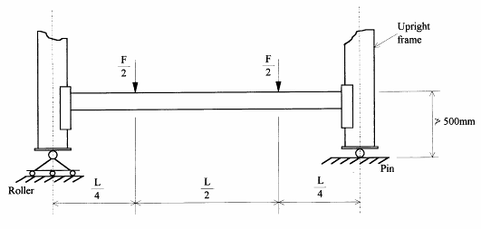

14

## Figure 5.11.1

**5.11.3 Test Method**

The load shall be increased to the service load for the beams and the absolute rotation 4 of the beam about its longitudinal axis shall be measured at centre span. This measurement shall be made using an inclinometer or displacement transducer mounted independently of the test structure. The central deflection of the beams may be measured in order to estimate the flexural rigidity of the beam, in the manner described in section 5.10. For loading arrangements other than that shown in Figure 5.11.1, the method described in section 5.10 should be adapted to take account of the actual distribution of load in the span. Once measurements of beam deflection and load have been made, the load may be increased until failure occurs, and the failure moment in the beam, Mti, calculated.

**5.11.4 Corrections to the Observations**

Corrections to the observed value of the beam rotation,  shall be made as follows in which the third power for thickness corrections is used only for open sections, otherwise the first power shall be used:

 for open sections

or  for closed sections

in which:

 = observed value of the central rotation in the serviceability limit state

 = corrected value of the central rotation.

and corrections to the observed failure moment, Mti, shall be made thus:



in which:

Mni = the corrected value of the failure moment

Mti = the observed value of the failure moment

ft = the observed yield stress for the specimen

fy = the nominal yield stress

tt = the observed thickness for the specimen

t = the design thickness

 = 0 when 

 = 1.0 when 

 = 1 for t ≥ tt

 = 1 for t < tt if 

 = 2 for t < tt if 

where:



 and  are defined in Appendix D.

For  the value of  shall be determined by linear interpolation.

**5.11.5 Derivation of Results**

The design value of the beam rotation shall be taken to be the average value from at least three tests. The characteristic value of the moment of resistance shall be calculated in accordance with section 5.1.3(c).

**5.12 Tests on shelves**

**5.12.1 Purpose of the Test**

The purpose of the test is to determine the load-deflection characteristic of the shelf and to measure its ultimate load capacity.

**5.12.2 Test Arrangement**

The shelf shall be mounted in the same way as it is mounted in normal conditions, either on beams or on corner connections as appropriate. Provision shall be made to measure the deflection at each corner of the shelf and at the centre of each unsupported edge. Care should be taken to ensure that curling of the flanges, which may develop as the test proceeds, does not affect deflection observations.

A typical arrangement is shown in Figure 5.12.1.

*Comment: This test does not deal with accidental loads for which separate tests are necessary to manufacturers' own specifications. Note that measurement of the deflection at the centre of the shelf is not a requirement of this test, but it is advisable to record this deflection for the sake of completeness.*

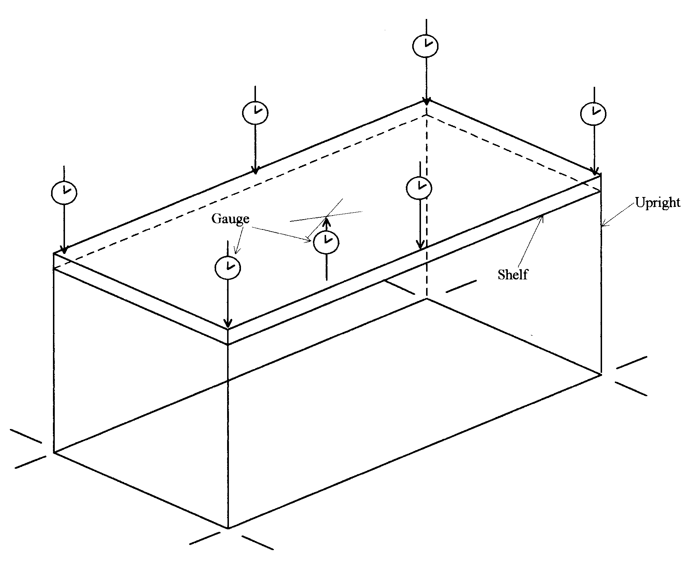

15

## Figure 5.12.1

**5.12.**3 **Test Method**

The load shall be applied as a uniformly distributed load over the whole surface of the shelf. Load may be applied as dead load or using hydraulic, mechanical or air bag systems. When dead load is used, care shall be taken to ensure that unrealistic results are not obtained as a consequence of bridging. With hydraulic or mechanical systems, the loads shall be applied as a symmetrical array of point loads as follows:

In a direction in which the overall dimension is less than or equal to 1.5 metres, a minimum of 4 point loads shall be used. Where 4 loads are used, they shall be applied at intervals of 1/8 - 1/4 - 1/4 - 1/8 of the span.

In a direction in which the overall dimension is greater than 1.5 metres, a minimum of 8 point loads shall be used. Where 8 loads are used, they shall be applied at intervals of 1/16 - 1/8 - 1/8 - 1/8 - 1/8 - 1/8 - 1/8 - 1/16 of the span.

*Comment: Thus the minimum number of point loads is 16.*

During the test, the load shall be increased gradually until collapse occurs. Deflections shall be measured at the ends and at the centre of each unsupported shelf edge, at least five measurements being made before the service load is reached. The magnitude of the collapse load Fti shall be noted. Deflections at the centre of the shelf should also be measured in order to observe any dishing effect.

A graph of shelf load, F, against the average central deflection 5 of each pair of parallel shelf edges shall be plotted, and the slope measured to obtain the effective stiffness at the mid-point of the shelf edge, kti. Where the design of edges is not the same, separate values of the edge stiffness shall be calculated and the lowest value adopted in design.

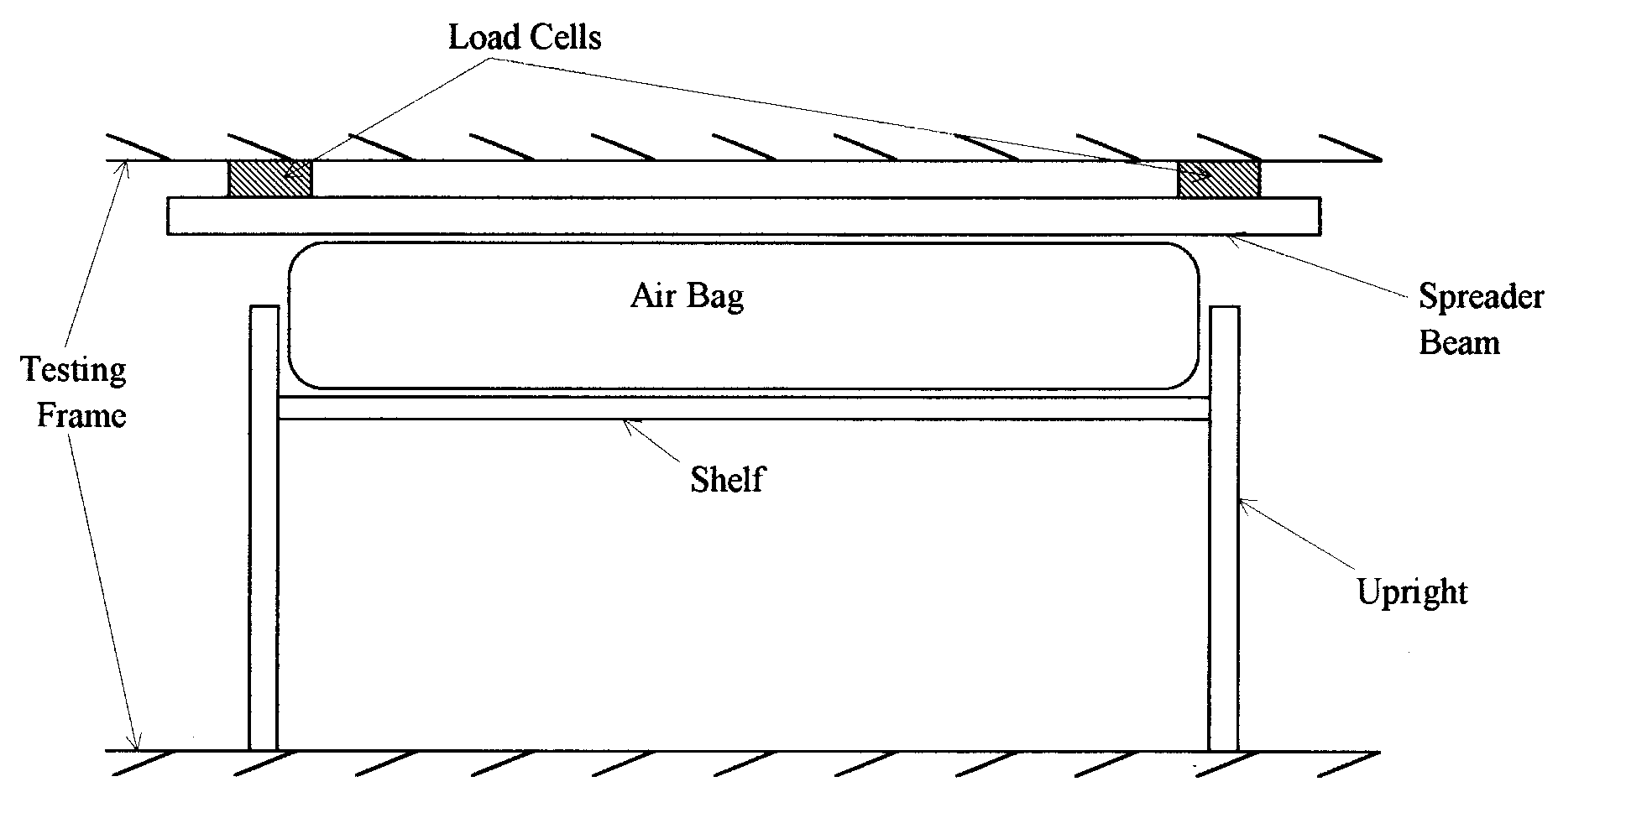

16

**Figure 5.12.2** **Arrangements for the use of air bags for loading shelves**

**5.12.4 Corrections to the Observations**

The stiffness measured in the test shall be adjusted for thickness, so that

kni = 

and the load capacity of the shelf shall be adjusted for thickness and yield stress, so that,

Fni = 

in which:

Fti = observed failure load

Fni = corrected failure load

kti = average stiffness of two parallel edges

kni = corrected average stiffness

t = design thickness

tt = actual shelf thickness

fy = nominal yield stress

ft = actual yield stress

 = 0 when 

 = 1.0 when 

 = 1 for t ≥ tt

 = 1 for t < tt if 

 = 2 for t < tt if 

where:



 and  are defined in Appendix D.

For  the value of  shall be determined by linear interpolation.

**5.12.5 Derivation of Results**

The design value of the stiffness of the shelf shall be taken to be the average value from at least three tests. The characteristic value of the strength of the shelf shall be calculated in accordance with section 5.1.3(c).

**5.13 Bending tests on shelf to upright connections**

**5.13.1 Purpose of the Test**

The purpose of this test is to determine the effective stiffness and strength of the connection between the shelf and upright of a shelving system.

This test is only necessary if the shelf to upright connection is designed to be moment-resisting.

This test is similar to the portal frame test (Alternative 2 in document 10.2.02) for beam end connectors in pallet racking systems.

*Comment: The cantilever test arrangement shown in Figure 5.5.1 may not be suitable for use with shelf to upright connections. In general, shelf to upright connections exhibit a different stiffness for positive and negative rotation. Consequently, the effective stiffness measured in this test is an approximate average of the two. In addition, the measured stiffness includes the effects of shelf flexibilities.*

All combinations of upright type, shelf type and size should be tested separately unless it can be reasonably demonstrated that interpolation of the test results provides a conservative estimate of the performance. For each shelf and upright assembly, a number of nominally identical tests shall be performed so that the results can be interpreted statistically in accordance with section 5.1.3.

**5.13.2 Test Arrangement**

The shelf shall be supported on four uprights, in the same way that it is supported in normal use, at a height of not less than 0.5 m. The bases of these uprights shall be pinned to the foundation or test frame. Provision shall be made to apply a horizontal load, F, in either direction to the assembly at the level of the top of the shelf. The horizontal deflection, , of the centre of the shelf shall be measured from the unloaded position of the test assembly at the same level as the point of application of the load. The test arrangement is shown in Figure 5.13.1.

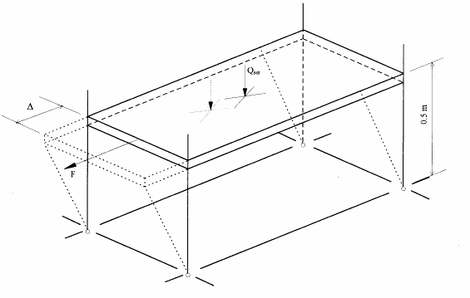

17

## Figure 5.13.1

In order to account for possible differences in the behaviour of the left and right hand connections, separate tests shall be carried out with the load applied in both directions.

**5.13.3 Test procedure**

At the commencement of the test, the shelf shall be loaded with its service load Qser. This load shall be applied gently and without shock. With this load in position, the horizontal load, F, shall be increased in increments from zero and the horizontal deflection recorded. The horizontal load shall be increased until the structure will accept no additional load.

For each test, the moment in the connection between the shelf and the upright shall be calculated as:



6

The corresponding rotation of the connection between the shelf and the upright may be calculated from the horizontal deflection taking into account the flexure of the uprights:



7

where EIc = flexural rigidity of the gross upright section.

**5.13.4 Derivation of results**

The derivation of the results from this test shall be carried out in the manner specified for beam end connectors in section 5.5.4.

**5.13.5 Corrections to the observations**

The yield stress and thickness of the uprights, shelves and any other components such as shelf clips which may influence the stiffness and strength of the connection shall be determined. The Engineer shall be satisfied that these are acceptably close to the nominal values before the test results shall be accepted.

**5.14 Tests on upright splices**

**5.14.1 Purpose of the Test**

The purpose of the test is to determine the stiffness and strength of splices between upright sections. Tests should be made at a range of values of the axial load, F1, equal to 0.25Fsd, 0.5Fsd, 0.75Fsd and 1.0Fsd where Fsd is the design load for the upright.

**5.14.2 Test Arrangement**

The test arrangement is shown in Figure 5.14.1 and comprises two uprights connected together by the splice under investigation, loaded axially with a force F1 through pin joints in the ends of the uprights. Care must be taken to ensure that the centroidal axes of both uprights, which may be of different sections, are coincident with the line of action of the force F1.

The total length  of the test specimen should not be greater than the length of the splice plus 1.2 metres.

Displacement transducers are fitted to the ends of the upright and on the splice, as shown in Figure 5.14.1.

*Comment: This test may be required in two directions, one in the cross-aisle direction, and one in the down-aisle direction.*

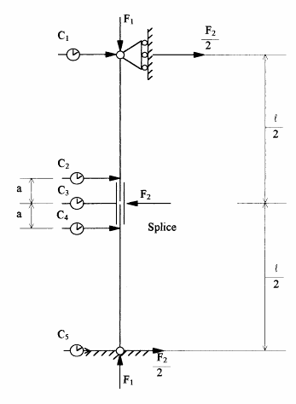

1

# Figure 5.14.1

**5.14.3 Test Procedure**

The load F1 is first applied at a chosen value and kept constant at that value as the horizontal load, F2, is applied. F2 is then gradually increased until failure of the splice occurs and no further load can be applied. The displacements shall be measured.

A graph of the moment, M, applied to the joint against the rotation  shall be plotted, for which:

M = 

and:

 = 

where:

 = distance between pins

a = distance between transducers

F1 = axial load

F2 = transverse load

1 to 5 = displacements at points 1 to 5

The calculation of the stiffness, and moment of resistance of the splice shall be made in accordance with section 5.5.4 for beam end connectors.

**5.14**.4 **Corrections to Observations**

No corrections need to be made to the results for variations of thickness and yield stress away from nominal values.

**5.14.5 Derivation of Results**

The characteristic values for the stiffness and strength of the splice for each value of the axial load F1 shall be derived in the manner described for beam end connectors in section 5.5.4.

If the variation of stiffness or design ultimate moment with axial force is not greater than ± 10% of the mean value for the range of axial loads (F1) up to the design load for the upright, the mean value may be assumed and used in the analysis and design of the structure. Where there is greater variation in the failure moment and the stiffness of the splice, then appropriate values corresponding to the design axial force shall be used.

**5.15 Charpy type impact tests**

**5.15.1 Purpose of the Test**

The purpose of the test is to determine the effect of low temperature on the absorbed impact energy of critical elements of the connection between the beam or shelf and the upright, such as the connecter hook and the beam to connector weld. The information obtained in this test shall be used as a guide to determine whether the connection is suitable for use at low temperatures, such as in a cold store.

**5.15.2 Test Method**

The test method cannot be very precisely defined because of the variety of designs of the connection between beam and upright. However, it is essential that the test shall consist of a Charpy type impact test in which a sample is subjected to impact loading and the energy absorbed, as it fractures, is measured. It should be noted that as the test sample will normally be non-standard, the actual value of the energy absorbed is not significant. The testing machine must be capable of delivering enough energy on impact to fracture the sample, so that the residual energy may be observed, and the energy absorbed calculated. If this is not the case, and fracture does not occur, then the test arrangements must be changed.

For a typical beam to upright connection shown in Figure 5.15.1 the elements to be tested may be a single hook or a part of the weld between beam and connector, as shown in Figures 5.15.2 and 5.15.3, or, providing the testing machine has adequate capacity, it may be the complete assembly shown in Figure 5.15.1.

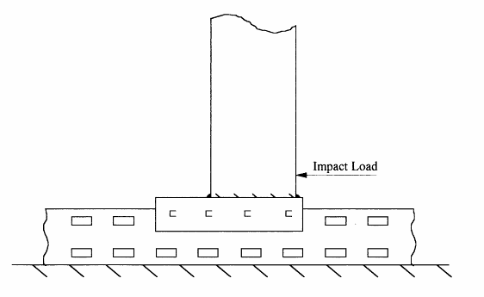

2

**Figure 5.15.1**

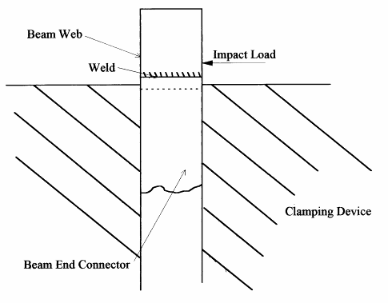

3

## Figure 5.15.2

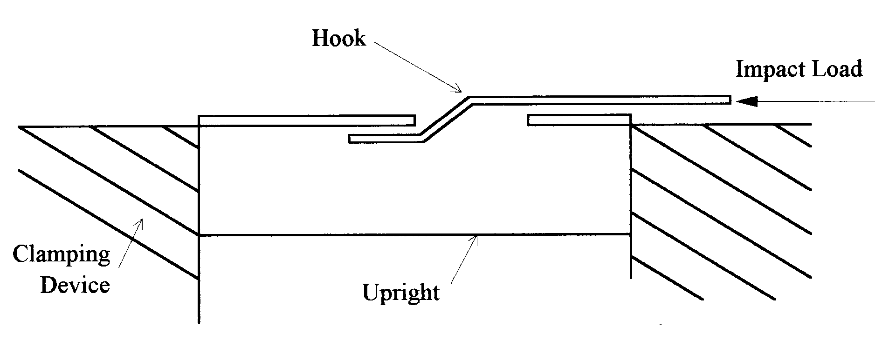

4

**Figure 5.15.3**

The test shall be made at different temperatures ranging from ambient temperature down to a temperature not less than 20oC below the service temperature for the connection. The minimum frequency of testing shall be a single test at each temperature, reducing from ambient in increments of 5oC.

Temperature control may be achieved by immersing the test samples in a fluid bath at the appropriate temperature prior to mounting them in the testing machine, but the design of the mount for the specimen shall be such that it can be so quickly installed that no significant change in temperature takes place before the impact test is made.

A plot of the energy absorbed against the temperature shall be made.

**5.15.3 Derivation of the Transition Temperature**

It is assumed that the behaviour at ambient temperature is ductile, although fracture surfaces should be inspected to confirm that this is so, and that brittle behaviour, as the temperature reduces, will be characterised by a significant drop in the energy absorbed. When the temperature at which the behaviour change is as sharp as that indicated in Figure 5.15.4 it is possible to define the transition temperature (TR) as shown. However, a less well defined characteristic may be expected in many instances, as shown in Figure 5.15.5, and in this case the precise definition of the transition temperature is less easy. For this reason, in order to remove uncertainty, the transition temperature shall be obtained by drawing a smooth curve below all the test results, and measuring the temperature (TR) at which the absorbed energy drops to 75% of that at ambient temperature (EA). This method is illustrated in Figure 5.15.5.

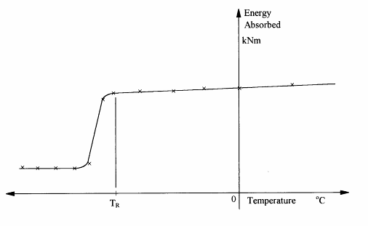

5

**Figure 5.15.4**

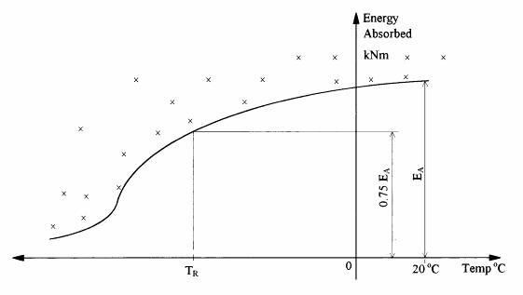

6

**Figure 5.15.5**

**5.16 Full scale tests**

**5.16**.1 **General**

Tests may be made on full scale shelving systems to confirm general structural behaviour (the acceptance test), to confirm the calculated load capacity of the structure (the strength test), or to determine the actual failure mode and the true load capacity (the failure test). The results of the failure test may be used to establish the design capacity of the structure tested or of a family of similar standard structures, of which the tested structure is demonstrably the weakest example.

In all tests the properties of the steel used in critical components of the test structure must be measured by performing tensile tests on coupons cut from undamaged areas of the tested structure, after the test has been completed. During any test the critical deformations should be observed, and a running plot of such deformations against the load made as a means of monitoring the progress of the test. Observations of deformations should be made at at least five regular increments of the load, both as it is increased and then, where appropriate, as it is removed. Where significant non-linearity is observed, the frequency of observation should be increased.

It is often advantageous to apply a bedding-in load not exceeding the specified service load for the structure, and then to remove it prior to the start of the test proper.

Where more than one type of load is applied, such as shelf or pallet loads simultaneously with side loads designed to simulate out of plumb and looseness, both the vertical and horizontal loads shall be increased together in the same ratio throughout the test.

**5.16.2 The Acceptance Test**

This is a non-destructive test designed to confirm the structural performance of the test structure. The maximum load to be applied during the acceptance test is:



using the definitions given in section 2.

In assessing this load, account may be taken of the actual deadload present during the test.

The test load shall be applied for a period of at least one hour and the structure shall be able to sustain this load without significant local distortion or other defects likely to render it unserviceable.

The structure shall demonstrate substantially elastic behaviour under the test load and on removal of the load the residual deflection should not exceed 20% of the maximum value observed. If these conditions are not met, the test should be repeated. In the repeated test, the structure should demonstrate essentially linear behaviour and the residual deflection should not exceed 10% of the maximum observed.

**5.16.3 Strength Test**

The purpose of this test is to confirm the calculated load capacity of the structure. Before the strength test is made, the structure should be subjected to the acceptance test and meet all the requirements of that test.

The test load for the strength test should be based on the design load for the structure given in section 2.7.1. The actual test load should be adjusted to take account of differences between the yield stress of the material used in critical components of the test structure and the nominal value of the yield stress guaranteed by the manufacturer. The test load is defined thus:

Test load = 

but Test Load ≥ Design Load

in which:

ft = observed yield stress

fy = nominal yield stress

The load on the structure should be increased to the strength test load, and maintained for a period of at least one hour. During this period, the principle deflections should be monitored and no significant creep should be in evidence. At the test load there shall be no failure by buckling or rupture of any part of the structure. At the end of this period, the load should be removed and the structure should show a recovery of at least 20% of the maximum value of the observed principle deflections.

*Comment: The procedure implies that ft would be determined before commencing testing.*

**5.16.4 Failure Test**

It is only from a test to failure that the real mode of failure and the true capacity of a structure can be determined. Where this item is not required for use it may be advantageous to secure this additional information after completing a strength test. Alternatively, the objective may be to determine the true design capacity from the ultimate test capacity. In this situation it is still desirable to carry out the load cycling of the acceptance and strength tests. An estimate should be made of the anticipated design capacity as a basis for such tests.

Prior to carrying out the failure test, the structure should be subjected to the strength test described in section 5.16.3. Provided the structure satisfies the strength test, the loads should be reapplied and increased in constant proportion until the ultimate load is reached. The ultimate load is the load at which the structure is unable to sustain any further increases.

(i) If only one test is carried out, then the characteristic resistance Rk corresponding to this test shall be evaluated as:

Rk = 

where Rni is the observed failure load adjusted for variations in yield stress and thickness. γk shall be taken as follows, depending on the failure mode.

Case 1: Yielding failure k = 0.9

Case 2: Failure due to gross deformation k = 0.9

Case 3: Failure due to local buckling k = 0.8

Case 4: Failure due to overall stability k = 0.7

(ii) If two or three tests are carried out, and the test results are within 10% of the mean value, Rm, the characteristic resistance, Rk shall be evaluated as:

Rk = 

(iii) If the test results do not lie within 10% of the mean, then the characteristic resistance, Rk shall be obtained by treating the lowest test result as a single result in (i) above.

(iv) When four or more identical failure tests are made, the characteristic resistance, Rk, shall be determined using the provisions of section 5.1.3.

The design resistance, Rd is given by:

Rd = 

where: M = 1.1 for the resistance of cross-section and members

and: M = 1.25 for the resistance of assemblies and connections.

**5.16.5 Low Rise Shelving Structures**

For low rise shelving structures not more than 2.5m high and not designed to support handling equipment or floors, the load rating may be confirmed by acceptance and strength tests. The configuration for the tests shall be three bays long and single sided, as shown in Figure 5.16.1. The height shall be the maximum specified for the product and the beam or shelf span and spacing shall be the most structurally demanding of the range of possible configurations. This normally means that there should be enough fully laden shelves or beams in the test structure to match the load capacity of the upright frame, subject to the limit that the shelf spacing shall not be less than the minimum specified by the manufacturer. However, careful consideration should be given to other configurations.

The basis of the loading for both the acceptance test and the strength test shall be the service load on the shelf, Wser. The test structure shall be loaded with a combination of shelf loads and horizontal loads in the patterns shown in Figures 5.16.2 and 5.16.3.

(i) *The acceptance test*

In the acceptance test, each shelf shall be loaded to 1.25 times its service value, Wser, and a horizontal load applied to the top of the structure equal to 1% of the total load in the prototype.

*Comment: This represents twice the effect of an initial sway imperfection of 1%, as it is applied at the top of the structure, rather than being distributed over the height.*

Two tests shall be made. In the first, the horizontal load shall be applied in the cross-aisle direction, as shown in Figure 5.16.2, at the top of each frame and the horizontal deflection at the top of an internal frame shall be measured. In the second test, the horizontal load shall be applied in the down aisle direction, as shown in Figure 5.16.3, shared equally between the front and rear faces of the assembly. The horizontal deflection of both the front and rear faces shall be measured.

In each case, the load shall be maintained for a period of at least one hour and the structure should not show any signs of significant distortion. The load deflection behaviour should be substantially linear, and on removal of the load the residual deflection should not exceed 20% of the maximum observed. If this is not the case, the test may be repeated, and provided the structure demonstrates essentially linear behaviour and the residual deflection does not exceed 10% of the maximum observed, the requirement of the acceptance test may be deemed to have been satisfied.

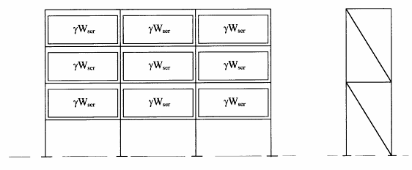

7

**Figure 5.16.1 Shelf load  = 1.25 for the acceptance test,  = 1.5 for the strength test**

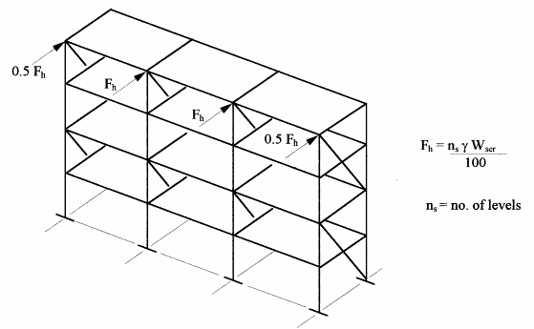

8

**Figure 5.16.2 Cross-aisle horizontal loads**

(ii) *The strength test*

The same loading configuration shall be adopted in the strength test, except that the shelf loads shall be increased to 1.5 times their rated value. The horizontal loads shall be 1% of the total factored shelf loads, and shall be applied at the top of the structure as before. Separate tests shall be made in the down-aisle and cross-aisle directions. The factored loads shall be maintained for at least one hour, and the deflections observed. During this period, no creep shall be observed, and

the horizontal deflection shall not exceed 2% of the height. On removal of the load, at least 20% of the deflections shall be recovered.

The tests described above may be carried out on two separate examples of the product, in the one case using cross-aisle horizontal loads, and in the other using down-aisle horizontal loads. Provided the structure satisfies all the requirements of both the acceptance and the strength tests, then it may be deemed to satisfy the requirements of this standard for the load rating adopted in the tests.

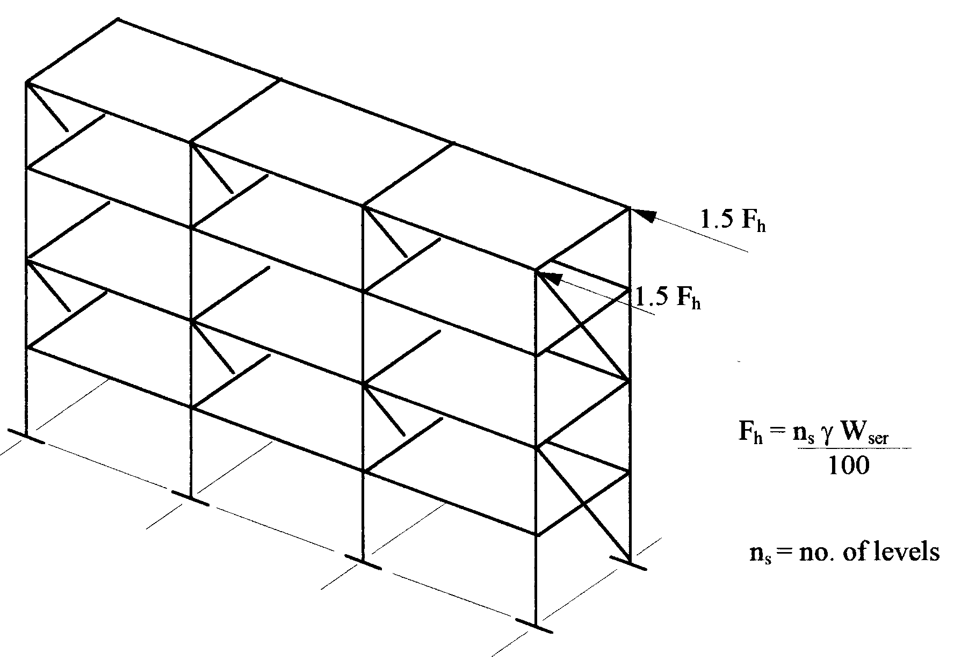

9

**Figure 5.16.3 Down-aisle horizontal loads**

**5.17 Tensile tests on shelf to upright connections**

5.17.1 **Purpose of the Tests**

The purpose of the tests is to measure the stiffness and strength of the connection between the upright and the shelf in the horizontal plane and in the down-aisle direction.

*Comment: The information gained from this test may be used to determine the stability of an upright which relies upon such connections for its structural integrity.*

**5.17.2 Test Arrangement**

Figure 5.17.1 shows a typical test arrangement in which advantage is taken of symmetry to design the test. Each upright is secured to a testing frame through its front face, to allow distortion of the cross-section to develop under load as appropriate, and the load is applied symmetrically through the shelf. The deflection of the shelf corners in relation to the centre line of the upright is measured.

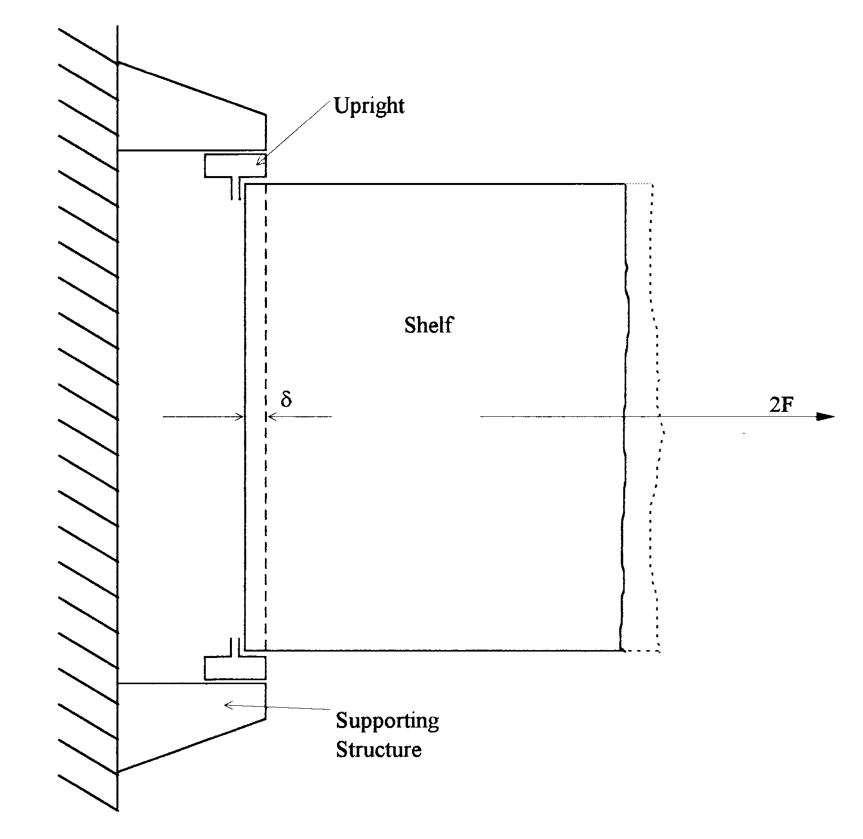

10

**Figure 5.17.1 Typical test arrangement for measuring the tensile**

**stiffness and strength of the shelf-upright connection**

*Comment: This arrangement is one of a number of test arrangements which are possible. The actual arrangement may be determined by the Engineer to take account of the characteristics of the design of the connection. The test arrangement should be designed to measure the local distortion of the shelf, the local distortion of the upright and the deflection or change in shape of any connecting devices, all of which contribute to the effective flexibility of the joint.*

**5.17.3 Test Method**

The load, F, shall be increased gradually until failure occurs. The deflection δ shall be measured during the test and a graph plotted of the load F against the deflection δ.

The initial slope, kti shall be measured from the graph, and the strength of the connection shall be taken to be the maximum value, Fti observed.

**5.17.4 Corrections to the Observations**

No corrections are required.

**5.17.5 Derivation of Results**

The characteristic value of the stiffness of the connection shall be taken to be the average value from at least three tests. The characteristic value of the strength of the connection shall be calculated in accordance with section 5.1.3(c).

**Symbols**

Note A number of the following symbols may be used together with standard subscripts which are given later. In general, primary symbols are not defined with all of the standard subscripts with which they may be used.

A accidental action

A cross-sectional area

Aeff effective cross-sectional area

Ag gross cross-sectional area

Aph accidental horizontal placement force

Apv accidental vertical placement force

b width of upright

b0 width of flat element (stiffened or unstiffened)

b1 width of loaded flange

bp notional plane width of element

C coefficient

Cn coefficient related to number of tests

D spacing of uprights in a frame

E modulus of elasticity

EA energy absorbed in a Charpy impact test at ambient temperature

e effective bearing width of baseplate

en shift of neutral axis due to movement of centroid

e1,e2 eccentricities in a bracing system

e0,d equivalent initial bow imperfection

F action

f strength

fcu characteristic cube strength of concrete

ft observed yield strength in test specimen

fu ultimate tensile strength

fy yield strength of base material

fya average design strength

fyb yield strength of base material (= fy)

G shear modulus

Gk characteristic value of permanent action (dead load)

H frame height

Hs height of top frame spacer above floor

h storey height

hc depth of compressed part of web

hp length of longest plane web element

hw depth of web normal to flanges

h1 total length of web between system lines

I second moment of area

IT St Venant torsional constant

Iw warping constant

i radius of gyration

i0 polar radius of gyration

K effective length factor

kb stiffness of beam to column connector

ke effective stiffness of beam to column connection

ks coefficient related to number of tests

l length

*l* effective length or buckling length

L span

M bending moment

N axial force

N number of 900 bends in a section

n number of tests

nb number of bays

ns number of storeys

Q variable action

Qf concentrated load on floor

Qh horizontal load per crane at guide rail level

Qph horizontal placement load

Qpv vertical placement load

Qu unit load

q distributed load

R resistance

Rm mean value of adjusted test results

Rn corrected failure load

Rt observed failure load

r bending radius measured to inside of corner

S shear force

s system length

s standard deviation

sw system length of web

T temperature

TR transition temperature

t thickness of material

tc core thickness exclusive of coatings

tN nominal sheet thickness inclusive of coatings

tt observed core thickness in test specimen

V shear force

V vertical load

Vcr elastic critical value of vertical load

W section modulus

W total load on a beam

Wf capacity of the most heavily loaded of a pair of frames

 coefficient of linear thermal expansion

 correction factor for yield strength

 imperfection factor

 beam coefficient

 correction factor for thickness

 amplification factor for second-order effects

 partial safety factor

 partial safety factor for accidental actions

 load factor

 partial safety factor for permanent actions

 material factor

 partial safety factor for variable actions

 deflection

 correction factor for corner radii

 strain

 rotation

 multiplication factor for web stiffeners

 slenderness ratio

 non-dimensional slenderness ratio

 Poisson's ratio

 density

 shear strength

 sway imperfection

 initial sway imperfection

 looseness of connector

 stress reduction factor for buckling

**Subscripts**

b buckling

c compression, capacity

cr critical

d design

FT flexural torsional

g gross

i test number

k characteristic

LT lateral torsional

m mean value

max maximum

min minimum

n corrected value

pl plastic

R resistance

S strength

ser service

T torsional

t observed value in a test

w web

Note Rd = design resistance

Sd = design strength

**APPENDIX A: AMPLIFIED SWAY METHOD FOR DOWN-AISLE STABILITY ANALYSIS**

The amplified sway method provides a close approximation to the value of the elastic critical load Vcr of a plane frame. It then allows the increase in the bending moments and deflections due to second order effects to be estimated. The basis is described in

*M R Horne "An approximate method of calculating the elastic critical loads of multi-storey plane frames" Structural Engineer, Vol. 53, No. 6, June 1975.*

The method is also given in clause 5.2.6 of ENV 1993-1-1.

The principles are described with reference to Fig. A.1.

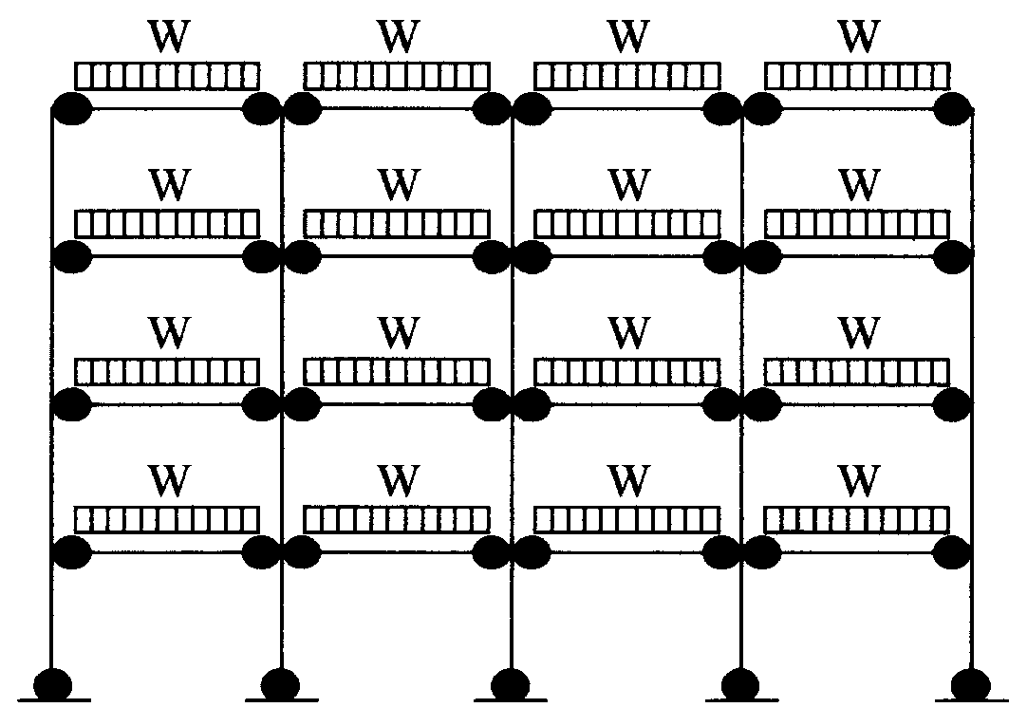

1

(a) Actual frame and loading

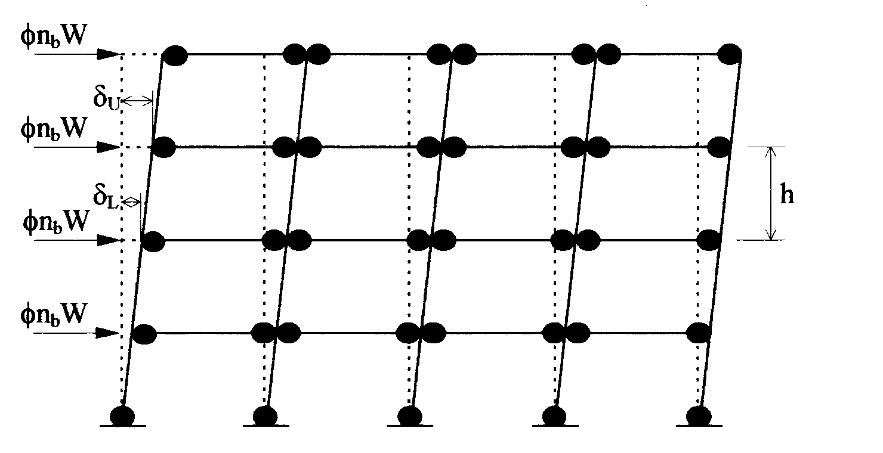

2

(b) Notional horizontal loads and resulting deflections

# Fig. A1 Basis of the amplified sway method

**A1** A linear elastic analysis of the complete frame should be carried out in order to determine the internal forces and deflections due to the notional horizontal loads as shown in Fig. A1. These loads are defined in section 2 and consist of φ times the design vertical load at any beam level applied horizontally at that level where φ is the sway imperfection.

The flexibility of the beam to upright connections must be taken into account.

Allowance may also be made for the stiffness of the upright to floor connections (see section 5.8).

**A2** The elastic critical value of the vertical load for failure in a sway mode, Vcr, may then be determined as



1

where VSd = design value of the vertical load on the frame.

φmax = largest value of the sway index φs of any storey

φs = (δU - δL)/h

h = storey height

δU = horizontal deflection at the top of the storey

δL = horizontal deflection at the bottom of the storey

**A3** At the required limit state, the design internal forces and deflections in any sway mode are amplified by the factor β, where



2